Verification of freesif test-data

Datasets have been established for testing of freesif. This document compares these datasets visualized in Paraview to the original data visualized in Xtract.

All datasets and .vtu-files have been created with freesif and the verified datasets will be used as basis for freesif testing.

All the verified datasets are located in ‘*tests/files/verified_testdata.h5’* in the freesif repository. All the vtu-files are located in ‘*tests/files/vtu’* directory.

# test01_1stord_linstat_R1

## LD_plates (triangular elements)

### Element results

#### General stress

|  |  |
| --- | --- |
| Component, Layer | SIGXX, Upper |
| Dataset | test01_1stord_linstat_R1/LD_plates/elemres/generalstress |
| Vtu-file | test01_1stord_linstat_R1_LD_plates_elemres.vtu |
| Xtract: | |
| Paraview: | |

|  |  |
| --- | --- |
| Component, Layer | SIGYY, Upper |
| Dataset | test01_1stord_linstat_R1/LD_plates/elemres/generalstress |
| Vtu-file | test01_1stord_linstat_R1_LD_plates_elemres.vtu |
| Xtract: | |
| Paraview: | |

|  |  |
| --- | --- |
| Component, Layer | TAUXY, Upper |
| Dataset | test01_1stord_linstat_R1/LD_plates/elemres/generalstress |
| Vtu-file | test01_1stord_linstat_R1_LD_plates_elemres.vtu |
| Xtract: | |
| Paraview: | |

|  |  |
| --- | --- |
| Component, Layer | VONMISES, Upper |
| Dataset |  |
| Vtu-file |  |
| Xtract: | |
|  | |

|  |  |
| --- | --- |
| Component, Layer | SIGXX, Lower |
| Dataset | test01_1stord_linstat_R1/LD_plates/elemres/generalstress |
| Vtu-file | test01_1stord_linstat_R1_LD_plates_elemres.vtu |
| Xtract: | |
| Paraview: | |

|  |  |
| --- | --- |
| Component, Layer | SIGYY, Lower |
| Dataset | test01_1stord_linstat_R1/LD_plates/elemres/generalstress |
| Vtu-file | test01_1stord_linstat_R1_LD_plates_elemres.vtu |
| Xtract: | |
| Paraview: | |

|  |  |
| --- | --- |
| Component, Layer | TAUXY, Lower |
| Dataset | test01_1stord_linstat_R1/LD_plates/elemres/generalstress |
| Vtu-file | test01_1stord_linstat_R1_LD_plates_elemres.vtu |
| Xtract: | |
| Paraview: | |

|  |  |
| --- | --- |
| Component, Layer | VONMISES, Lower |
| Dataset |  |
| Vtu-file |  |
| Xtract: | |
|  | |

#### Principal stress

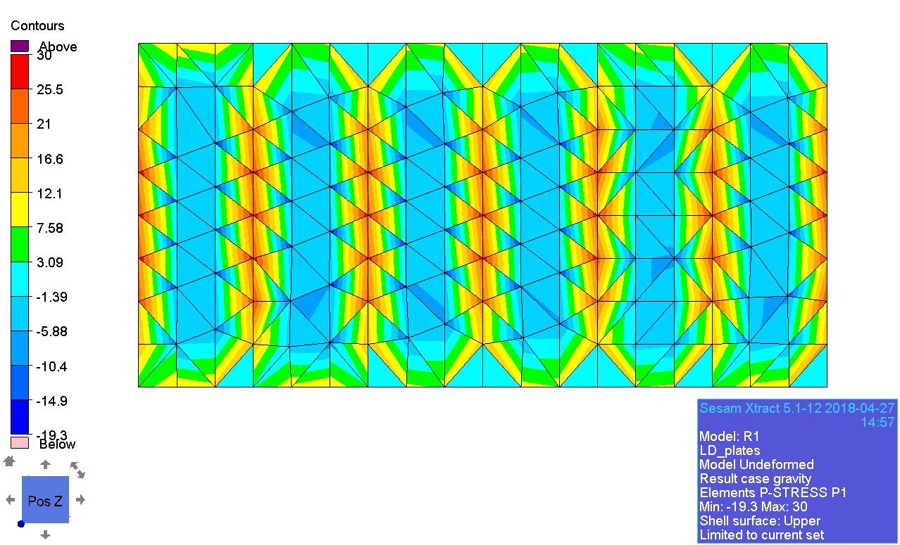

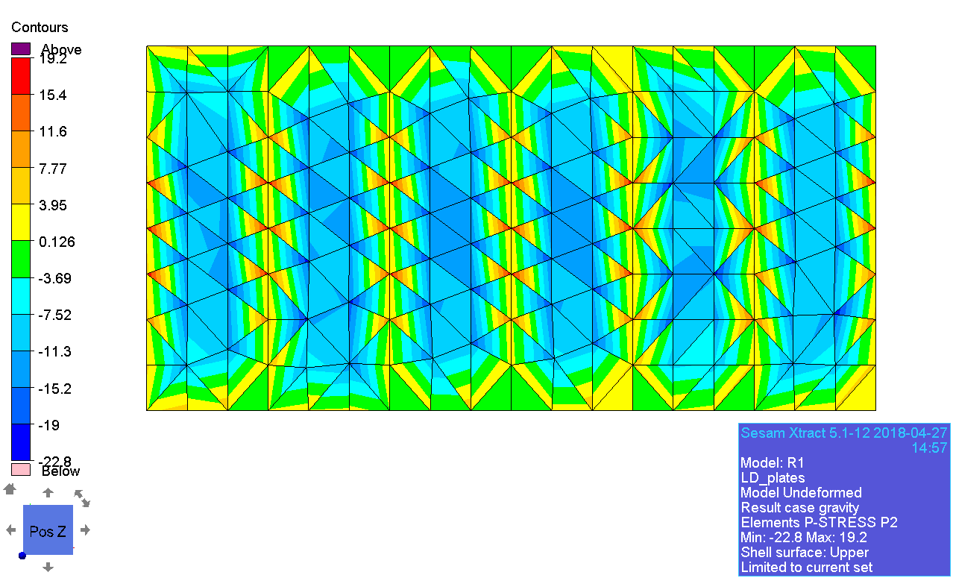

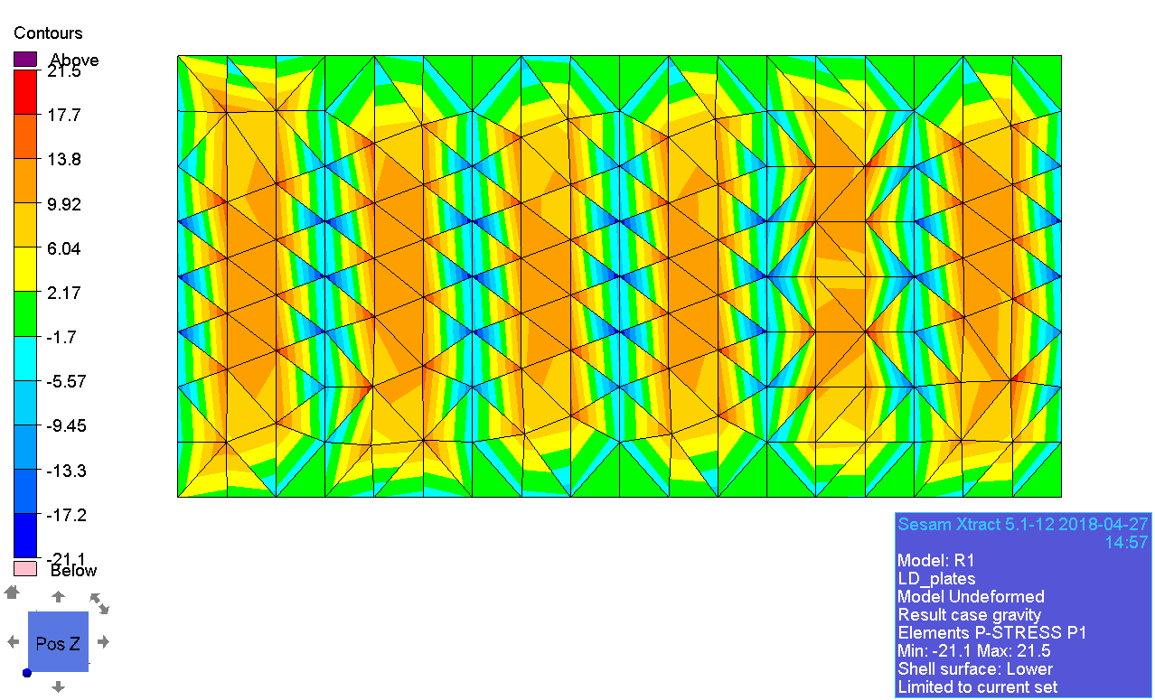

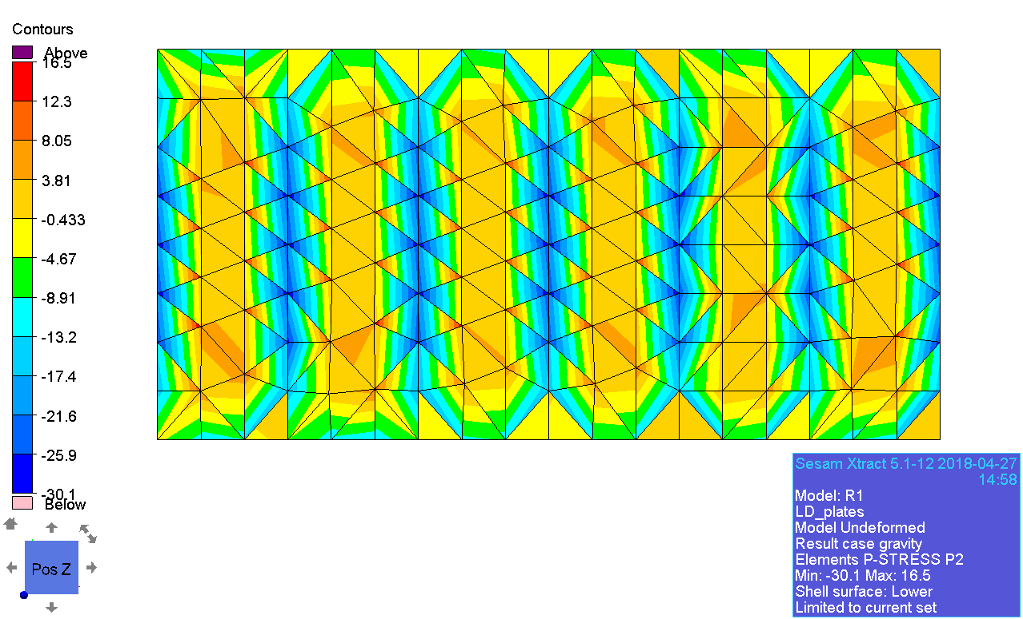

#### Decomposed stress

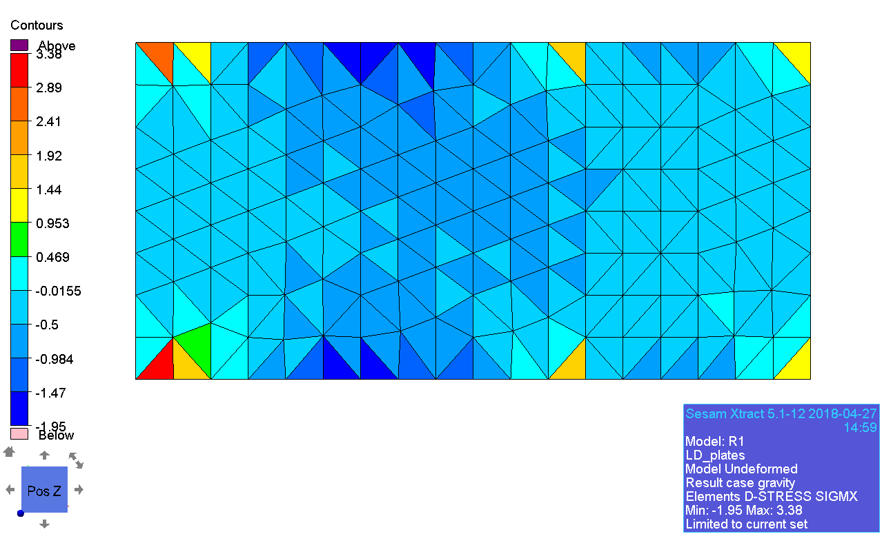

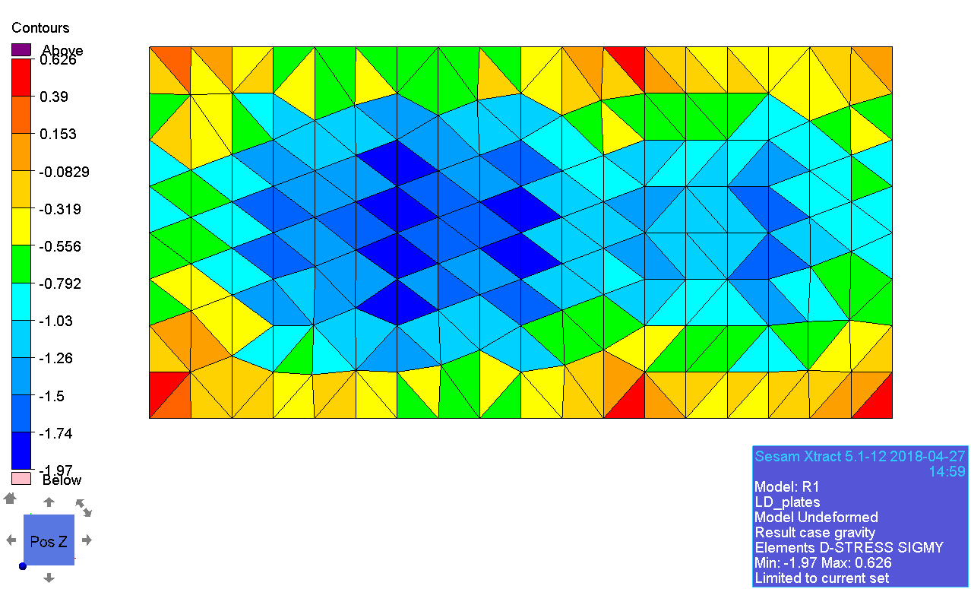

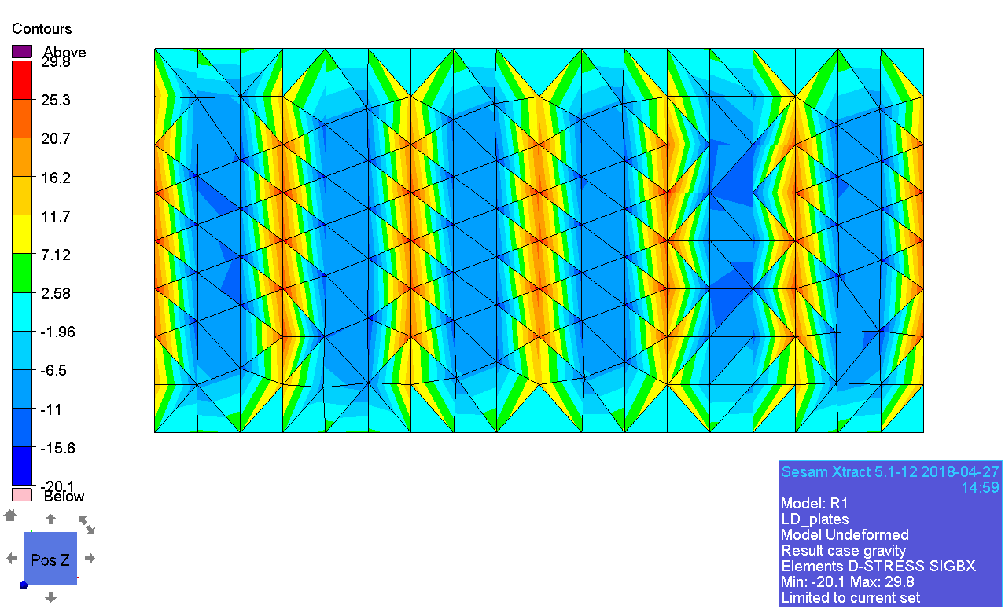

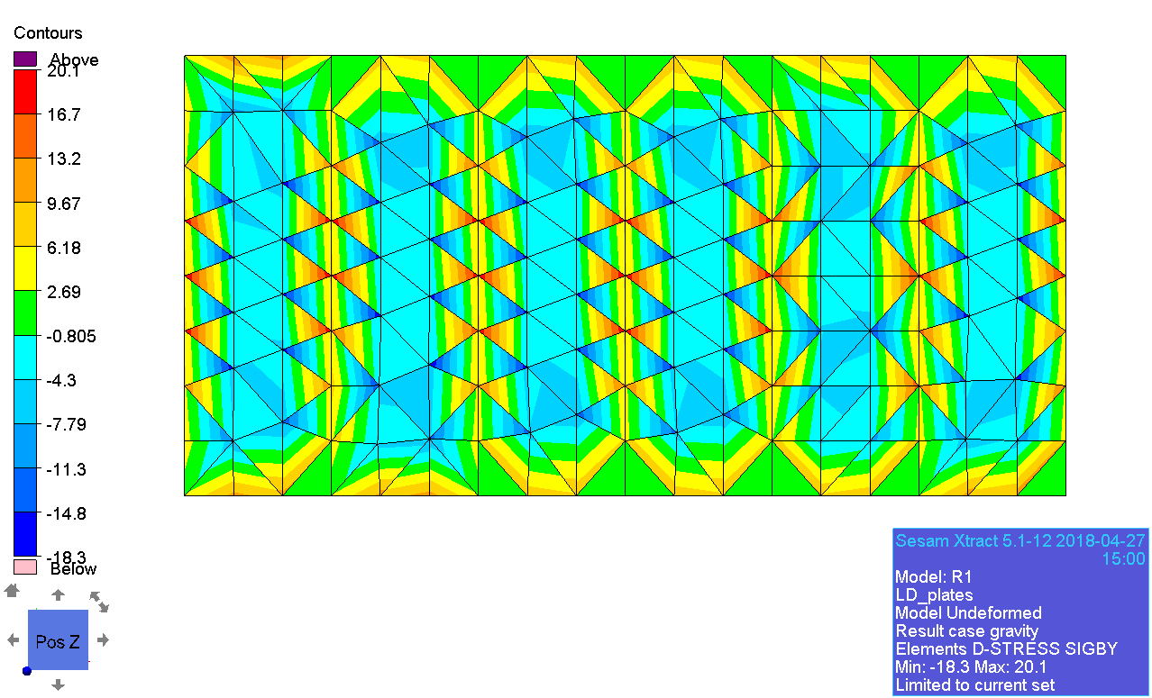

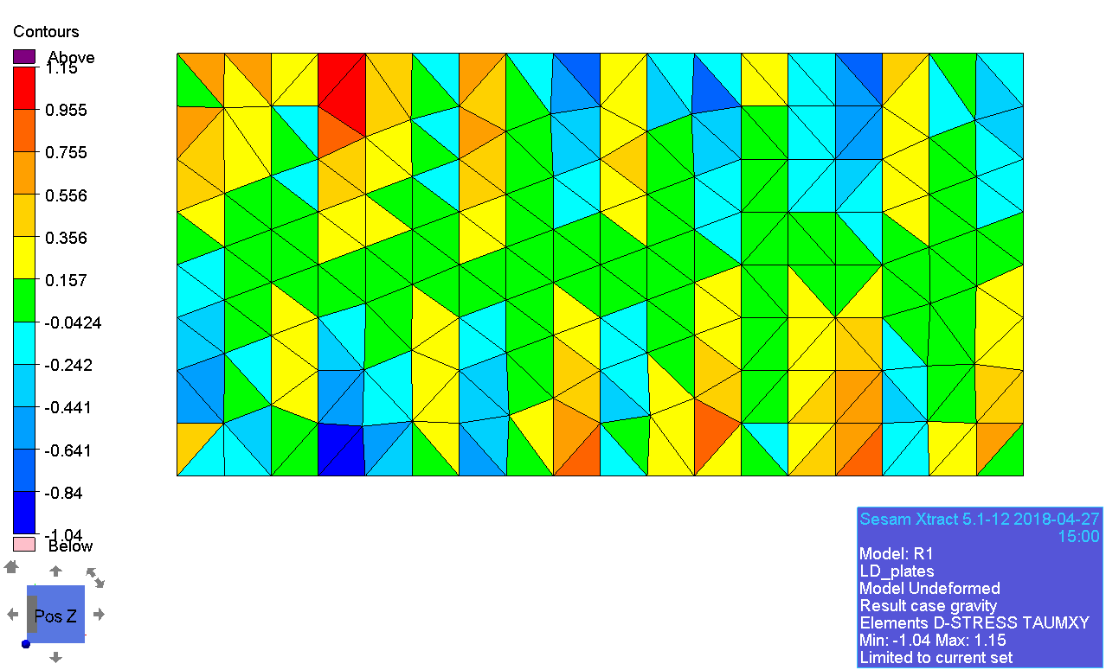

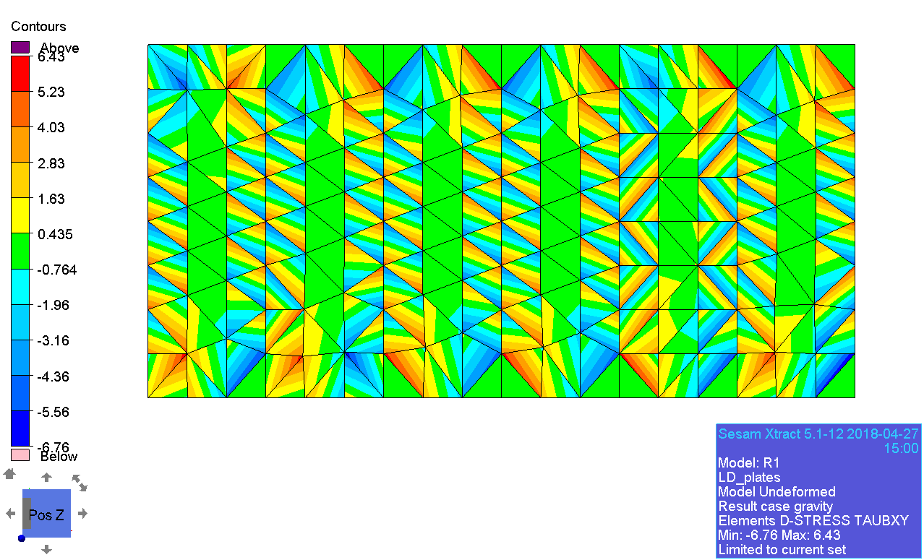

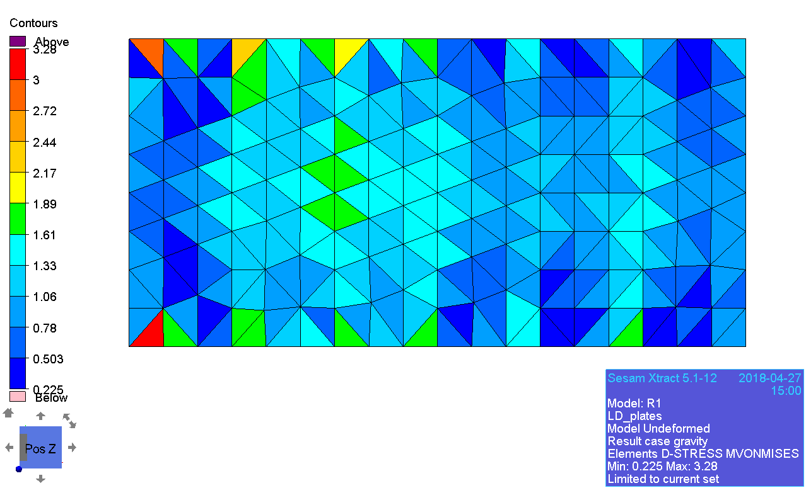

#### Membrane Principal stress

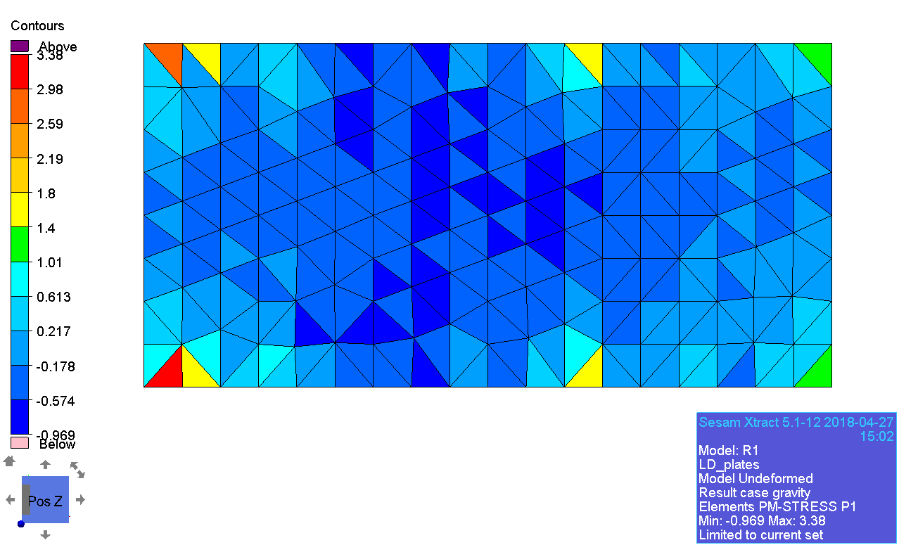

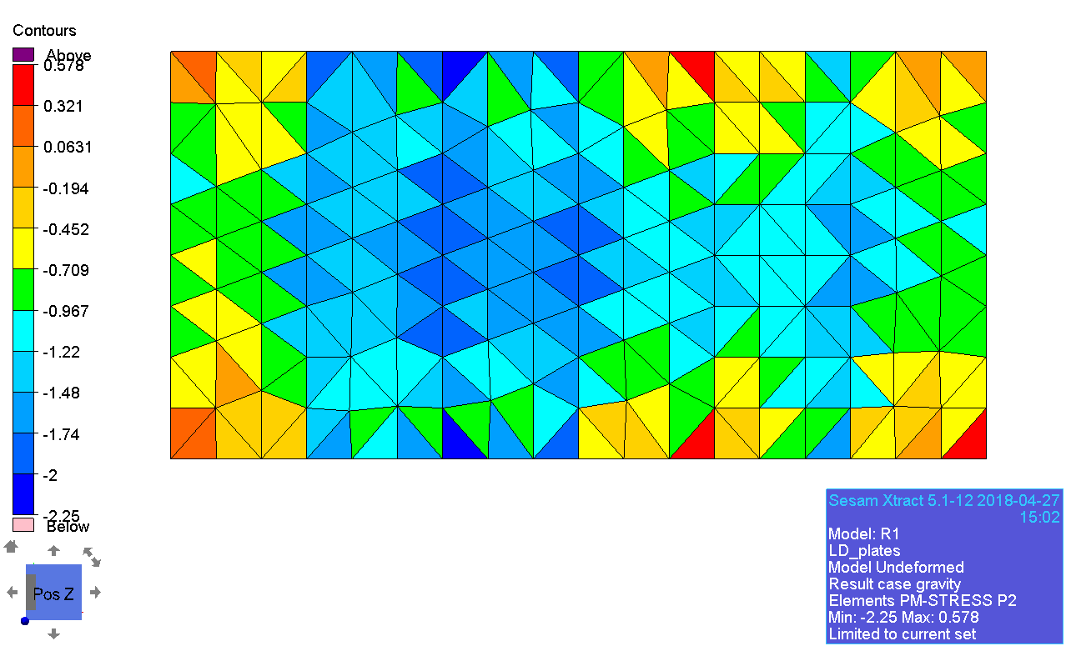

### Node results

#### Displacement

|  |  |
| --- | --- |
| Component | X |
| Dataset | test01_1stord_linstat_R1/LD_plates/noderes/displacement |
| Vtu-file | test01_1stord_linstat_R1_LD_plates_noderes.vtu |
| Xtract: | |
| Paraview: | |

|  |  |
| --- | --- |
| Component | Y |
| Dataset | test01_1stord_linstat_R1/LD_plates/noderes/displacement |
| Vtu-file | test01_1stord_linstat_R1_LD_plates_noderes.vtu |
| Xtract: | |
| Paraview | |

|  |  |
| --- | --- |
| Component | Z |
| Dataset | test01_1stord_linstat_R1/LD_plates/noderes/displacement |
| Vtu-file | test01_1stord_linstat_R1_LD_plates_noderes.vtu |
| Xtract: | |
| Paraview: | |

|  |  |
| --- | --- |
| Component | RX |
| Dataset | test01_1stord_linstat_R1/LD_plates/noderes/displacement |
| Vtu-file | test01_1stord_linstat_R1_LD_plates_noderes.vtu |
| Xtract: | |
| Paraview: | |

|  |  |
| --- | --- |
| Component | RY |
| Dataset | test01_1stord_linstat_R1/LD_plates/noderes/displacement |
| Vtu-file | test01_1stord_linstat_R1_LD_plates_noderes.vtu |
| Xtract: | |
| Paraview: | |

|  |  |
| --- | --- |
| Component | RZ |
| Dataset | test01_1stord_linstat_R1/LD_plates/noderes/displacement |
| Vtu-file | test01_1stord_linstat_R1_LD_plates_noderes.vtu |
| Xtract: | |
| Paraview: | |

## LD_beams

### Beam forces

|  |  |
| --- | --- |
| Component | NXX |
| Dataset | test01_1stord_linstat_R1/LD_beams/elemres/beamforce |
| Vtu-file | test01_1stord_linstat_R1_LD_beams_elemres.vtu |
| Xtract: | |
| Paraview: | |

|  |  |
| --- | --- |
| Component | NXY |
| Dataset | test01_1stord_linstat_R1/LD_beams/elemres/beamforce |
| Vtu-file | test01_1stord_linstat_R1_LD_beams_elemres.vtu |
| Xtract: | |
| Paraview: | |

|  |  |
| --- | --- |
| Component | NXZ |
| Dataset | test01_1stord_linstat_R1/LD_beams/elemres/beamforce |
| Vtu-file | test01_1stord_linstat_R1_LD_beams_elemres.vtu |
| Xtract: | |
| Paraview: | |

|  |  |
| --- | --- |
| Component | MXX |
| Dataset | test01_1stord_linstat_R1/LD_beams/elemres/beamforce |
| Vtu-file | test01_1stord_linstat_R1_LD_beams_elemres.vtu |
| Xtract: | |
| Paraview: | |

|  |  |
| --- | --- |
| Component | MXY |
| Dataset | test01_1stord_linstat_R1/LD_beams/elemres/beamforce |
| Vtu-file | test01_1stord_linstat_R1_LD_beams_elemres.vtu |
| Xtract: | |
| Paraview: | |

|  |  |
| --- | --- |
| Component | MXZ |
| Dataset | test01_1stord_linstat_R1/LD_beams/elemres/beamforce |
| Vtu-file | test01_1stord_linstat_R1_LD_beams_elemres.vtu |
| Xtract: | |
| Paraview: | |

## MD (quad elements)

### General stress

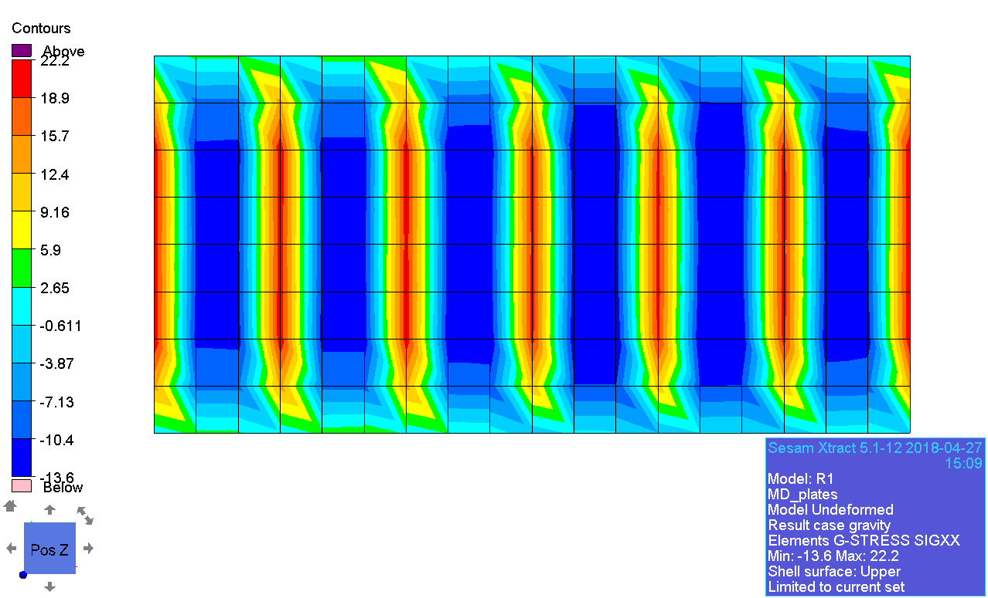

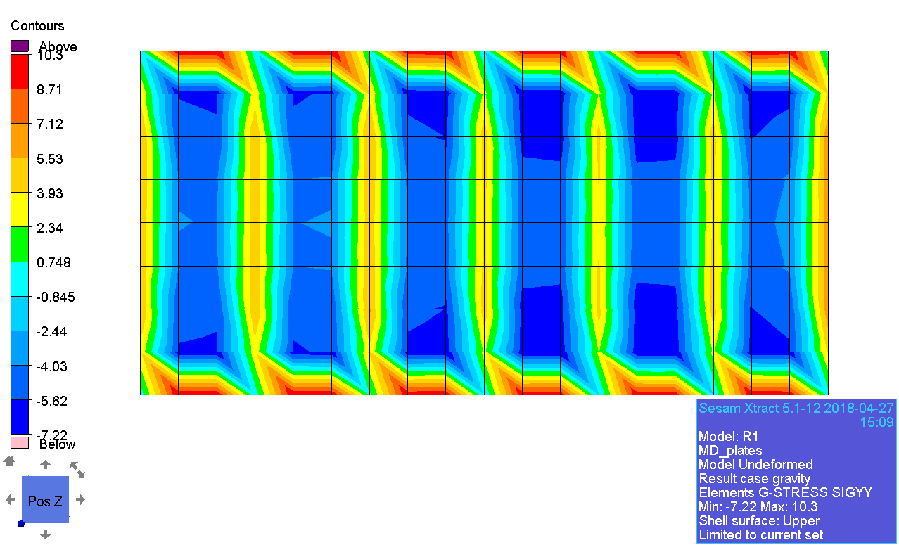

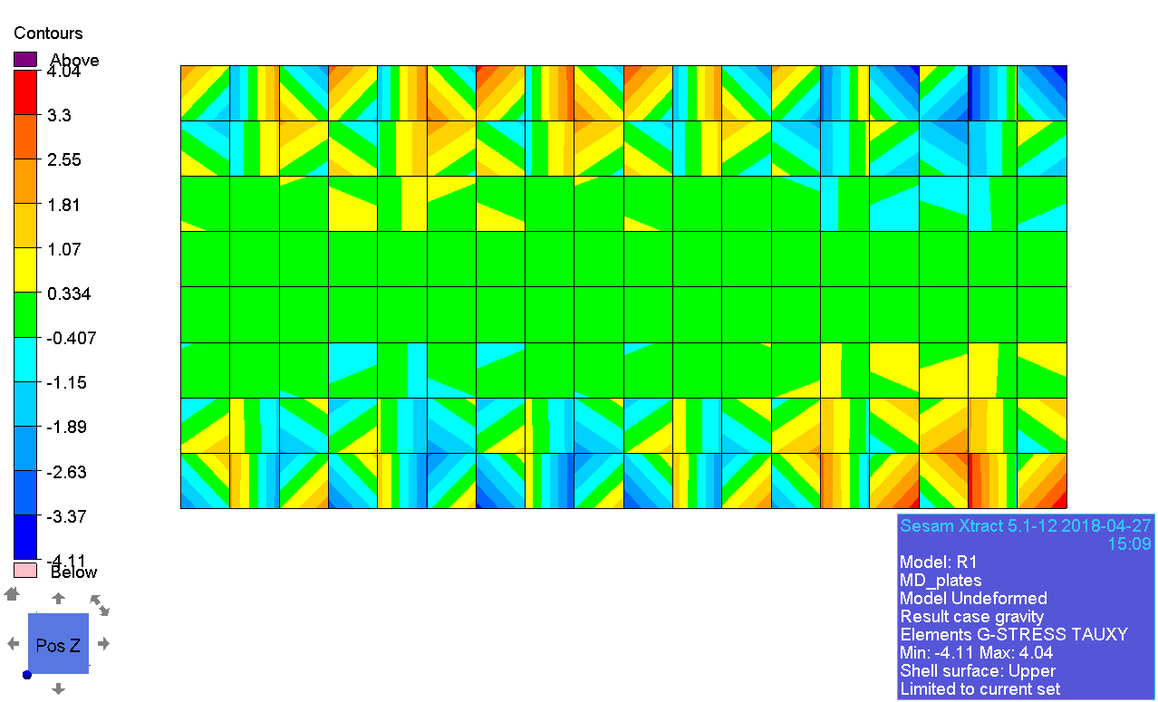

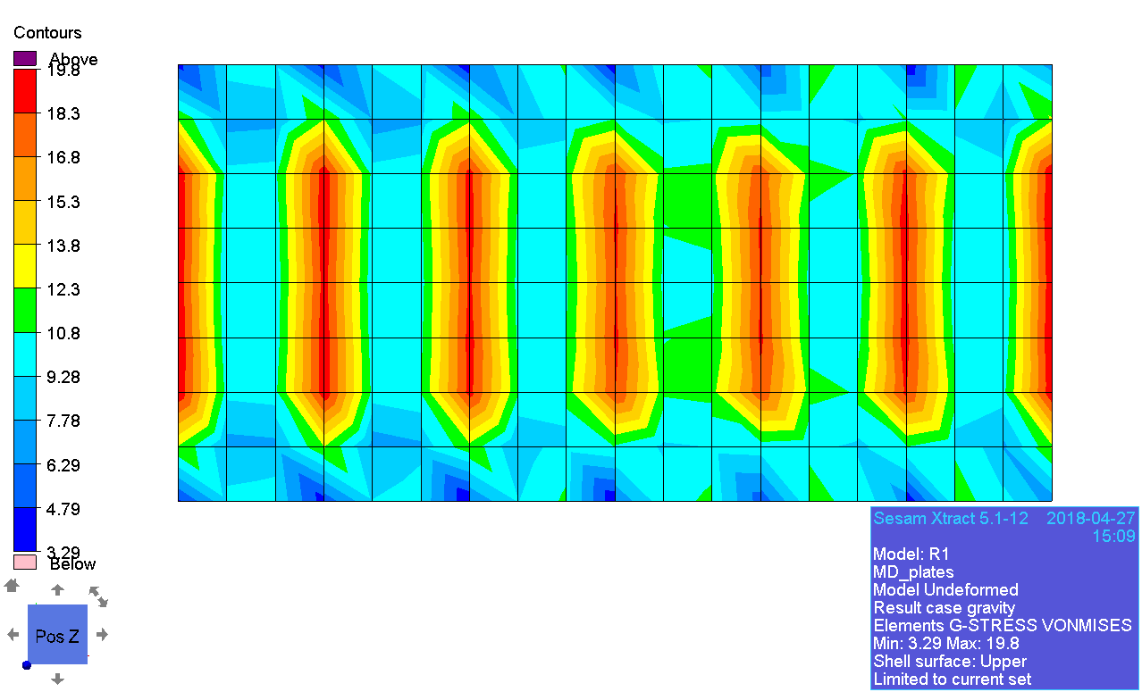

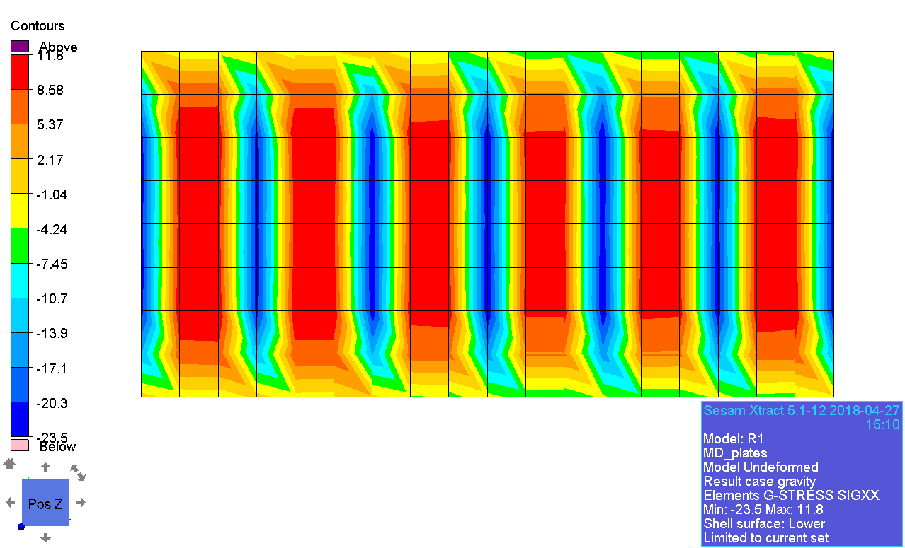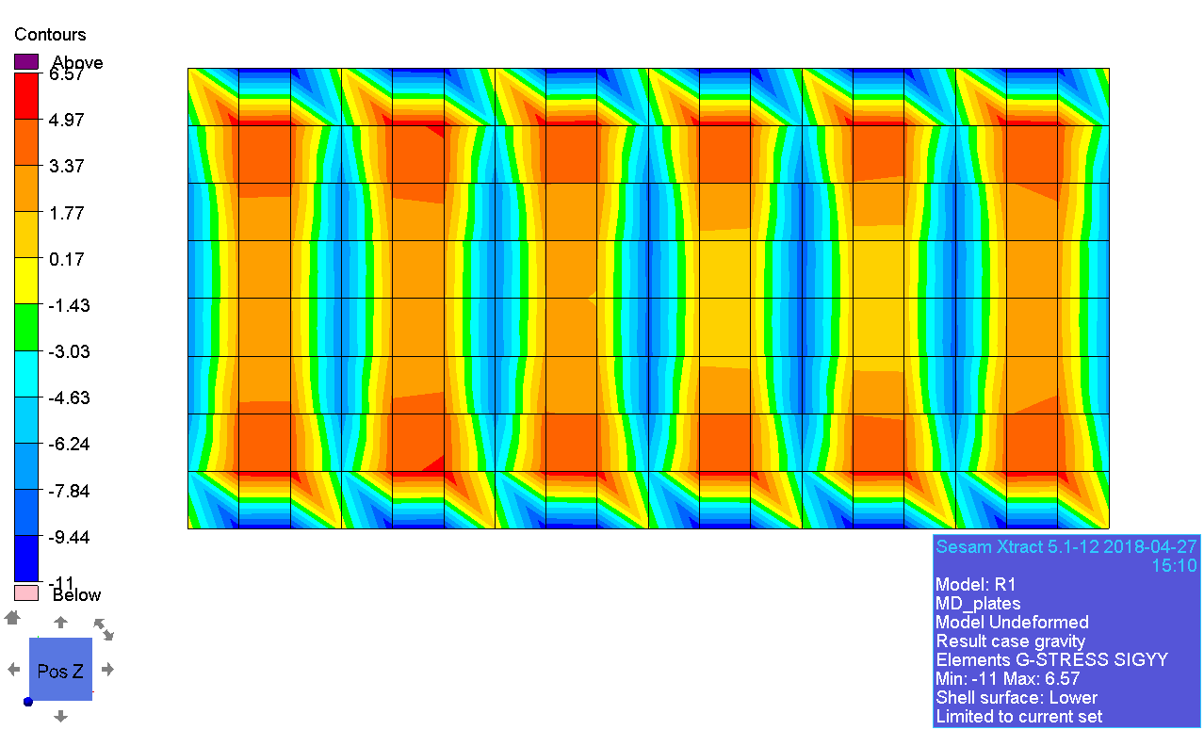

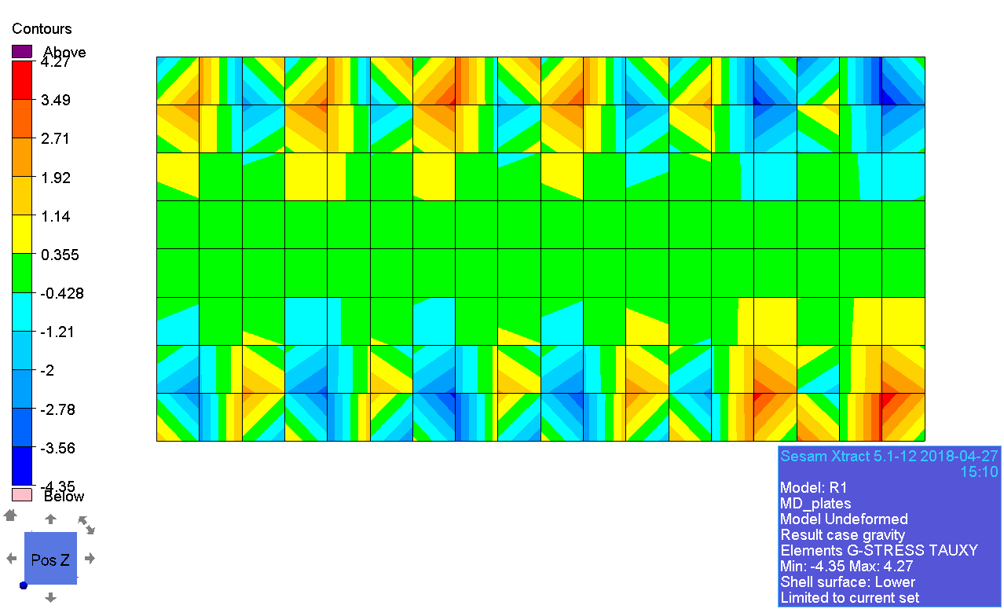

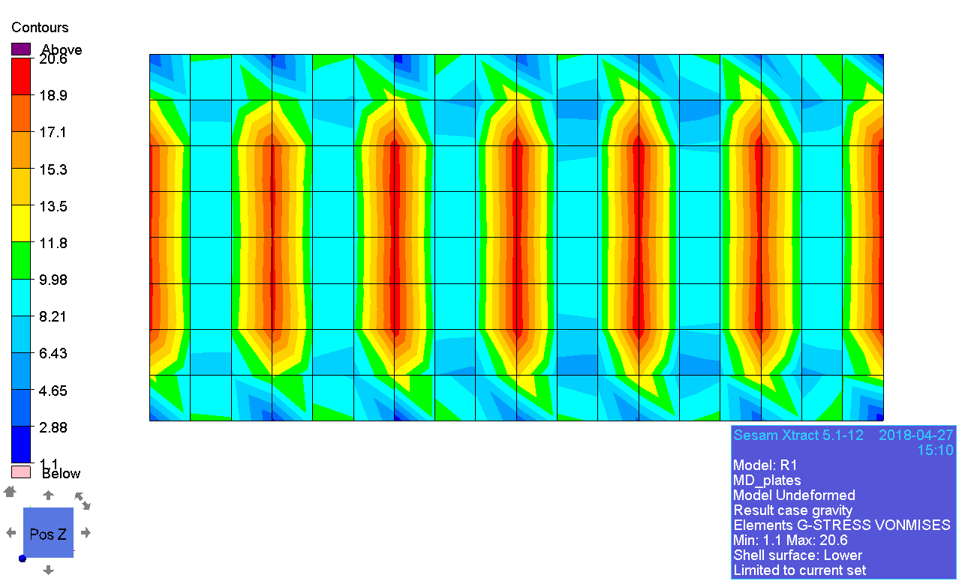

### Principal stress

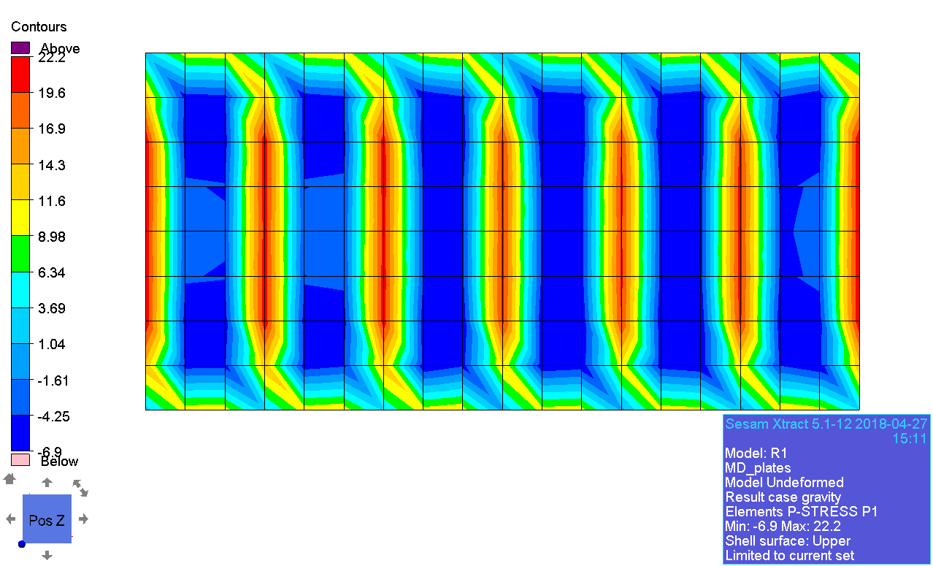

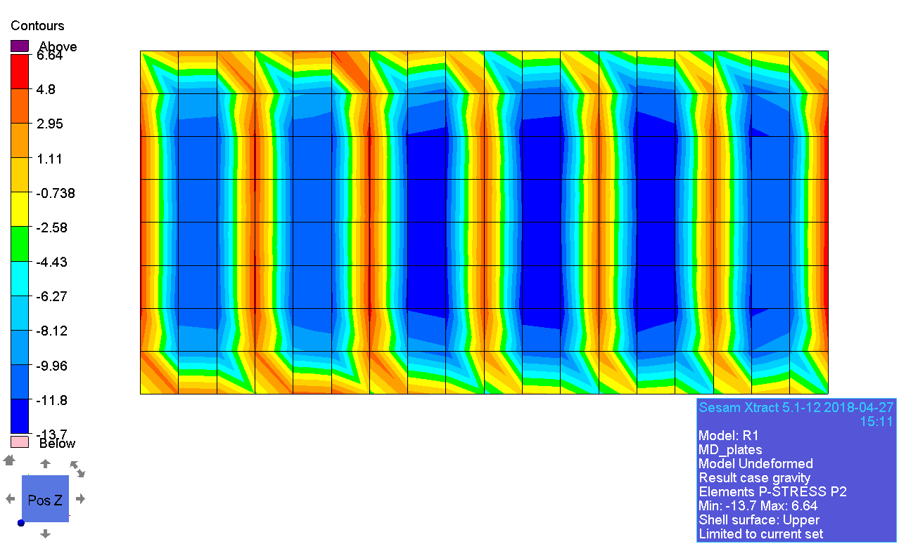

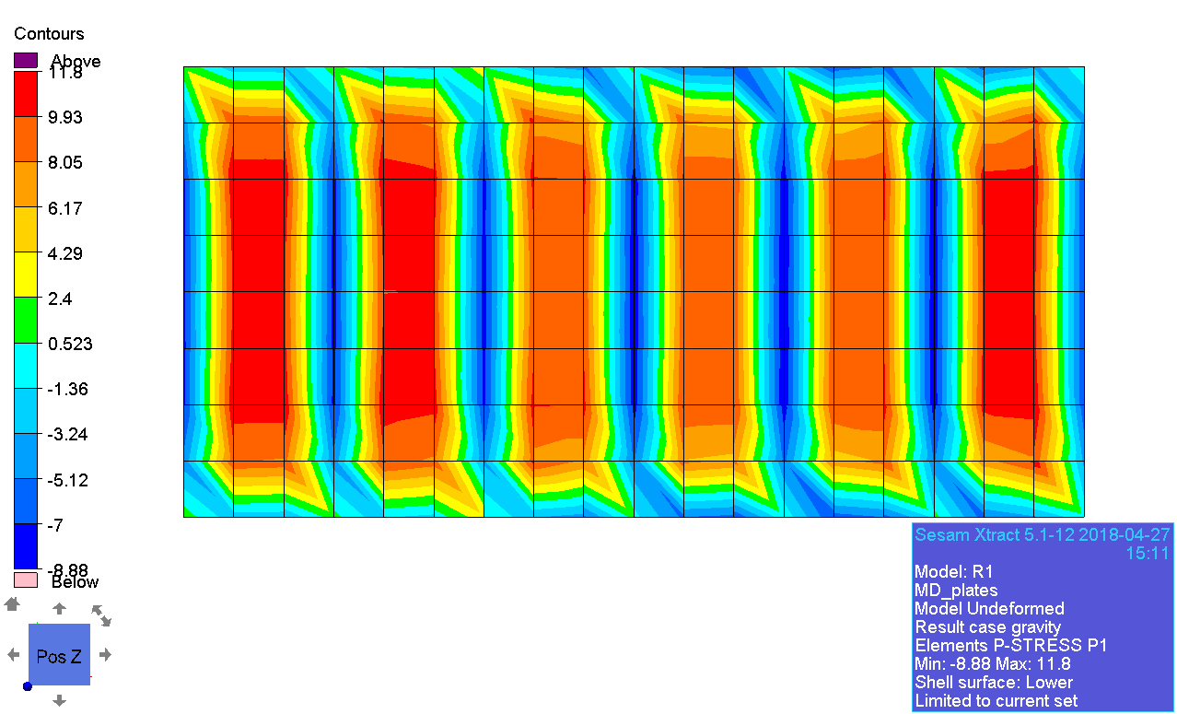

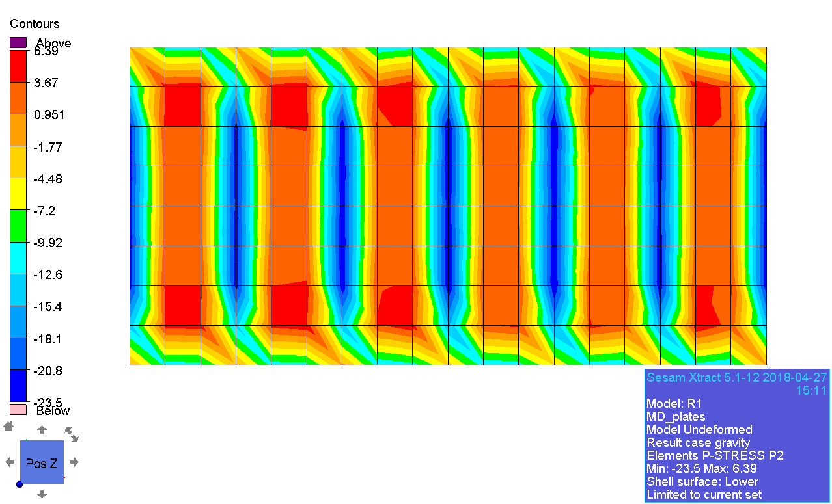

### Deccomposed stress

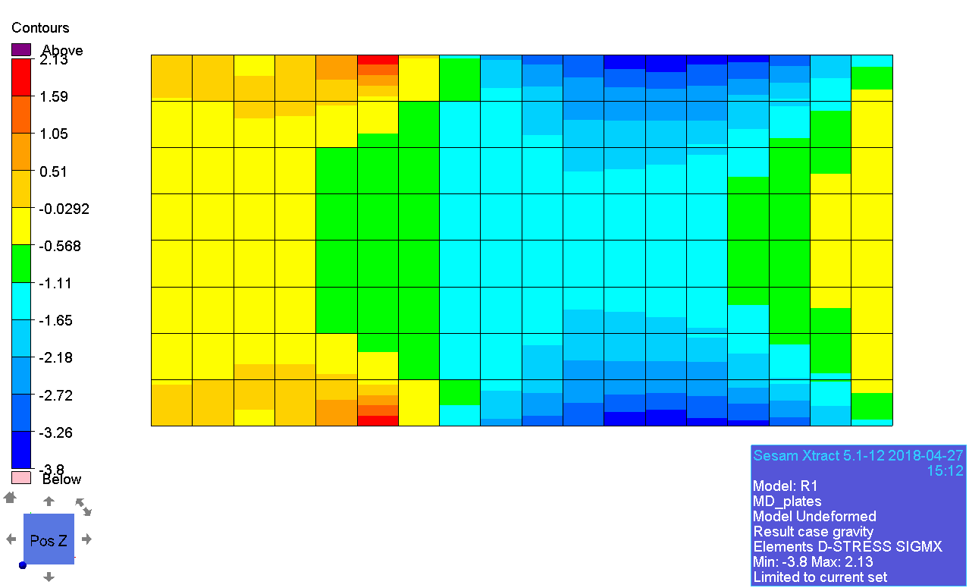

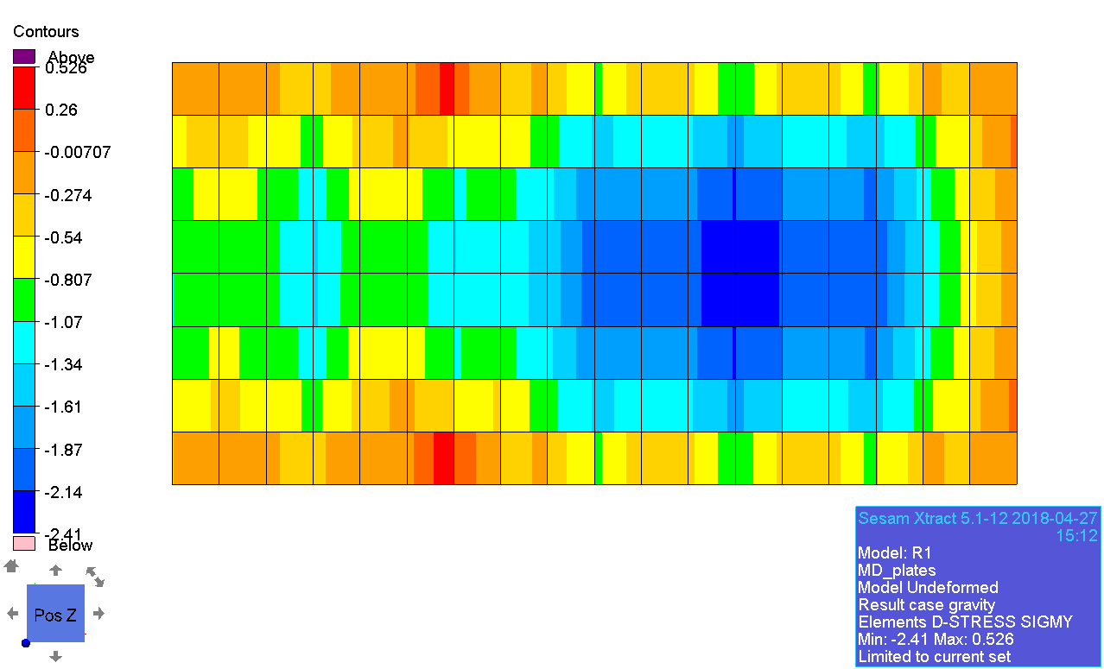

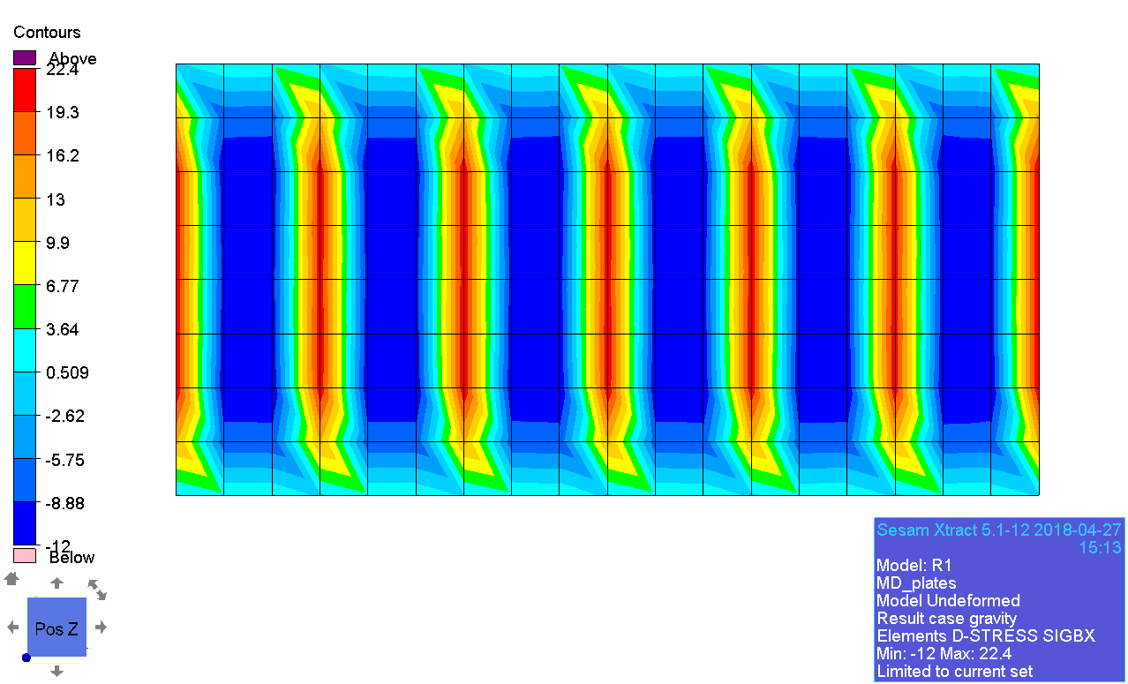

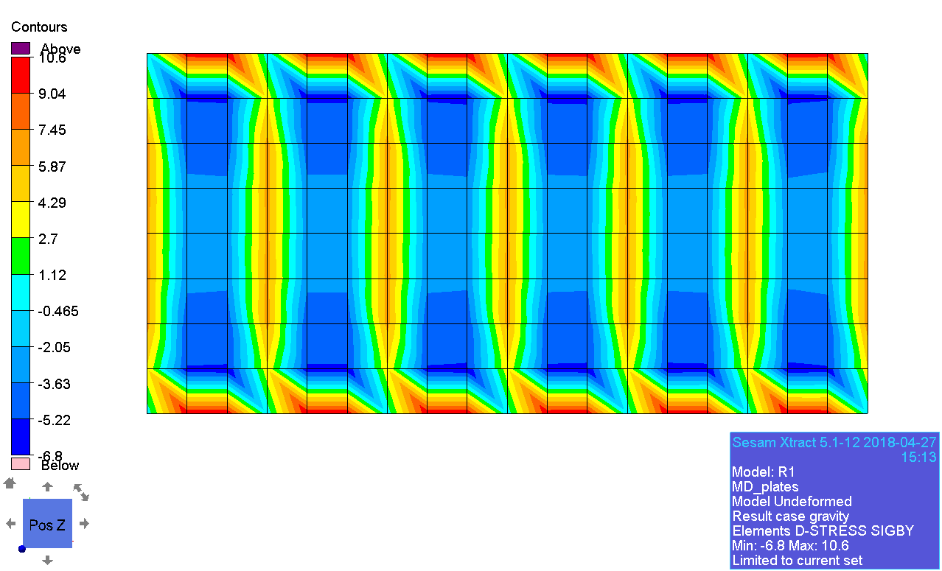

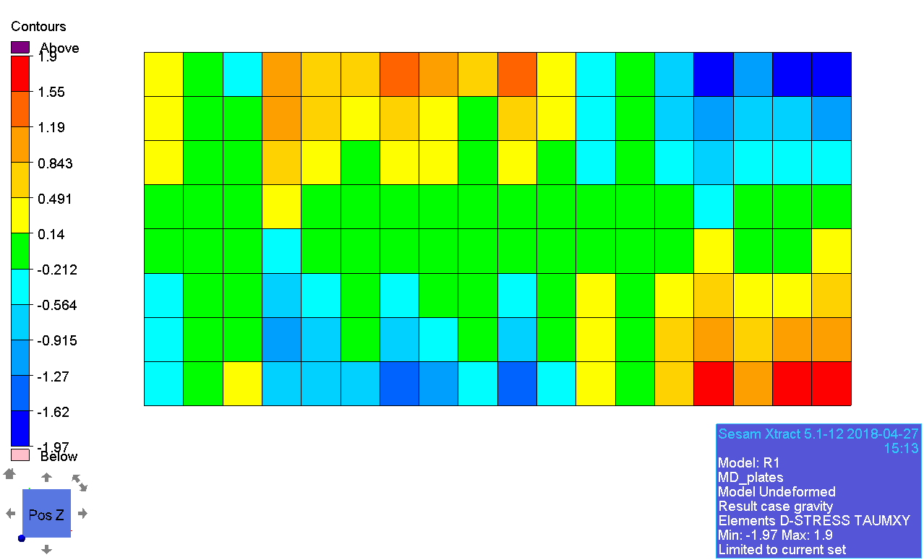

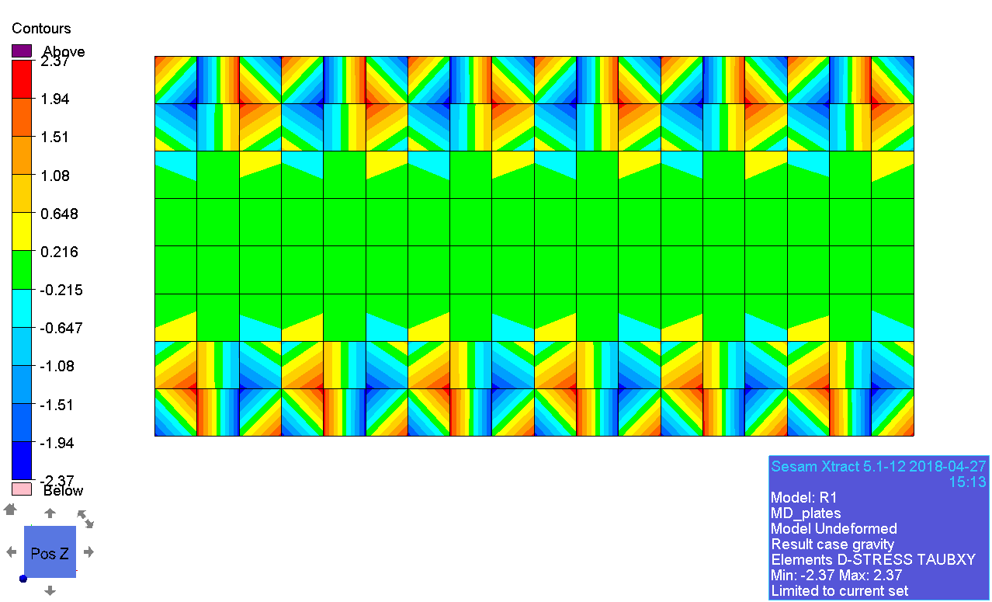

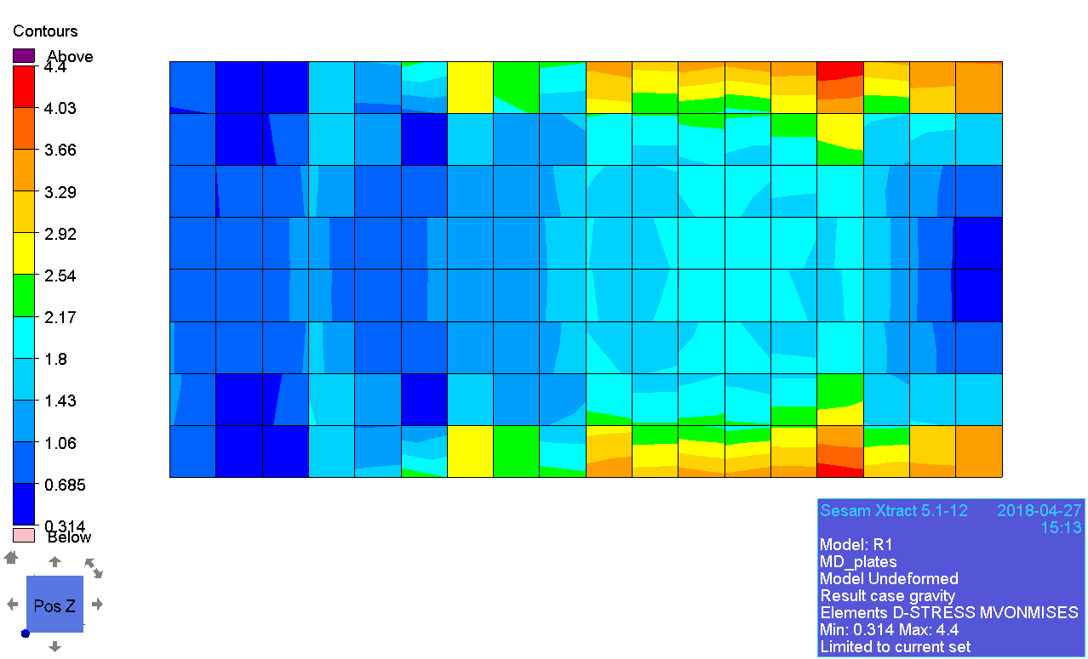¨

### Membrane principal stress

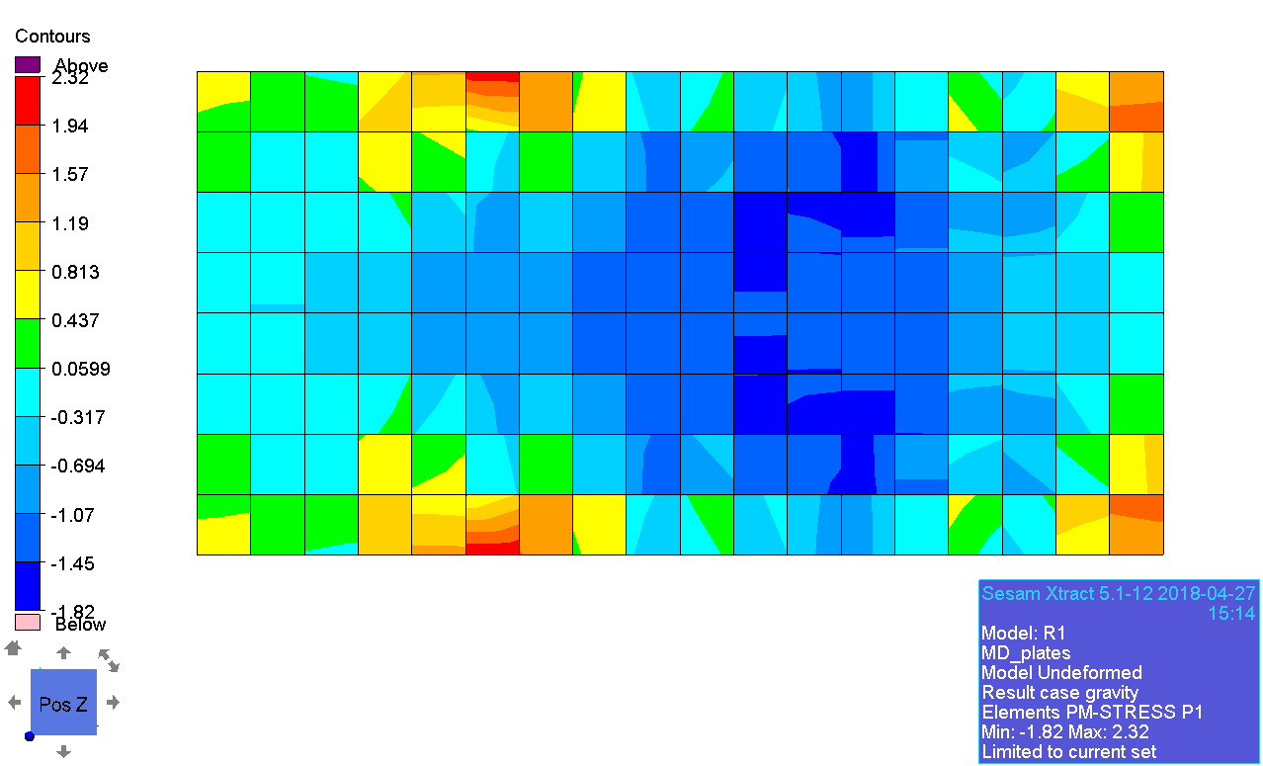

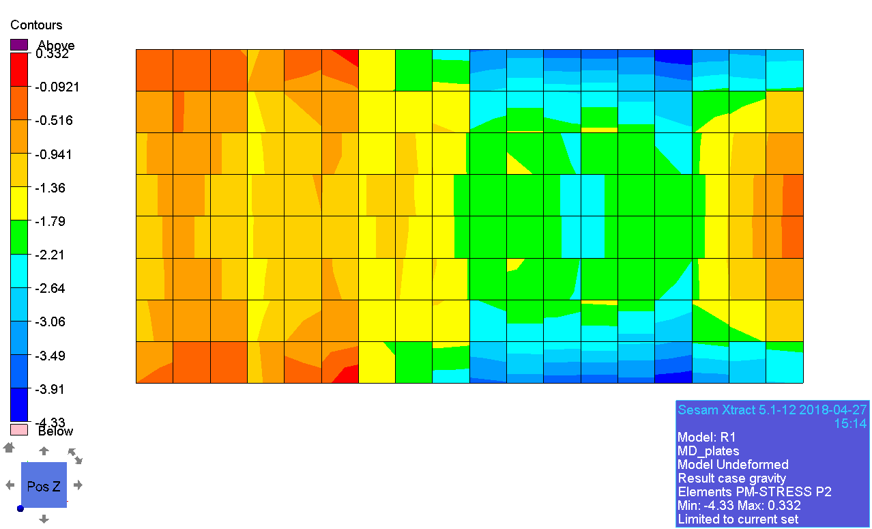

### Beam forces

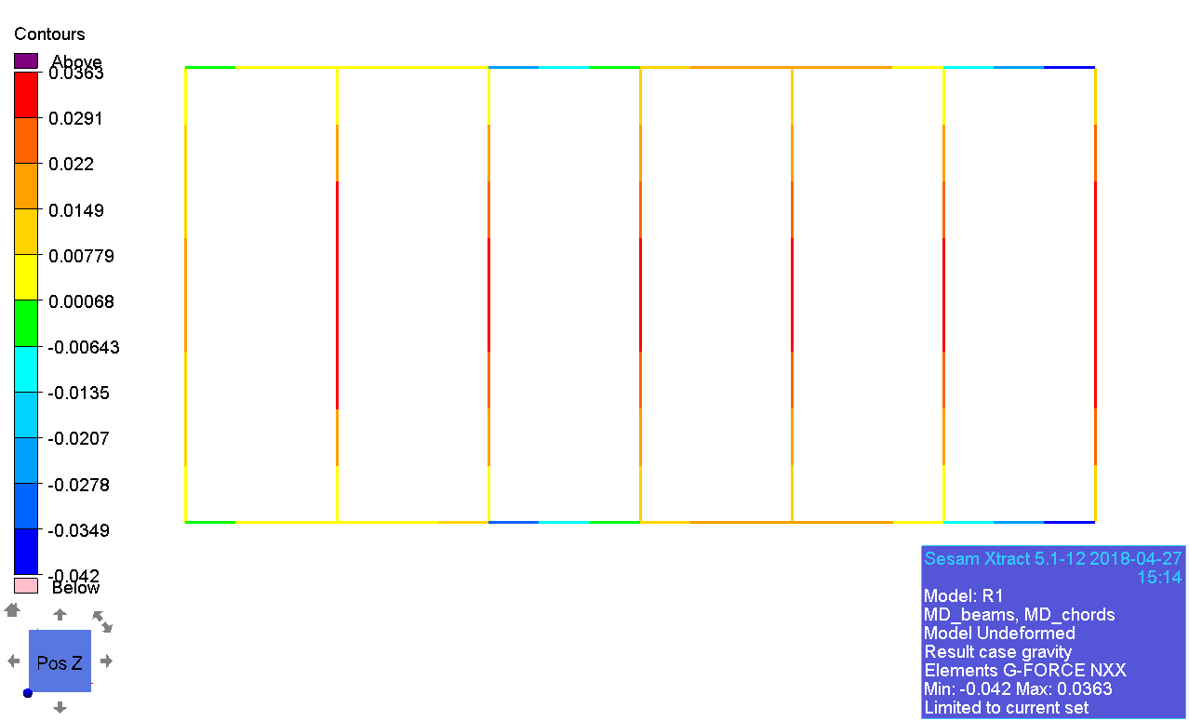

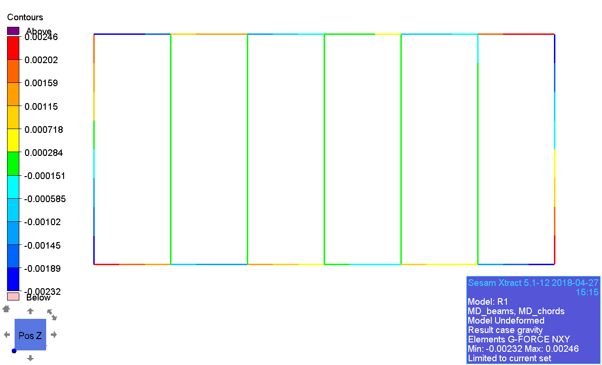

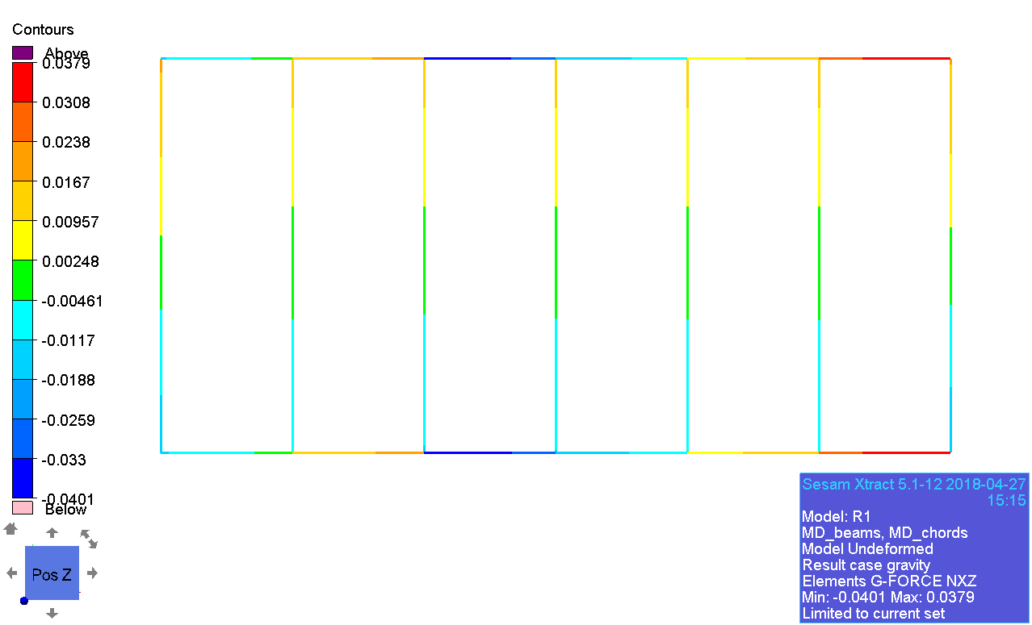

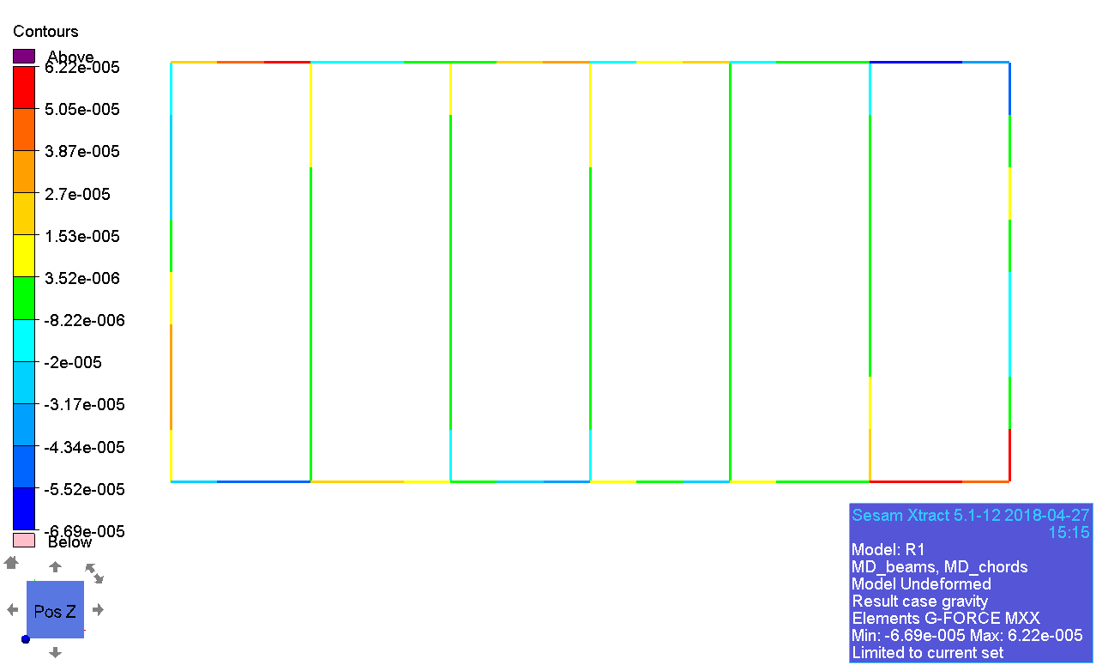

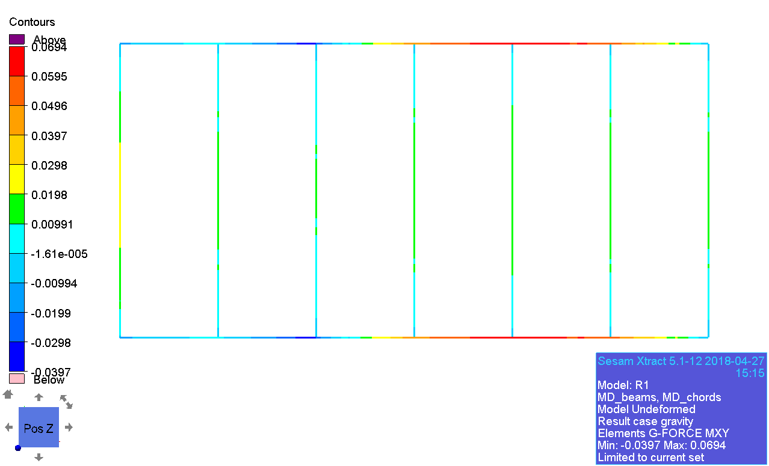

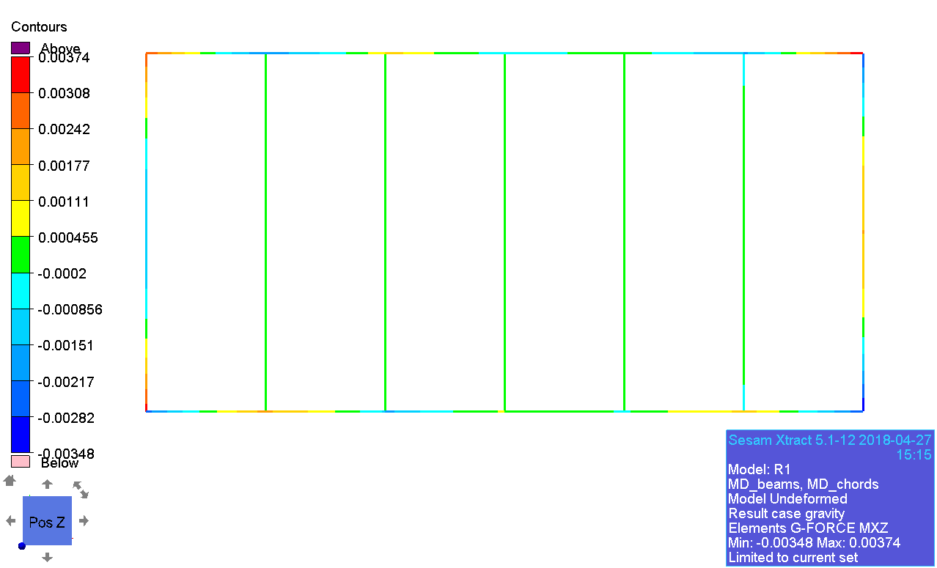

### Displacement

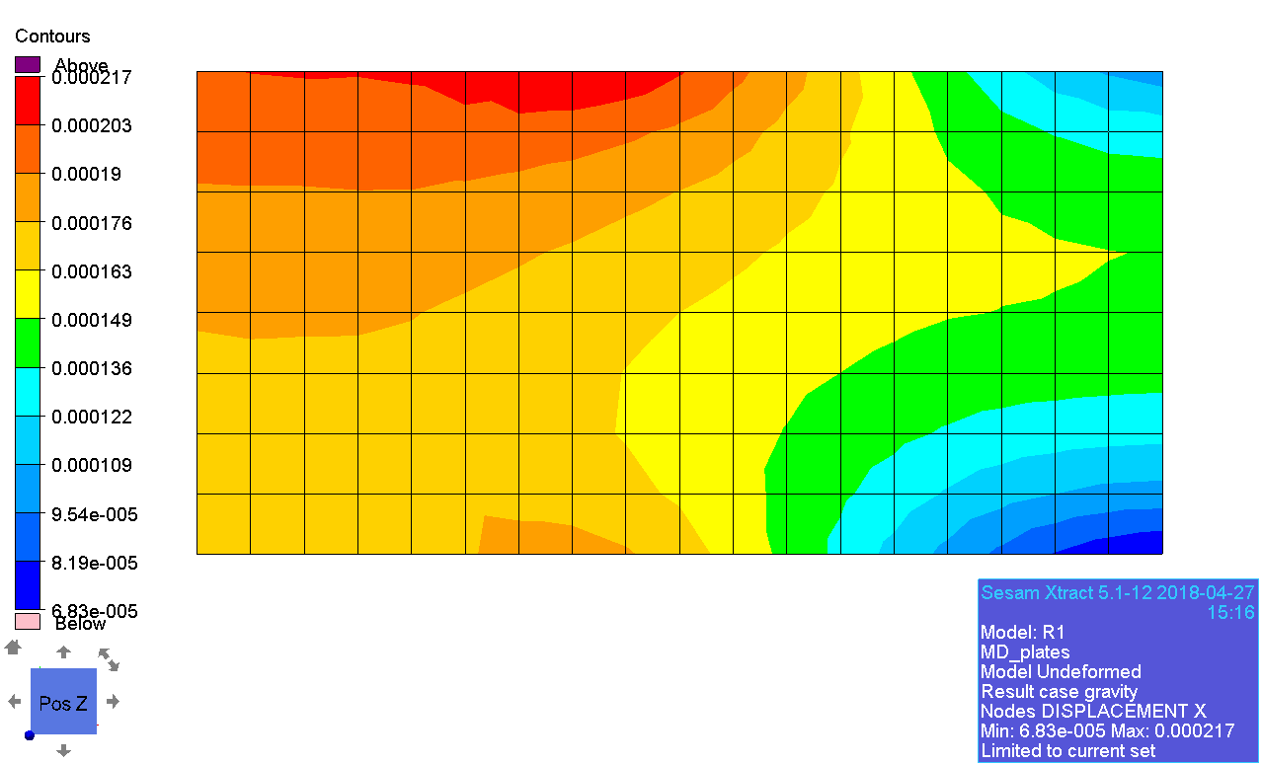

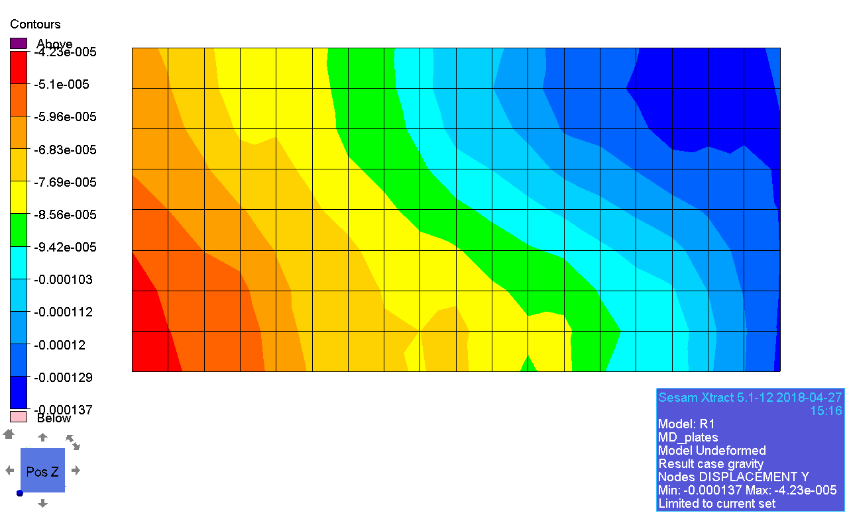

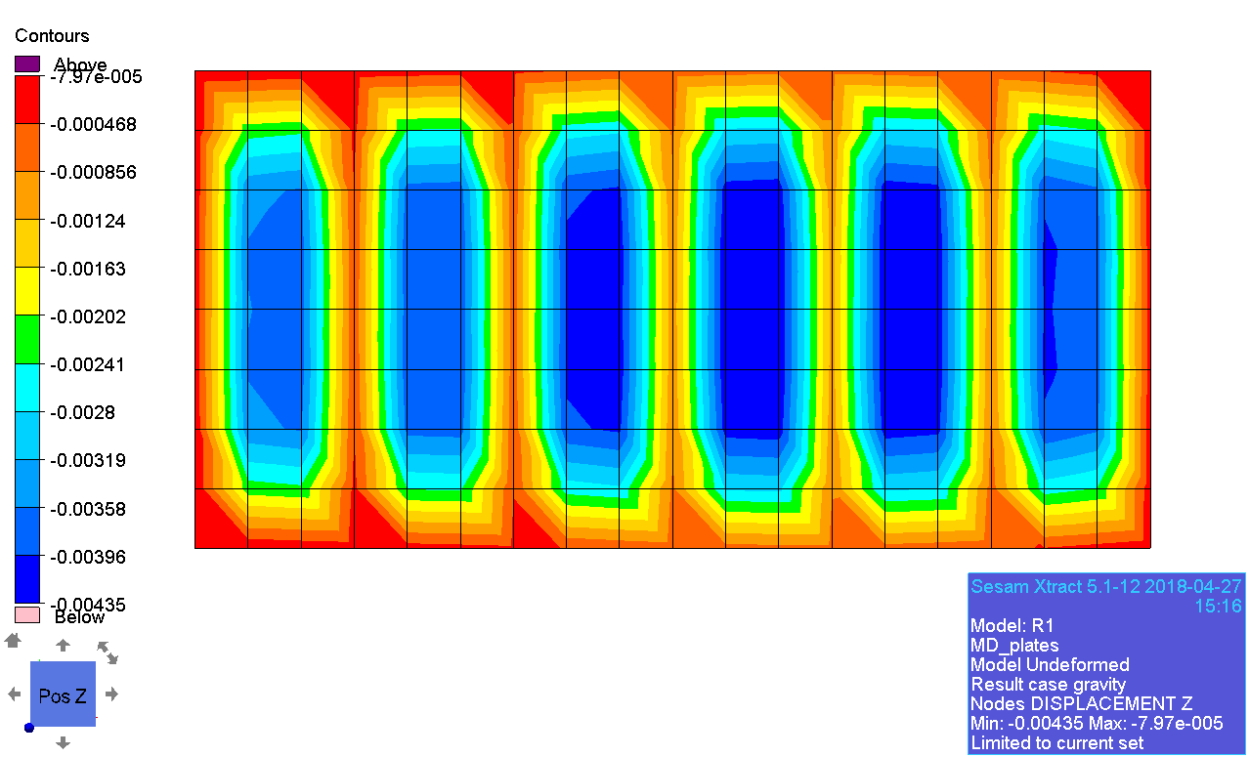

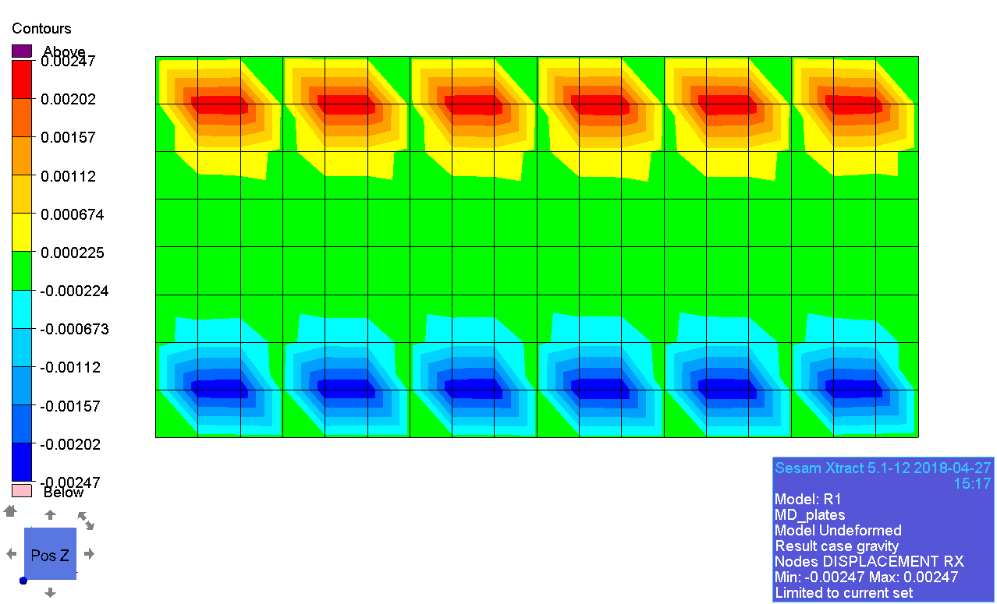

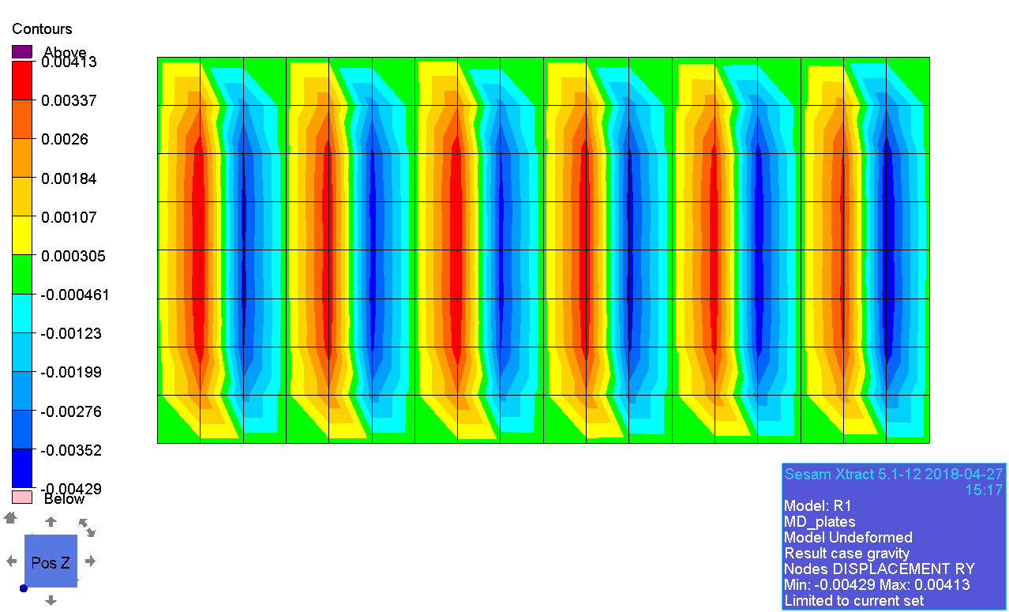

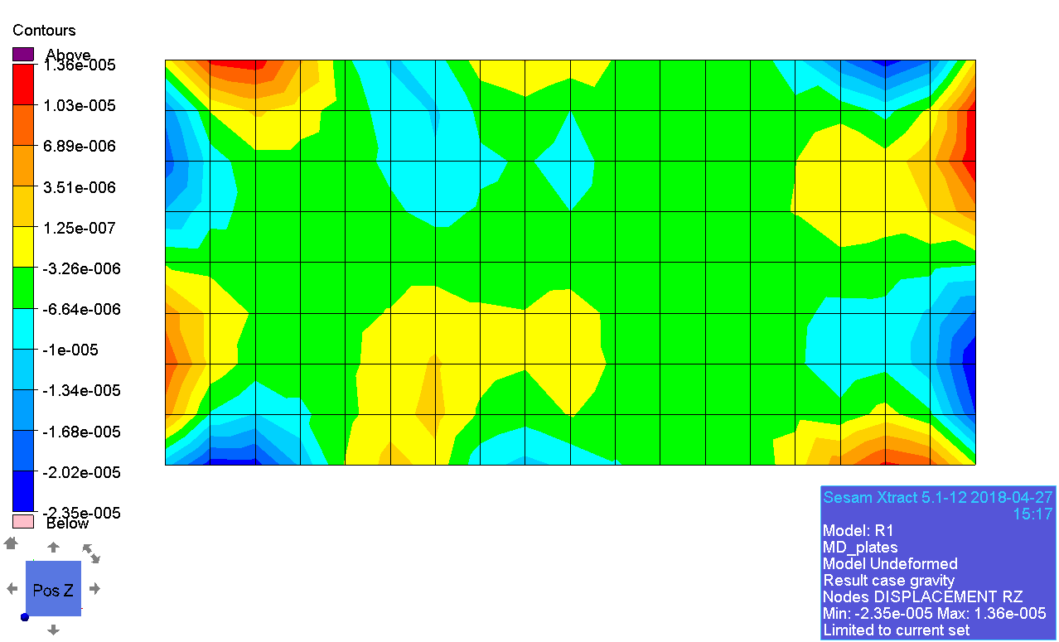

# test01_2ndord_linstat_R1

## LD

### General stress

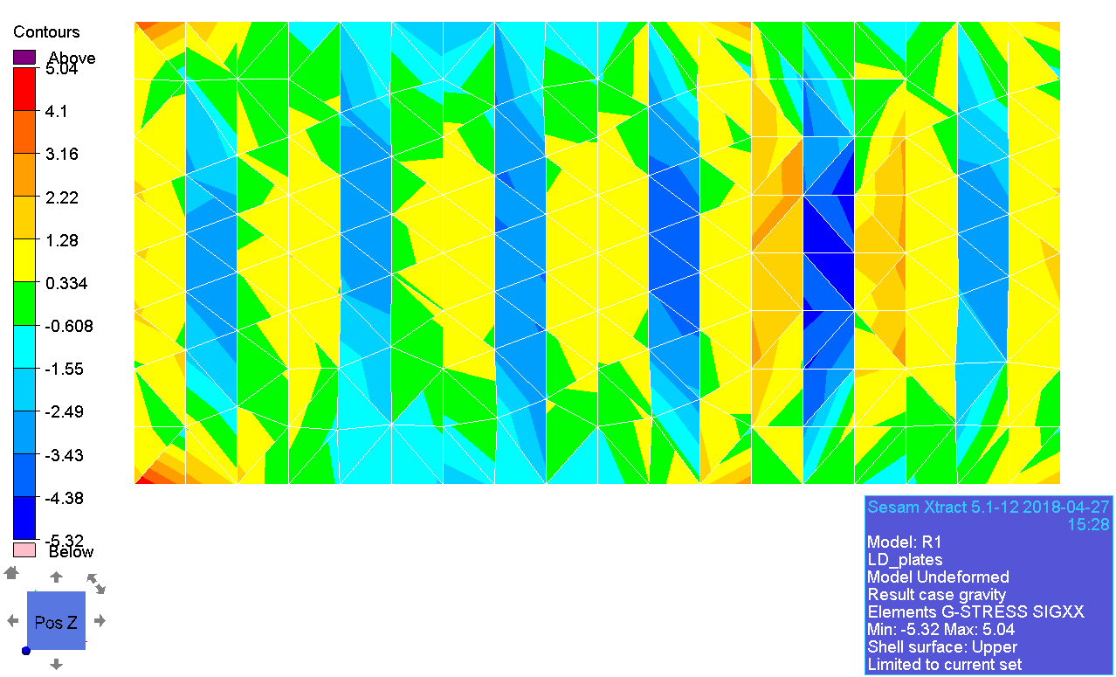

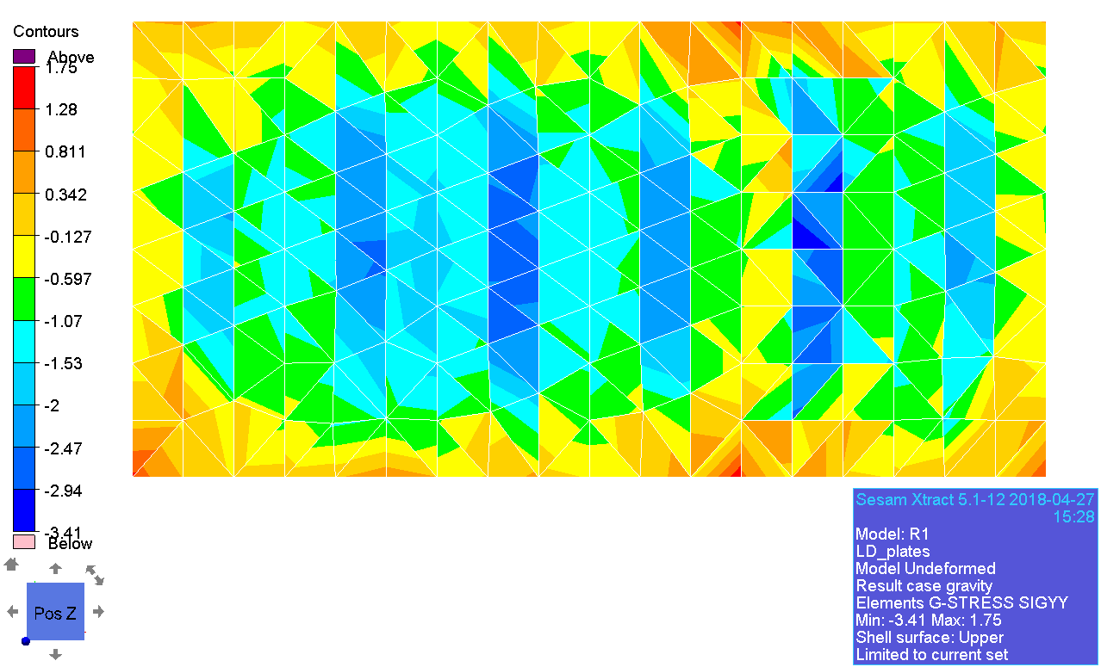

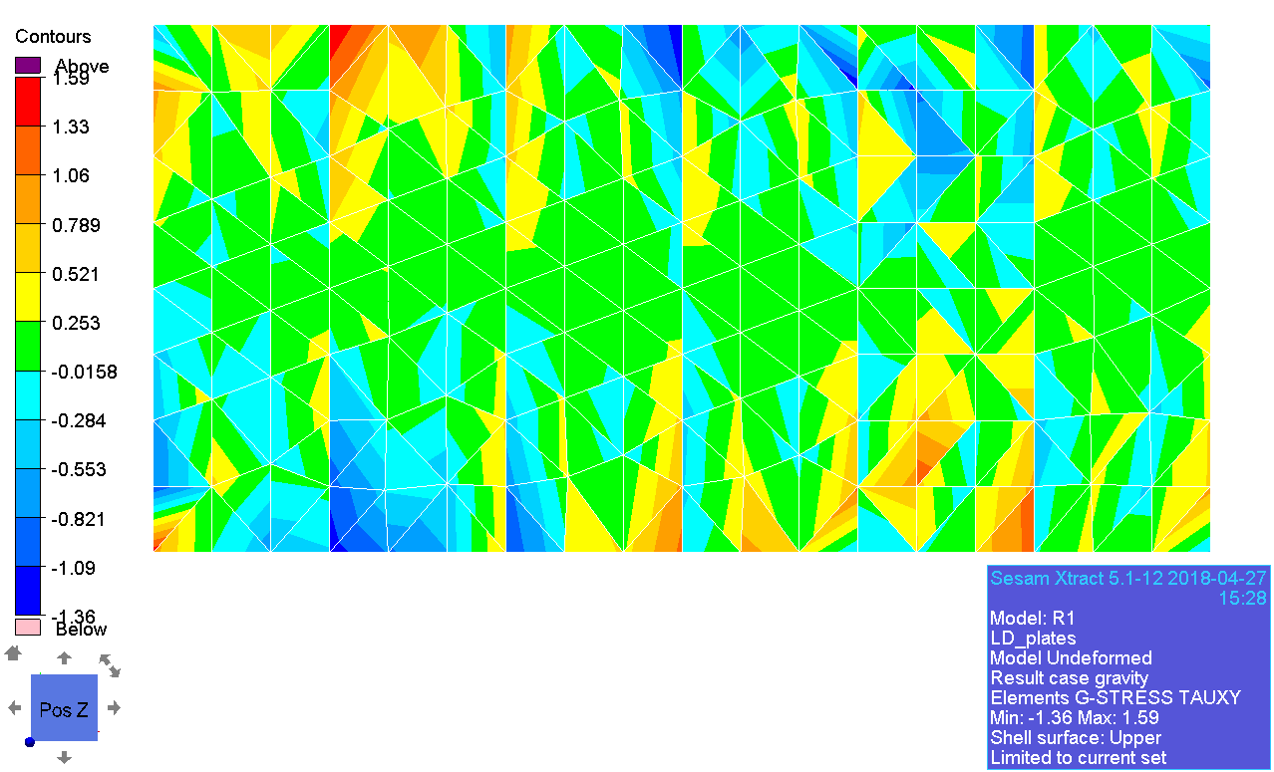

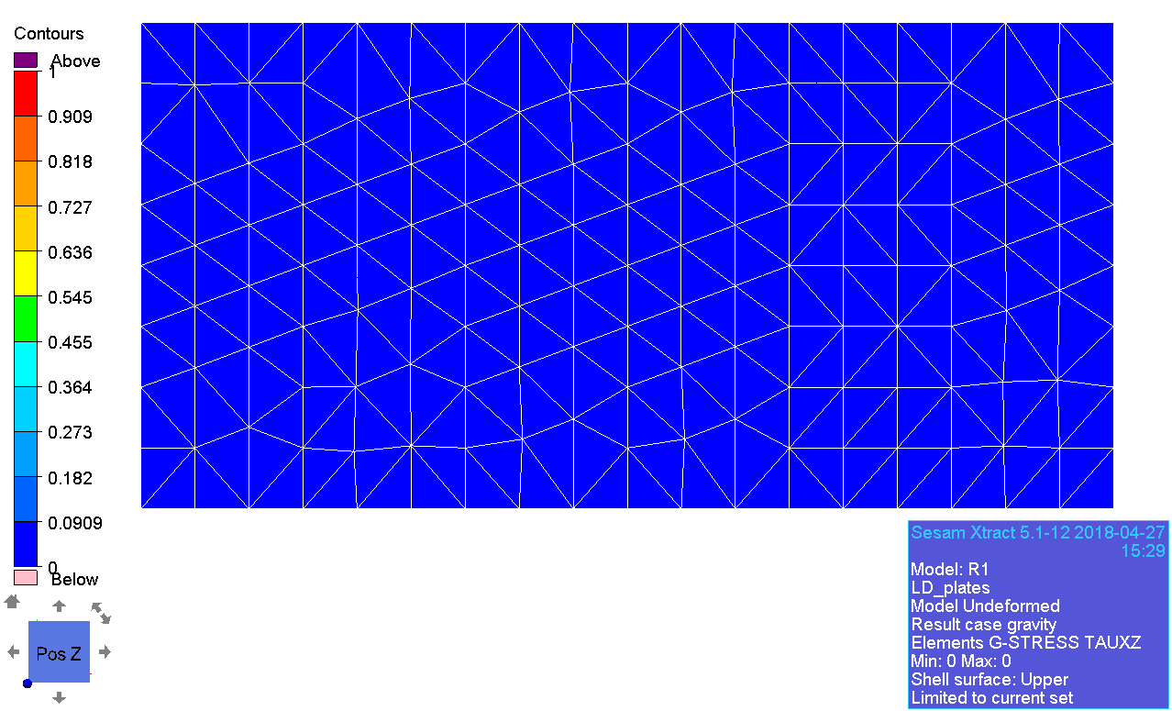

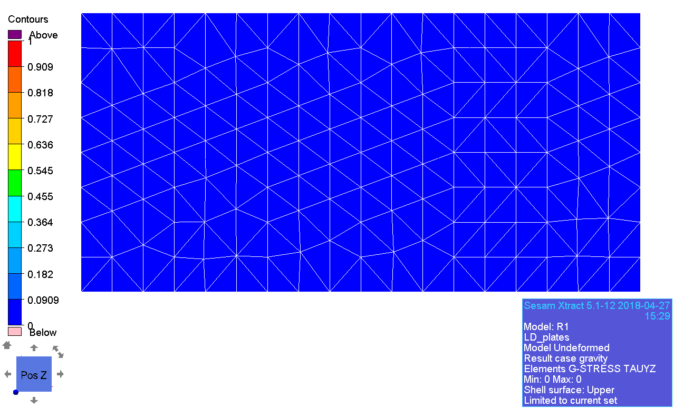

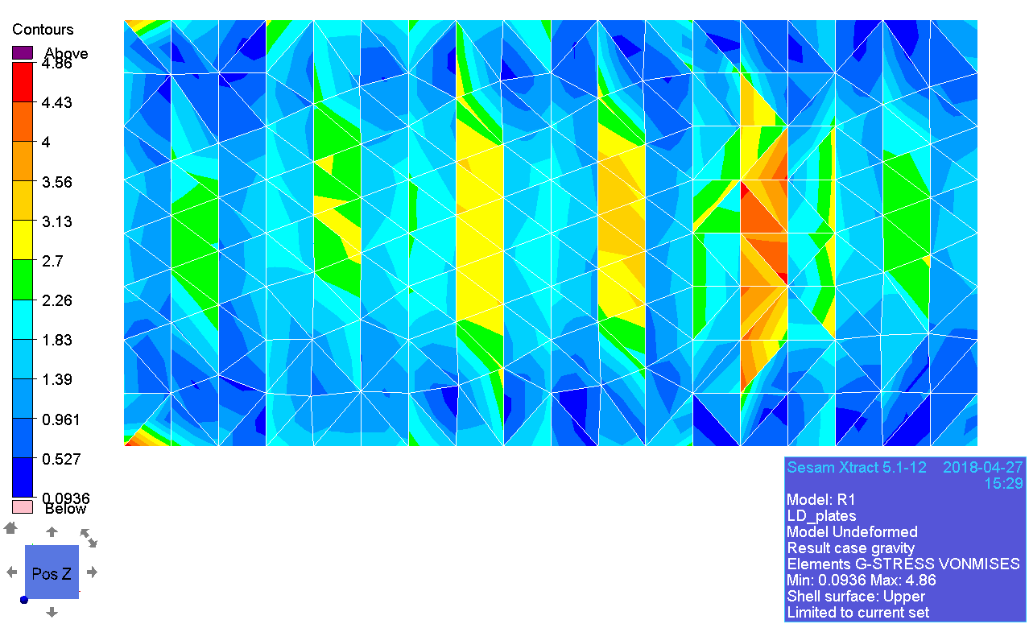

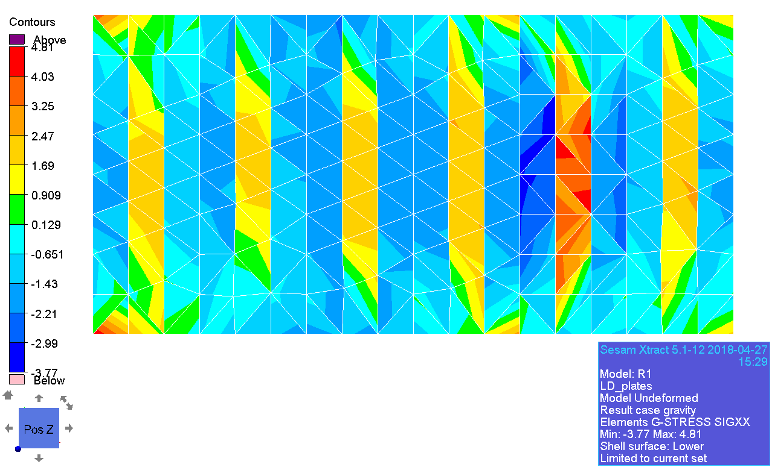

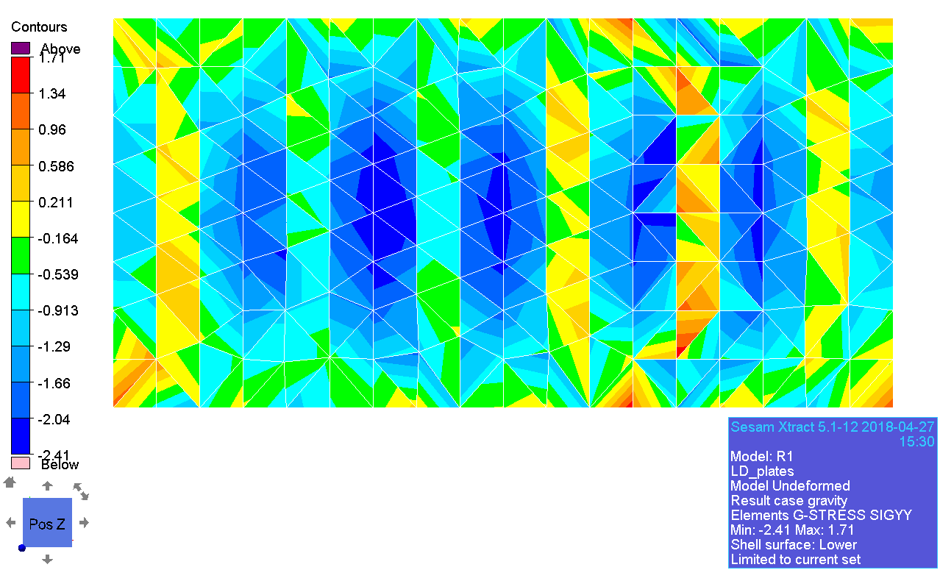

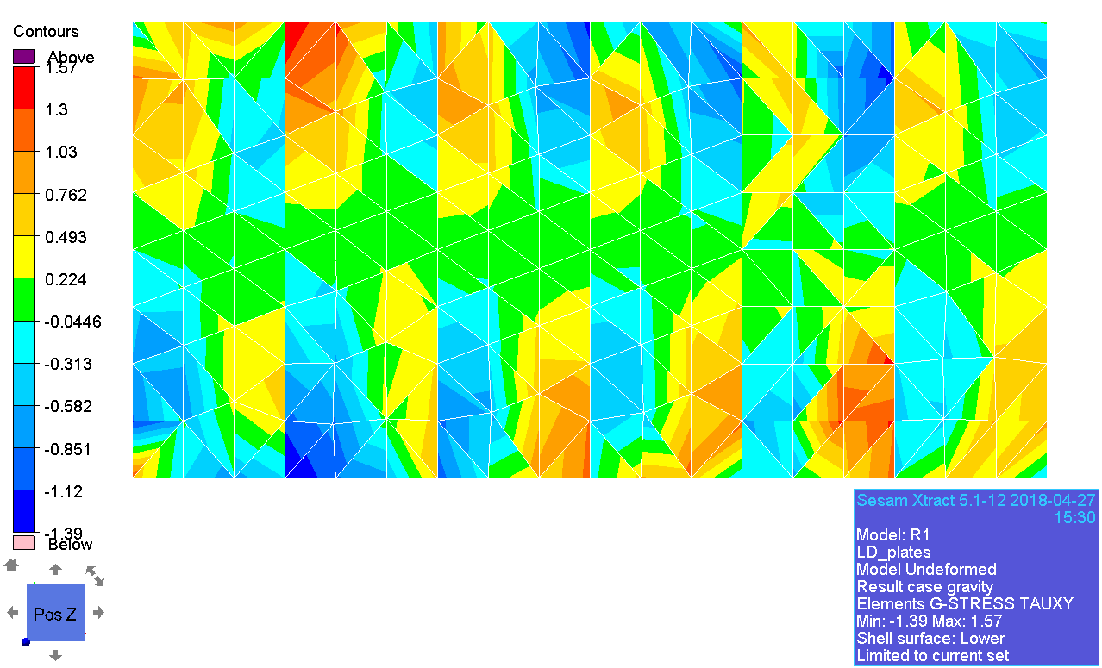

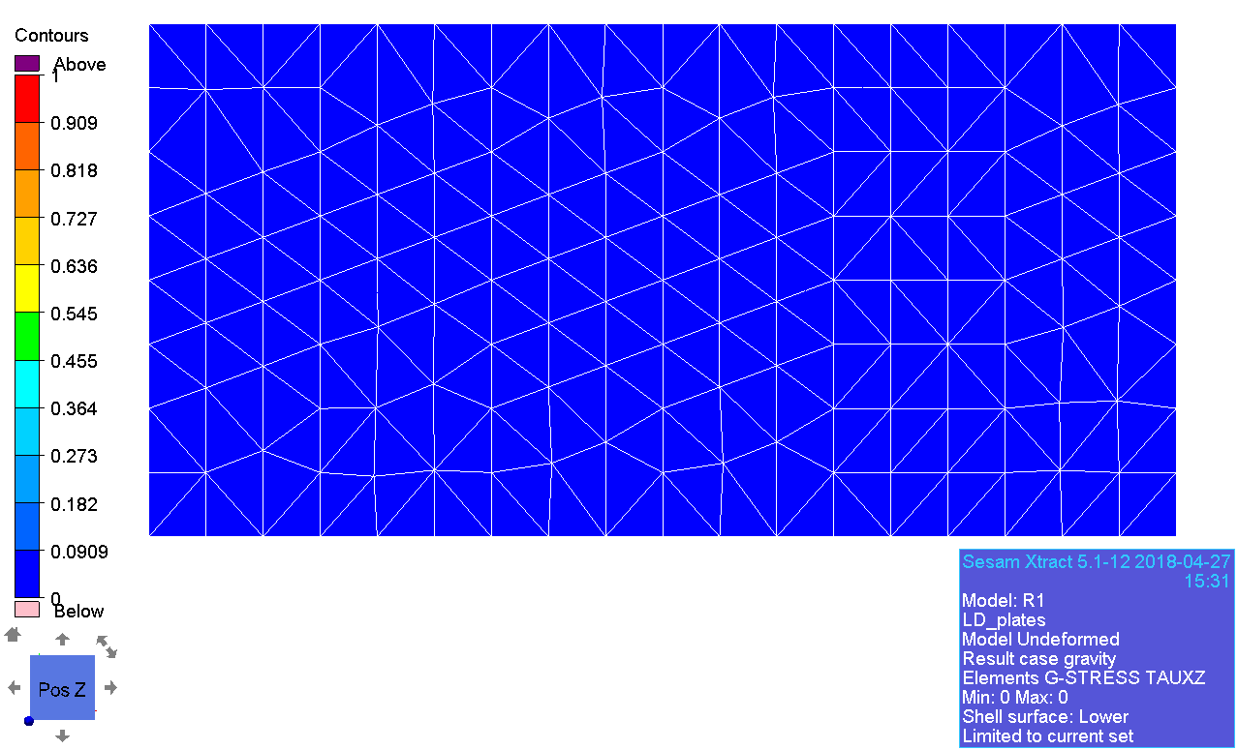

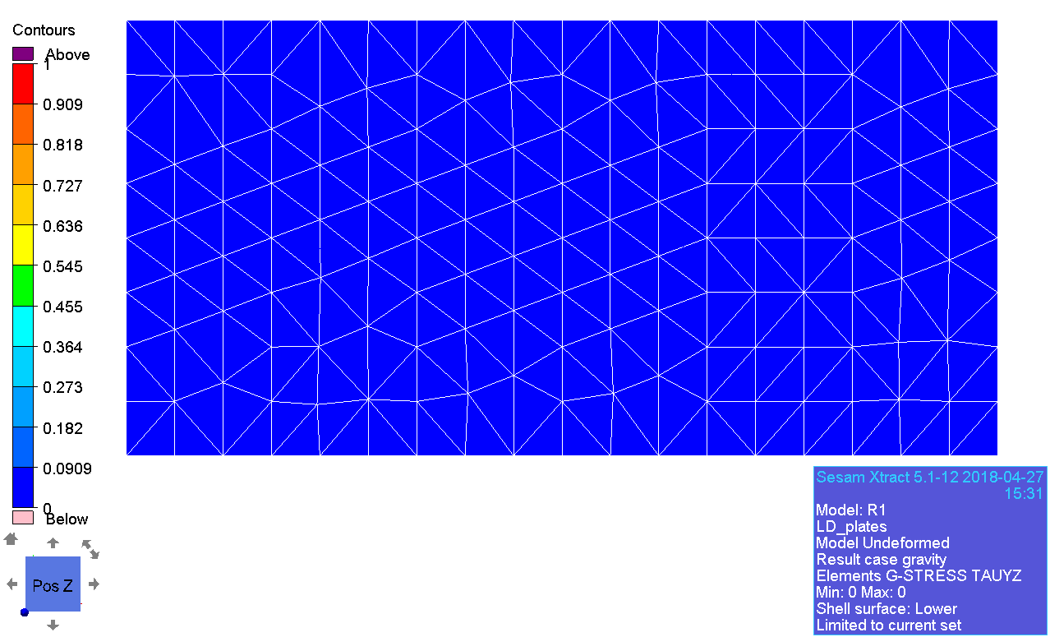

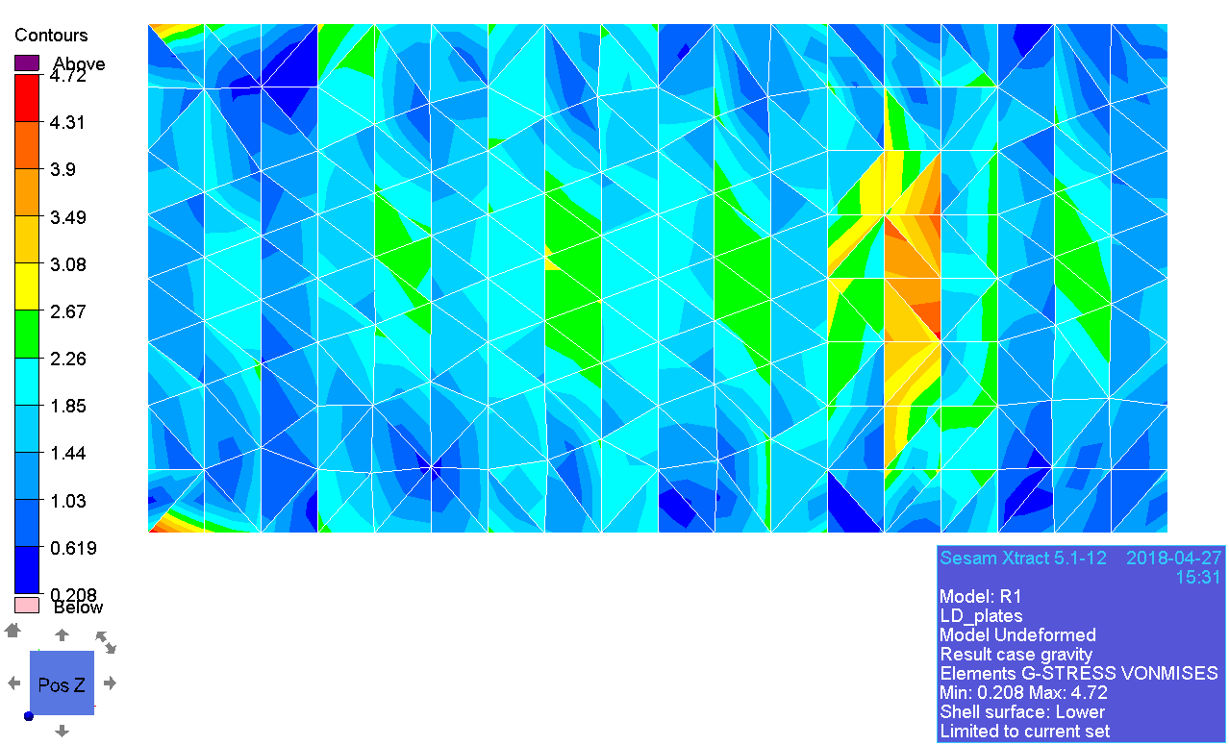

### Principal stress

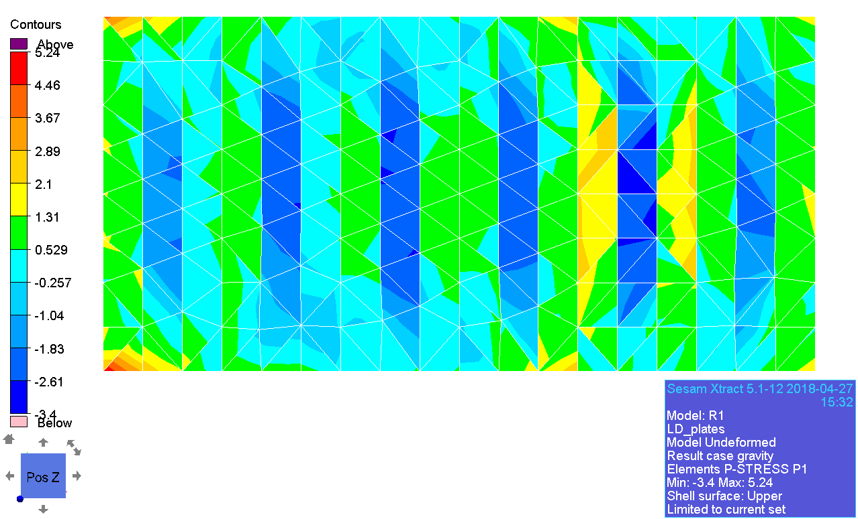

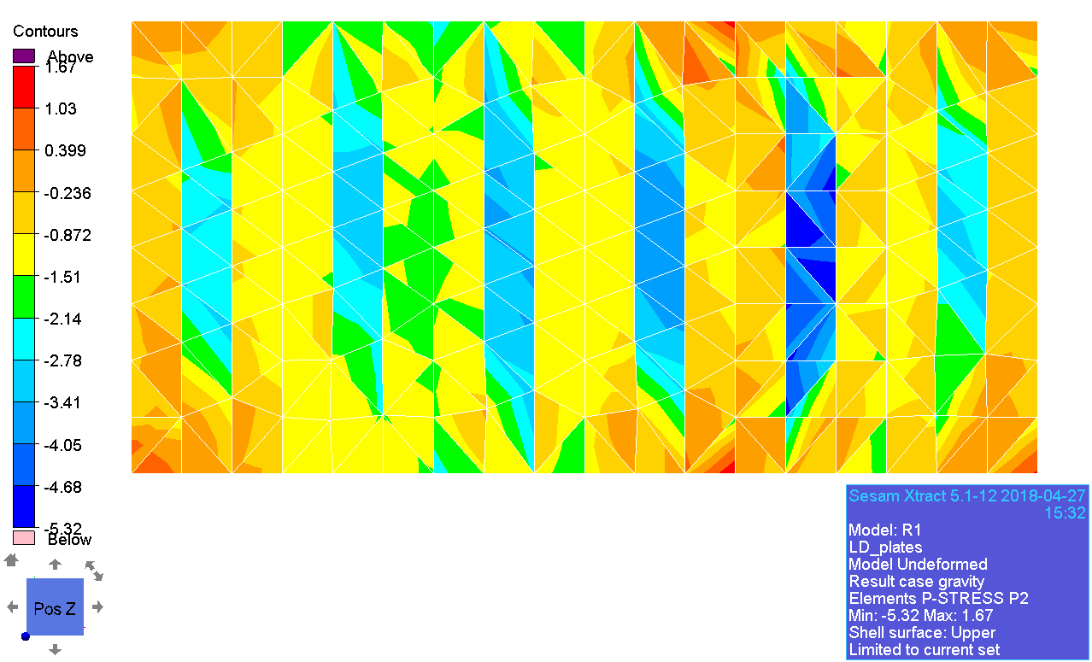

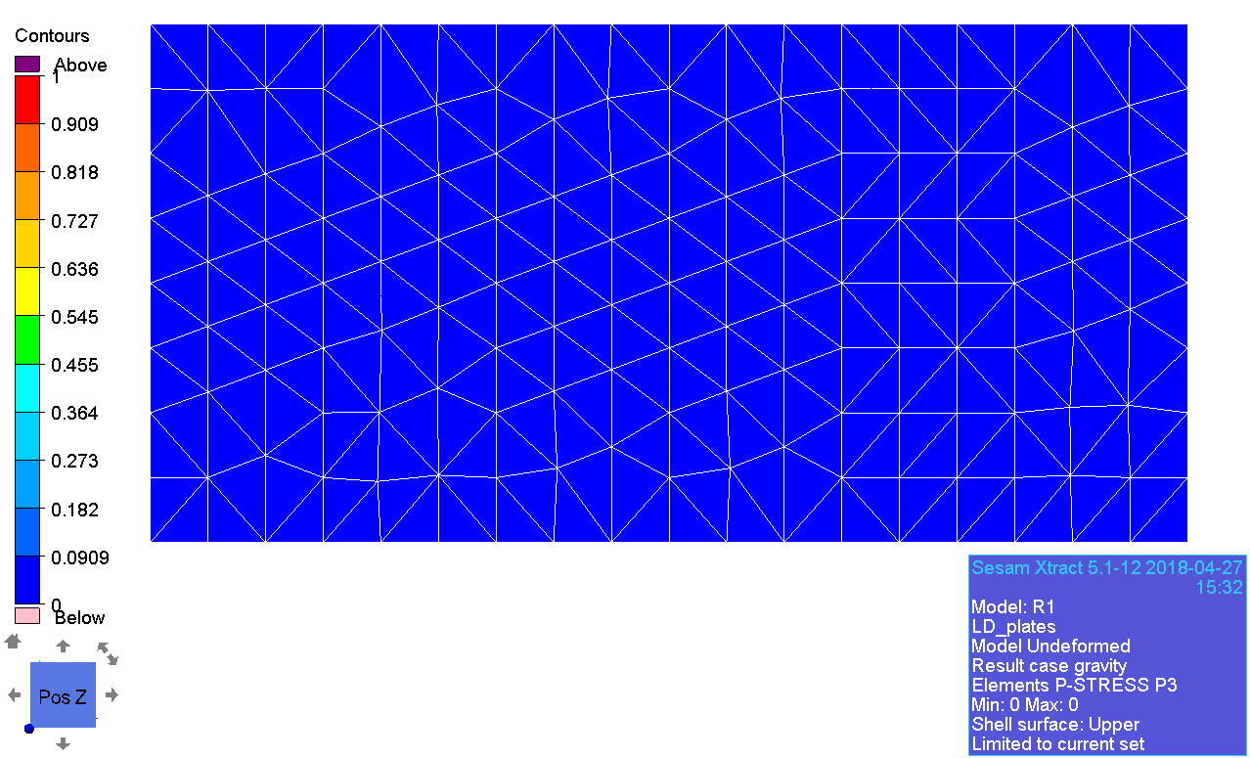

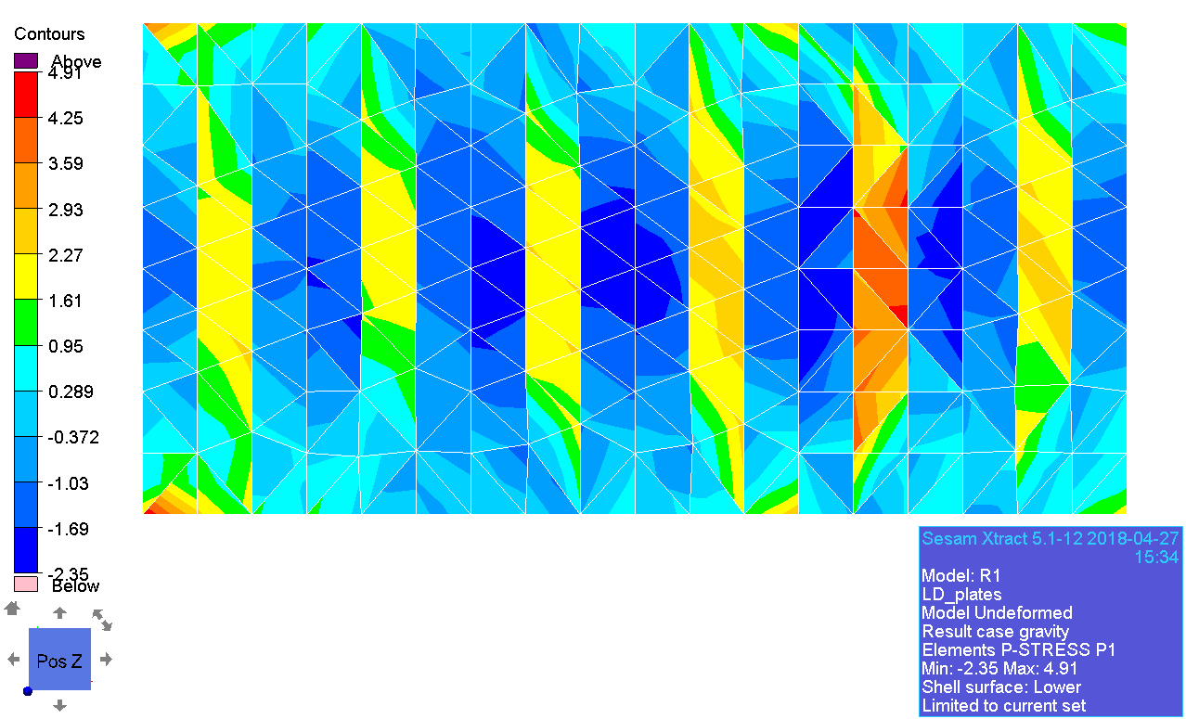

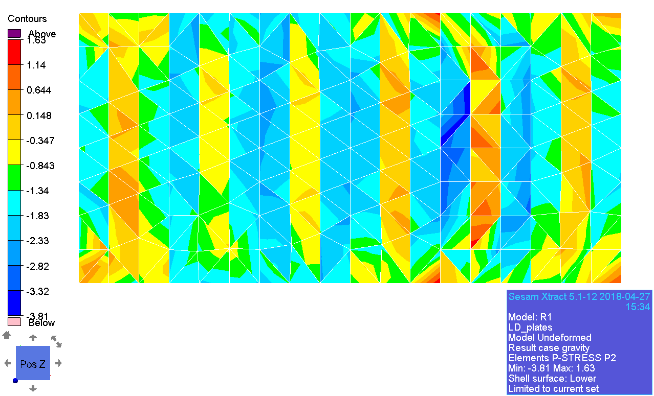

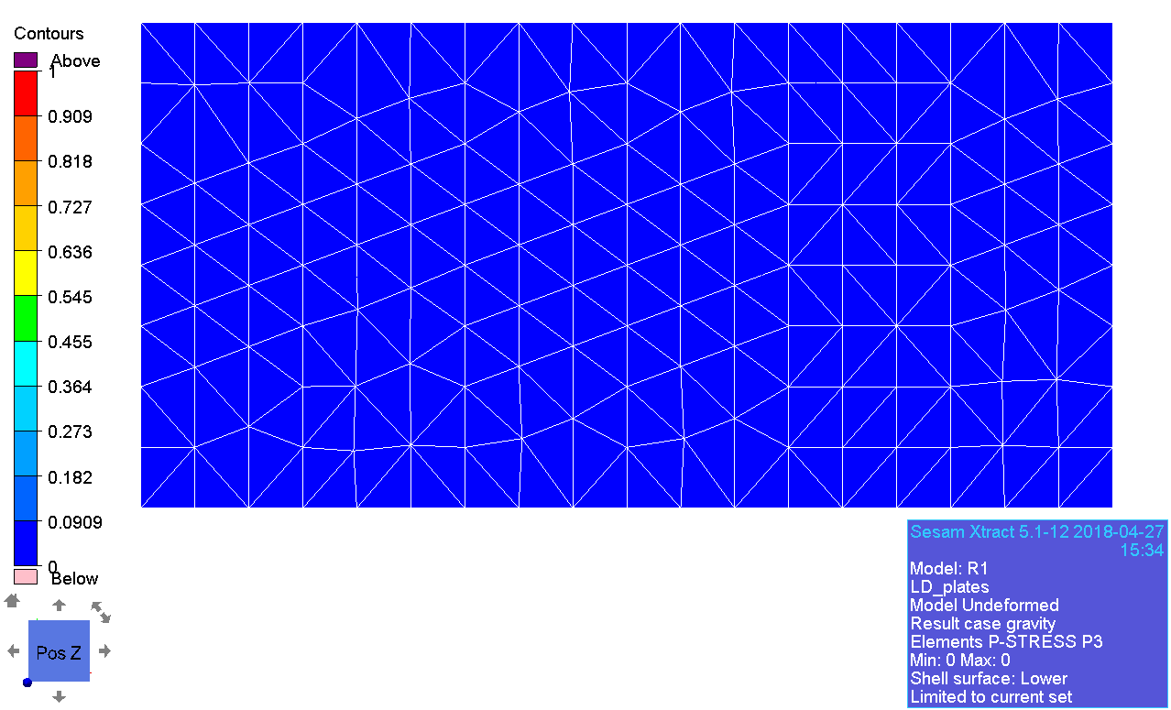

### Decomposed stress

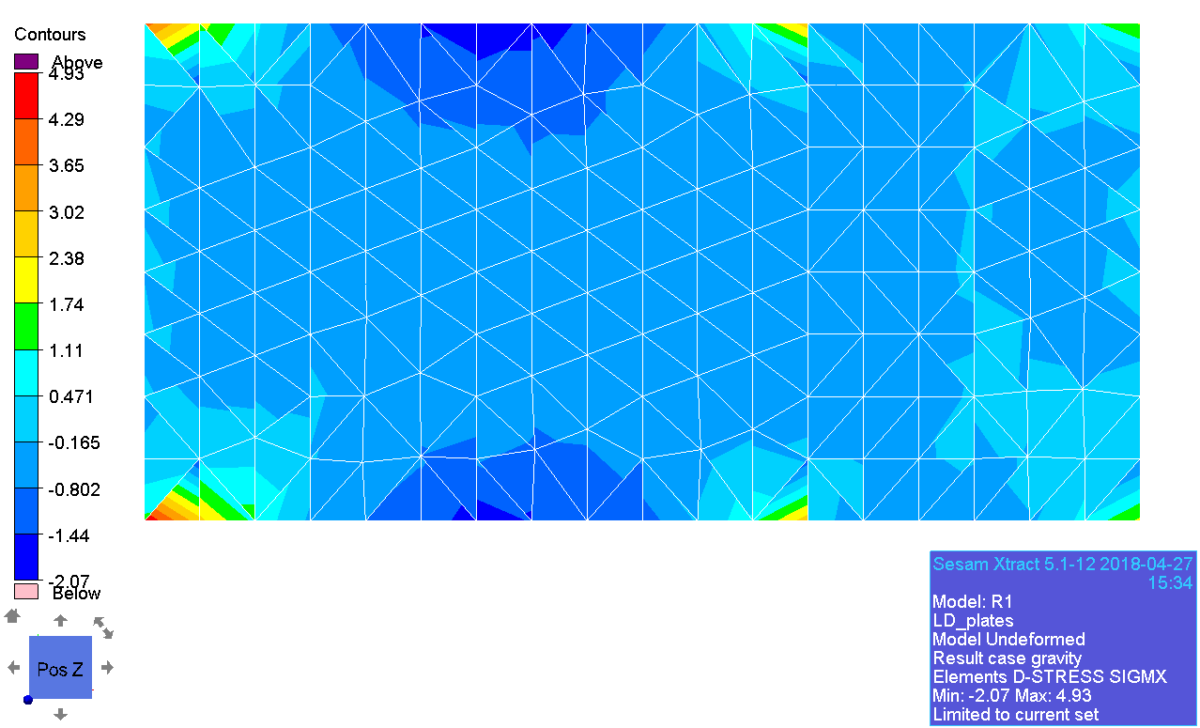

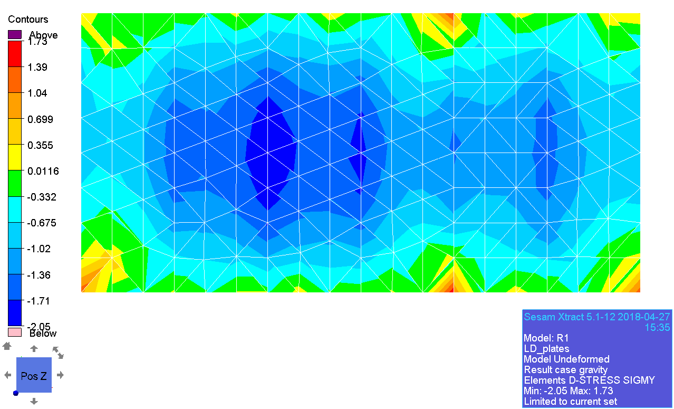

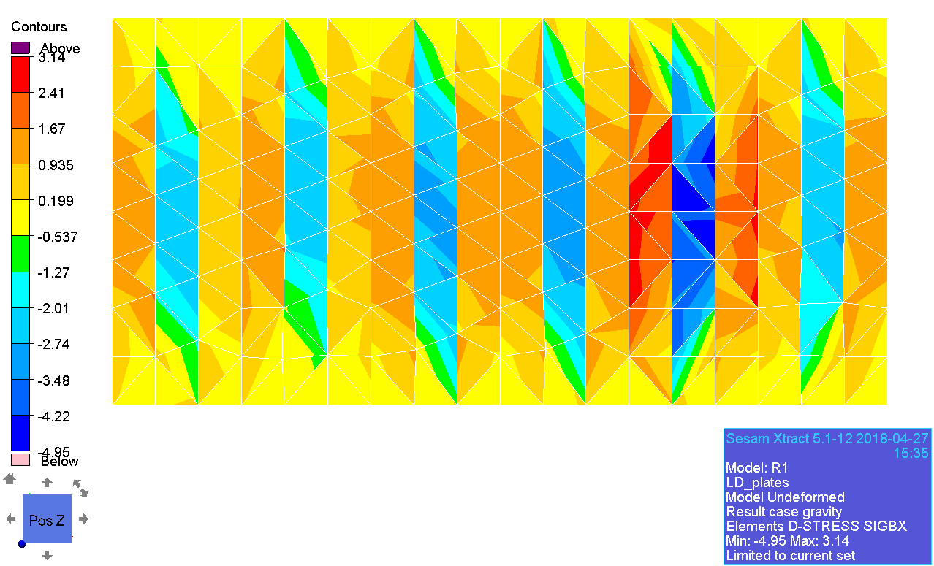

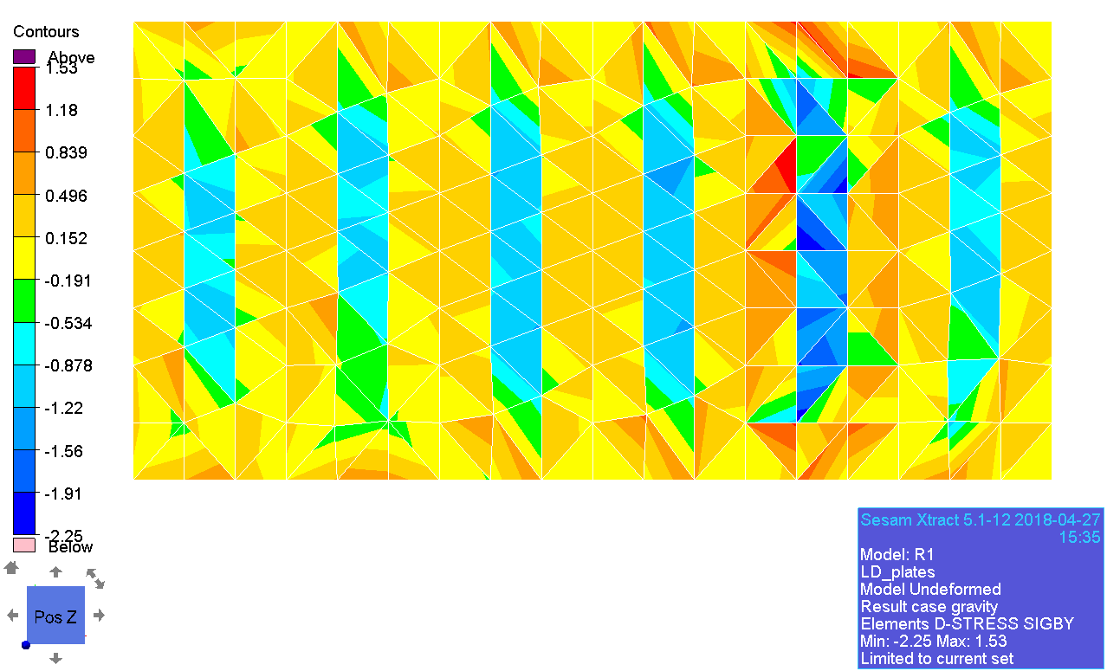

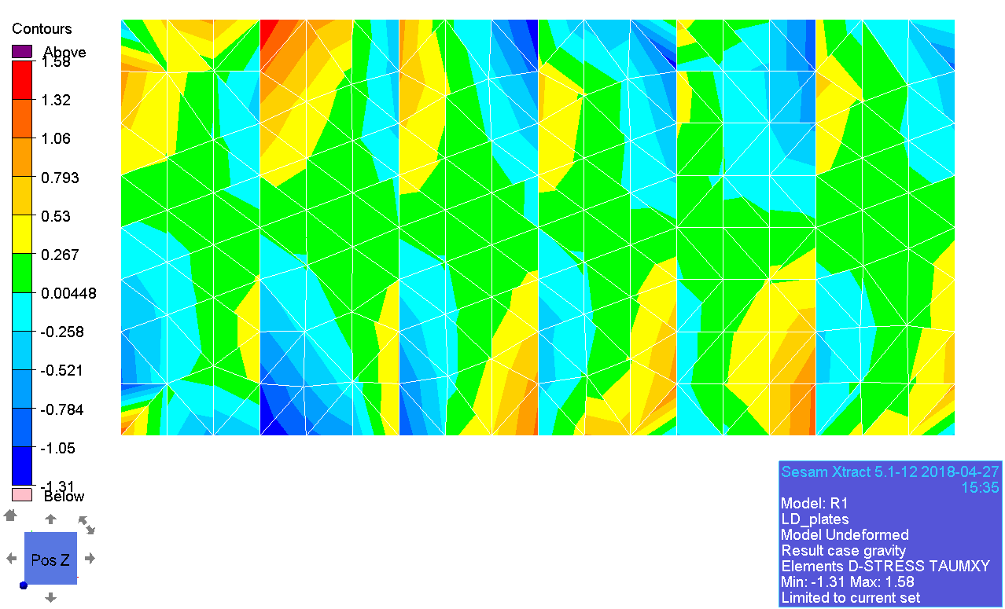

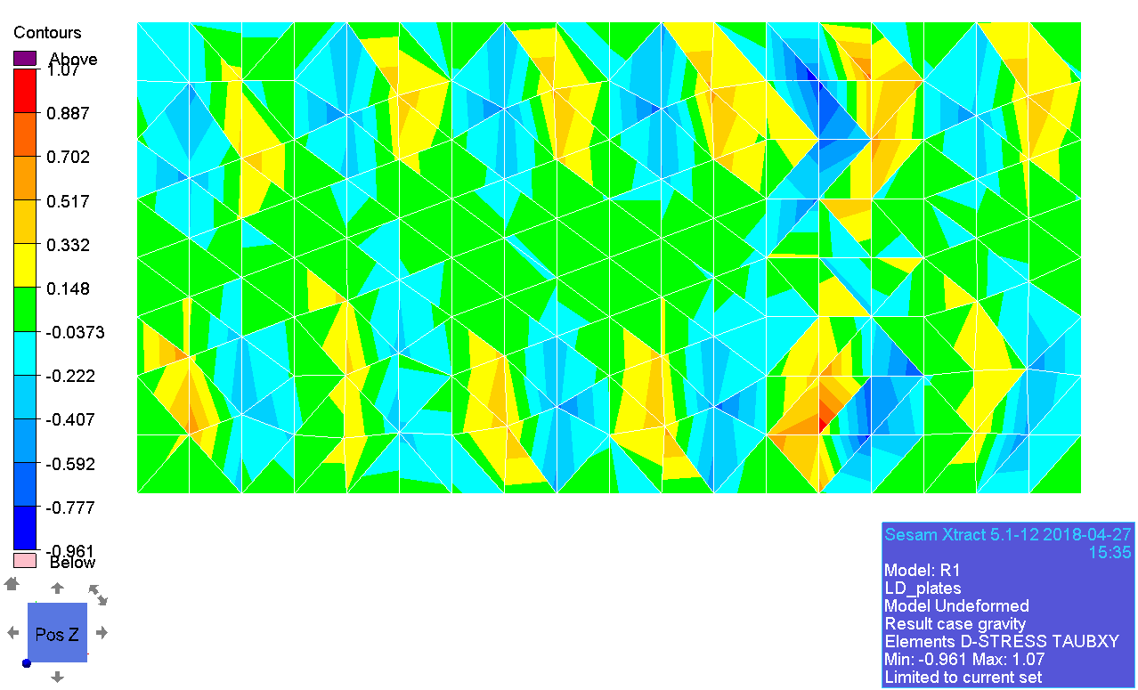

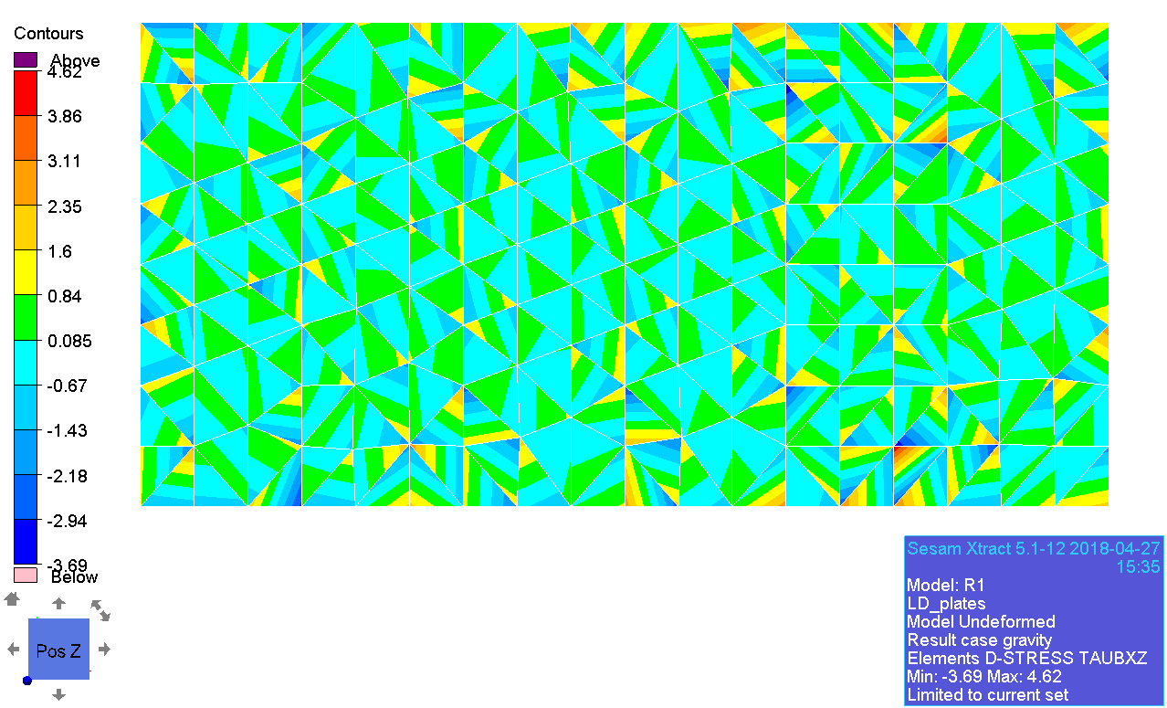

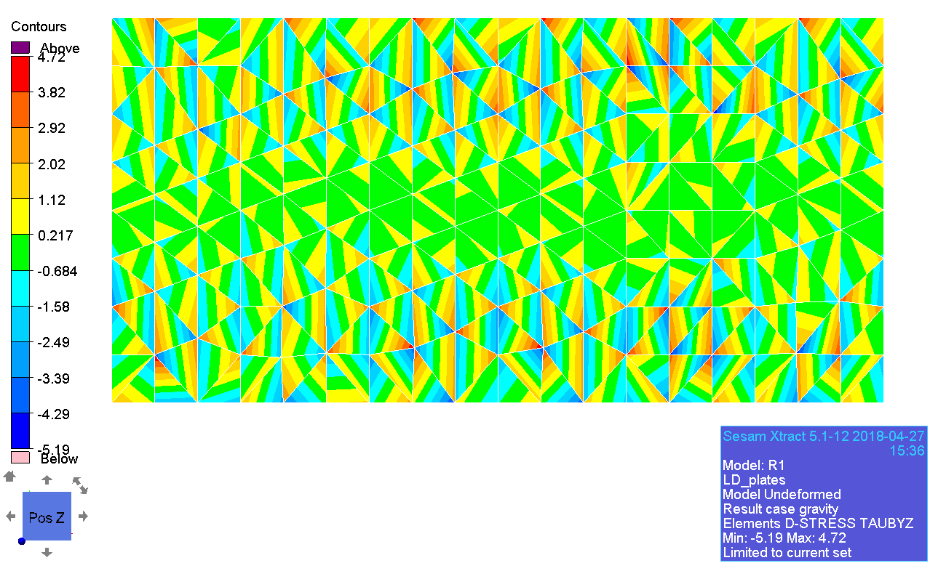

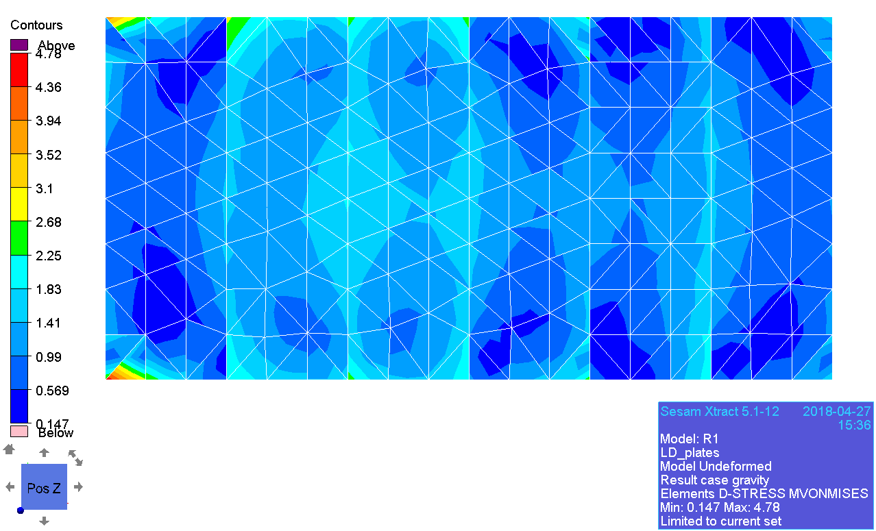

### Membrane principal stress

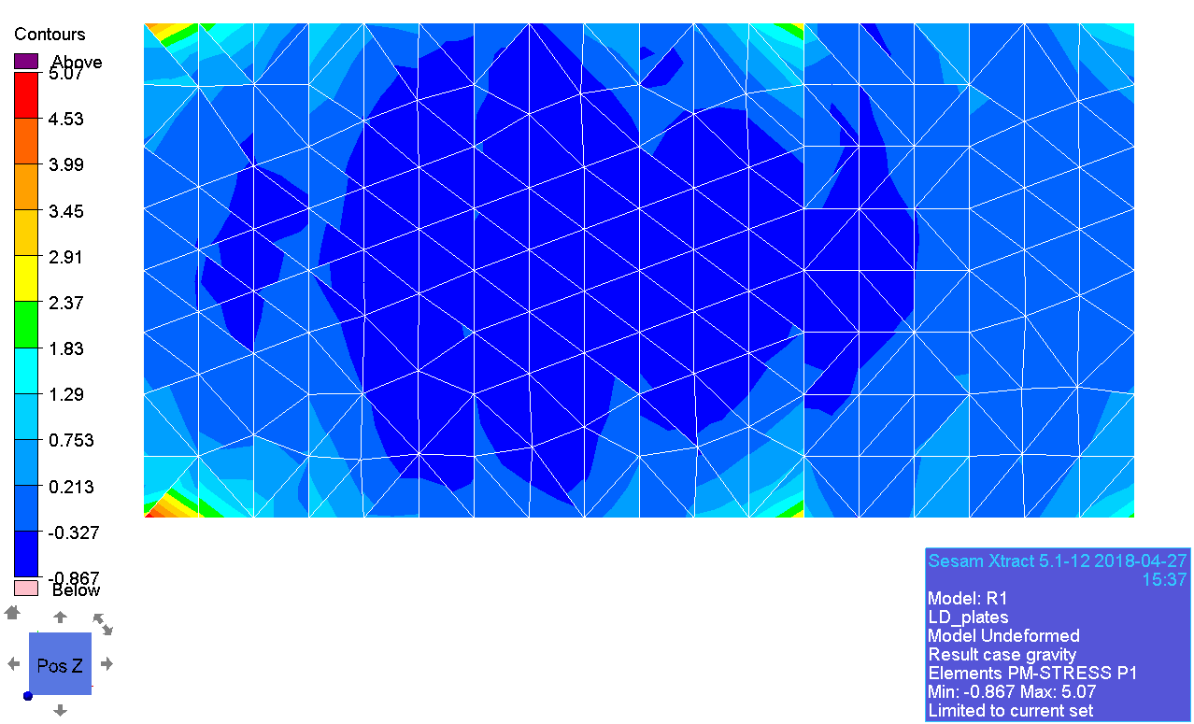

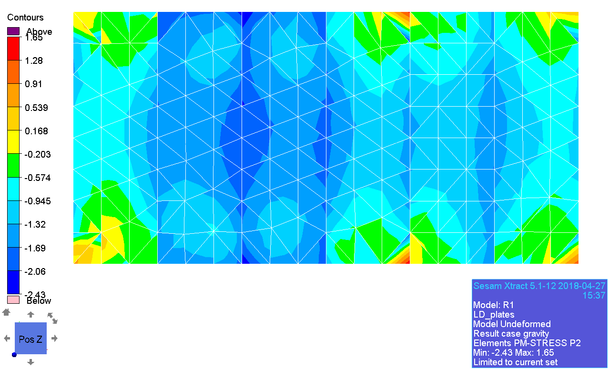

### Beam forces

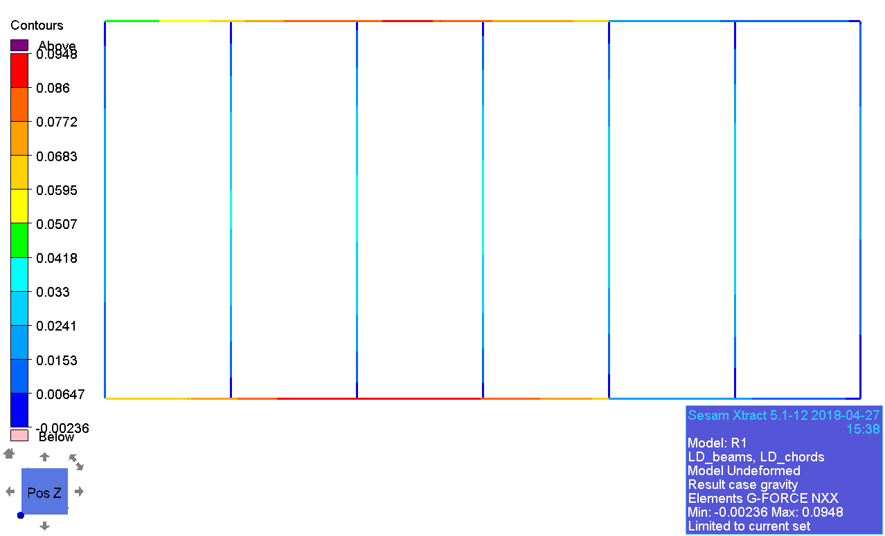

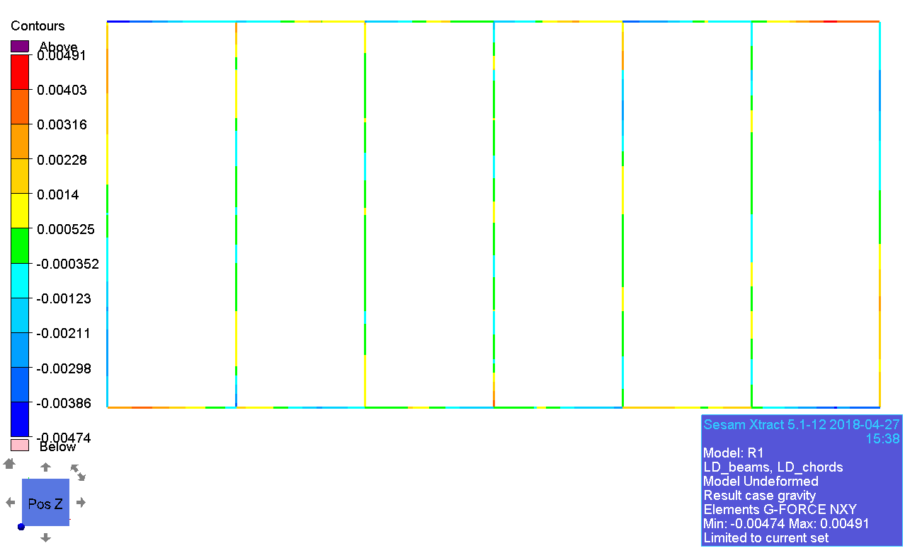

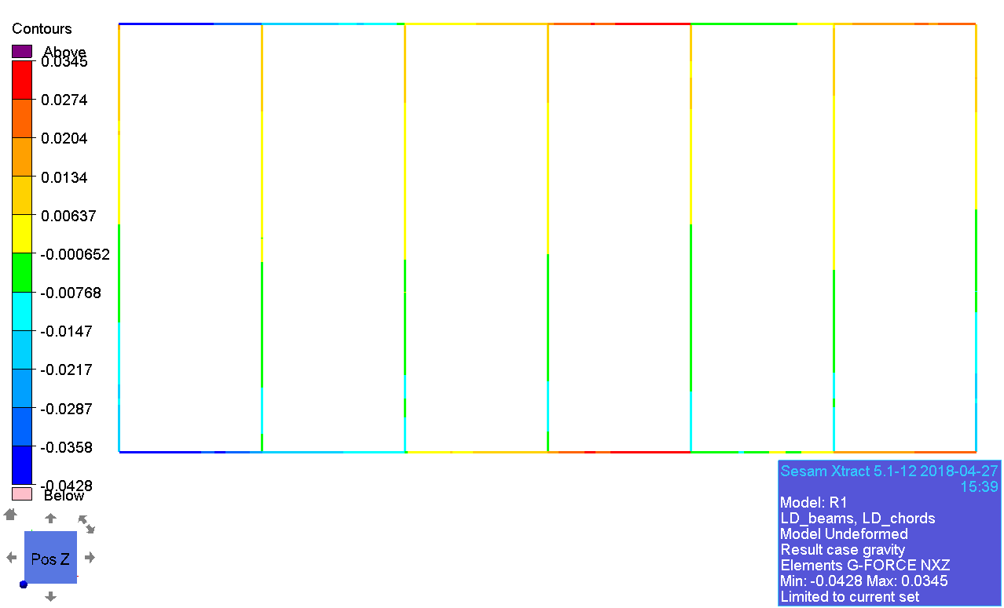

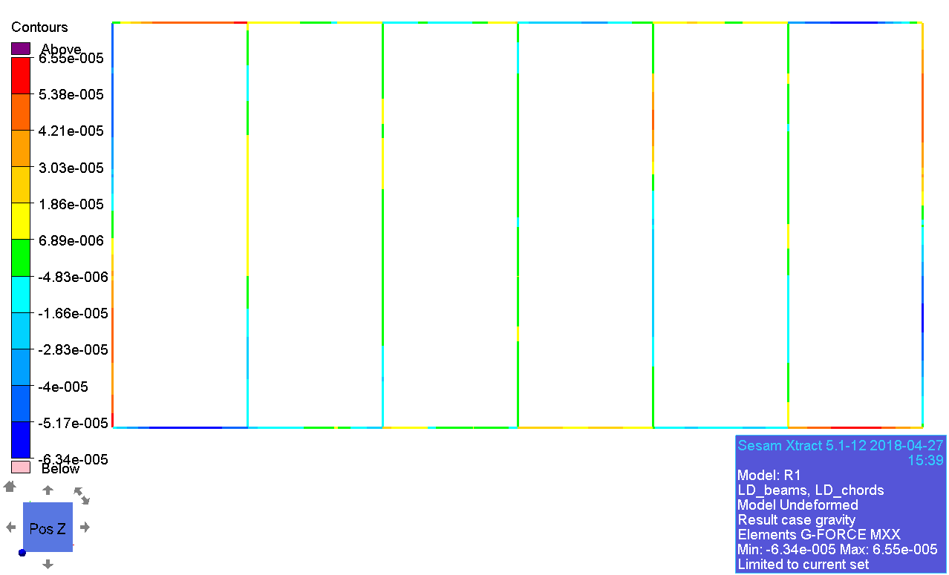

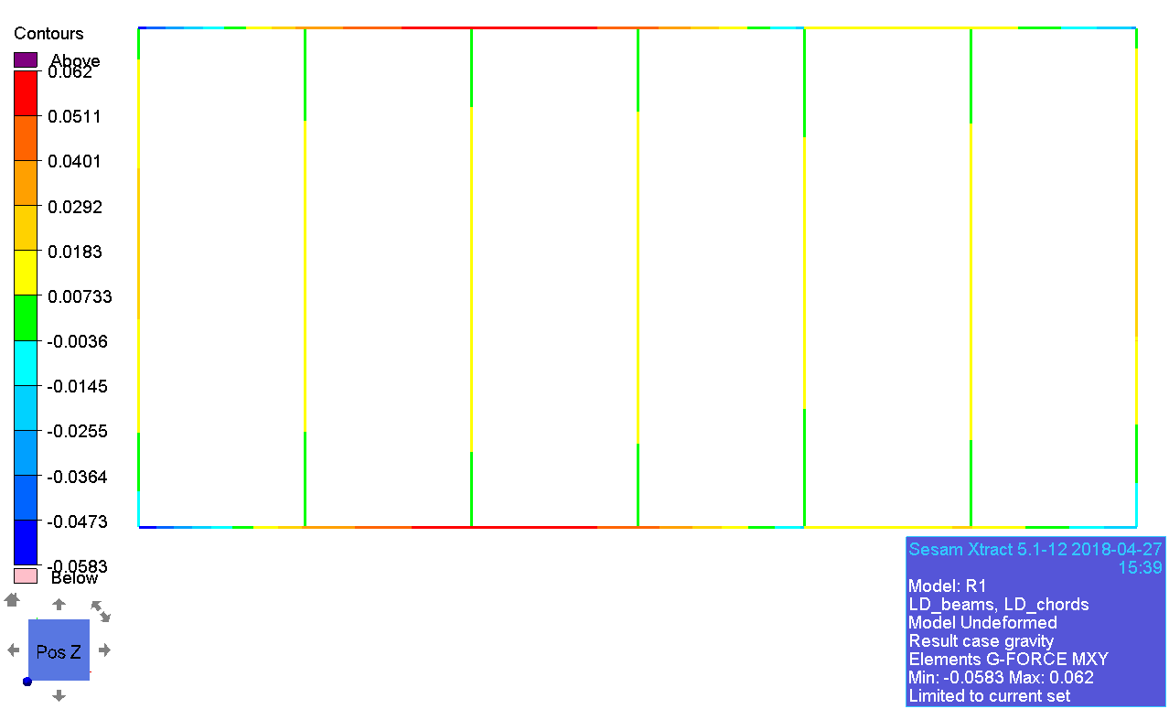

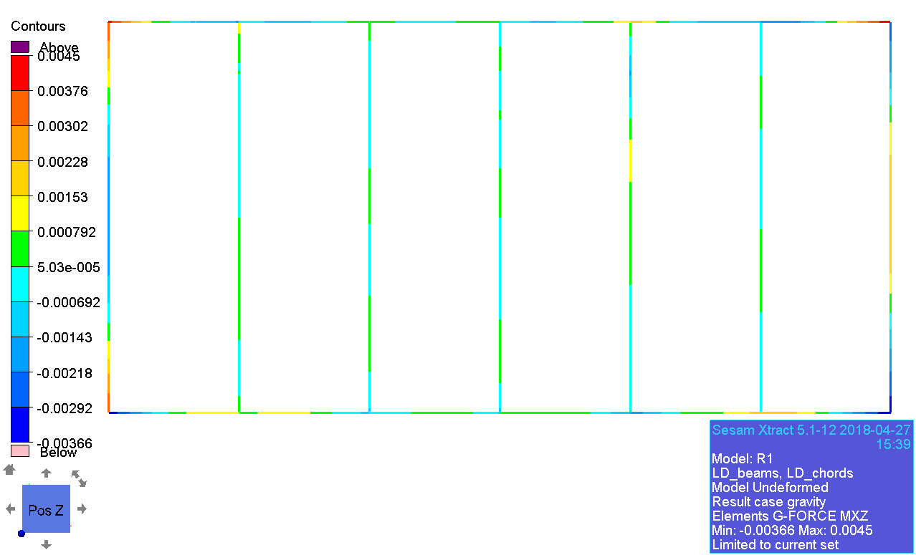

### Displacement

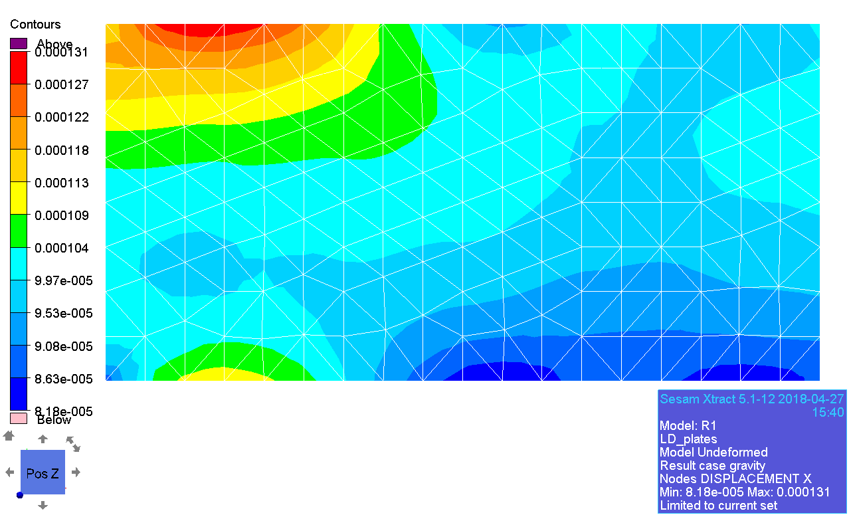

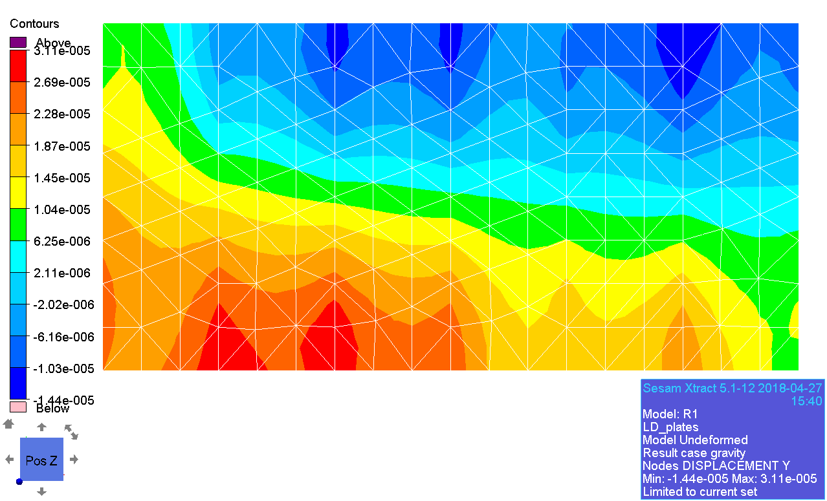

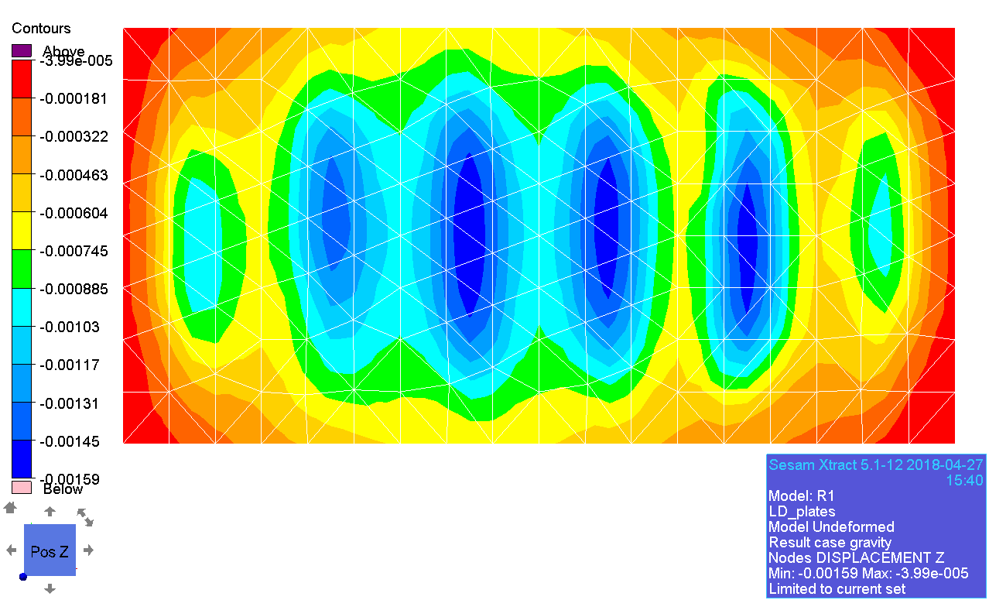

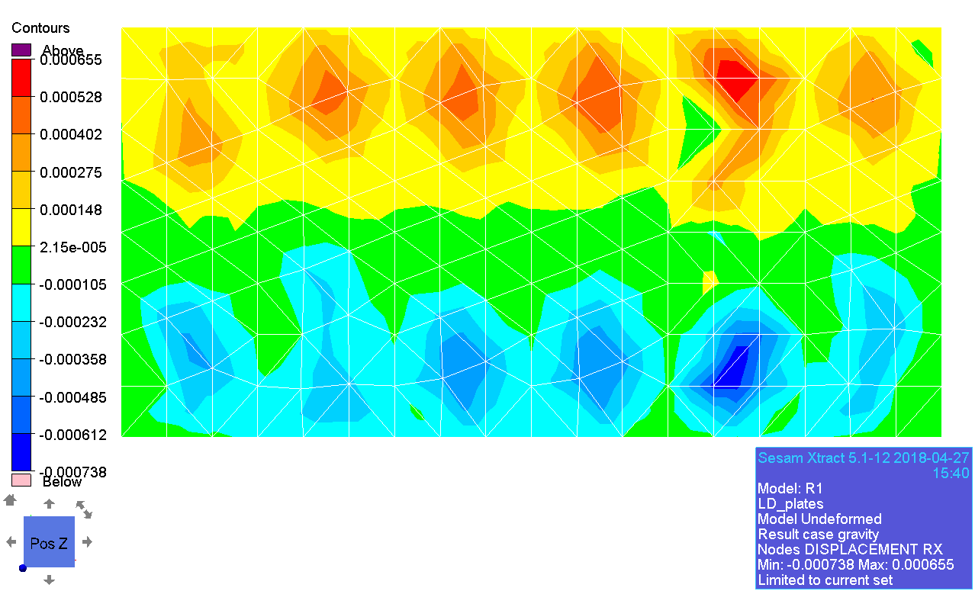

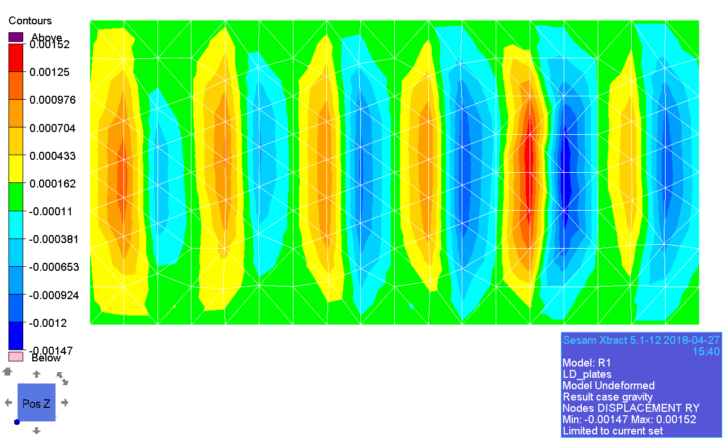

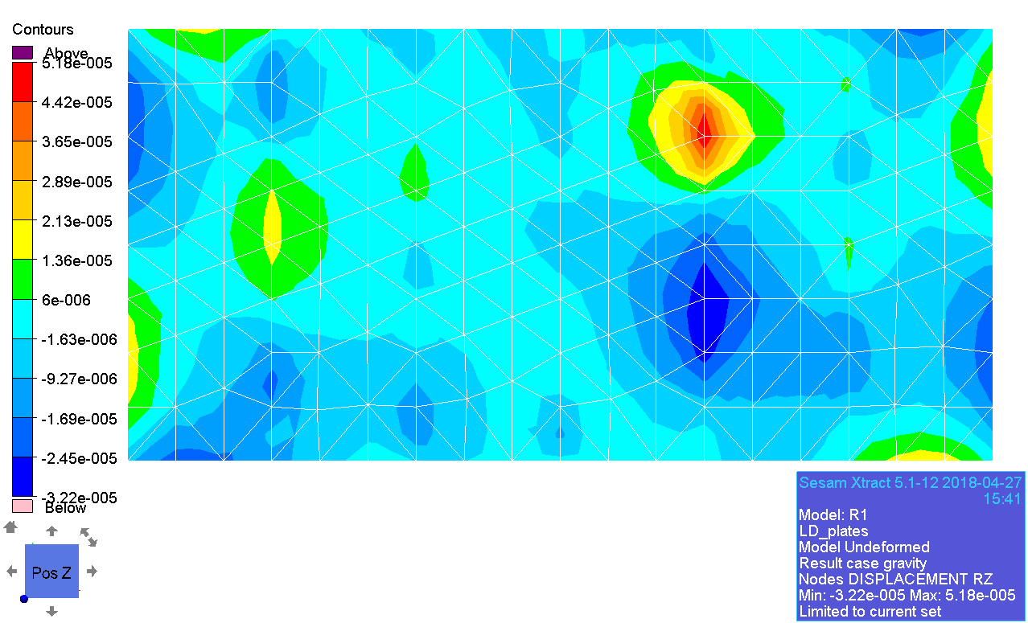

## MD

### General stress

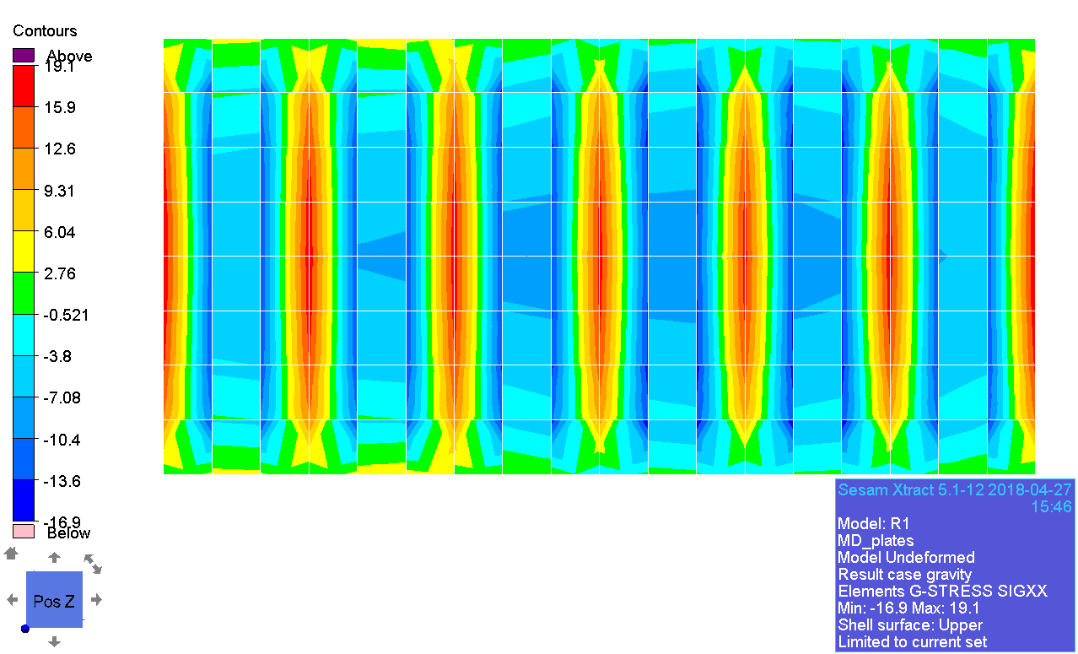

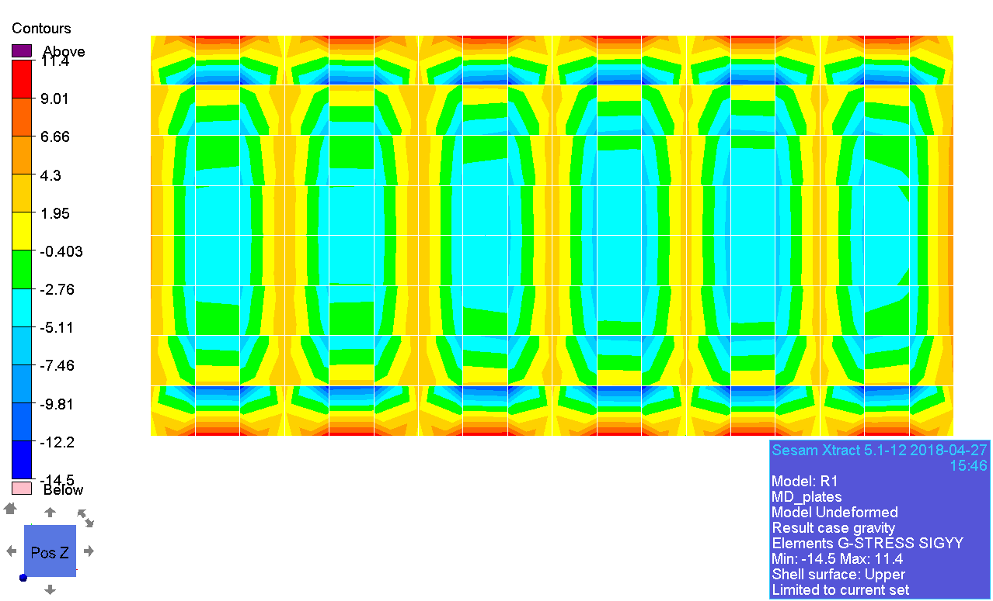

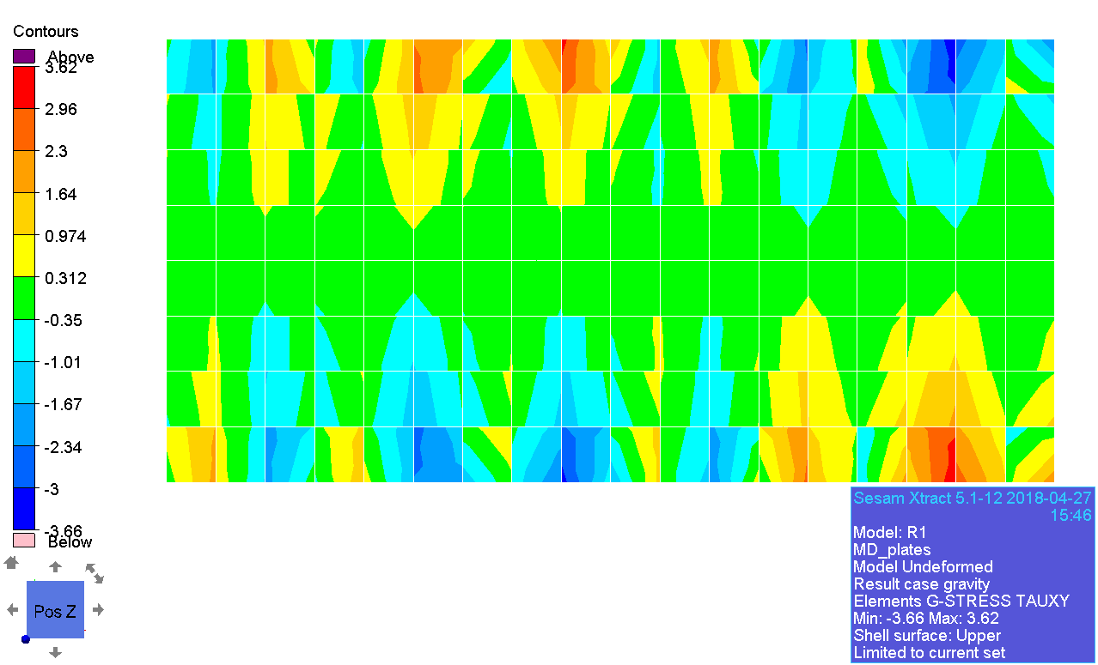

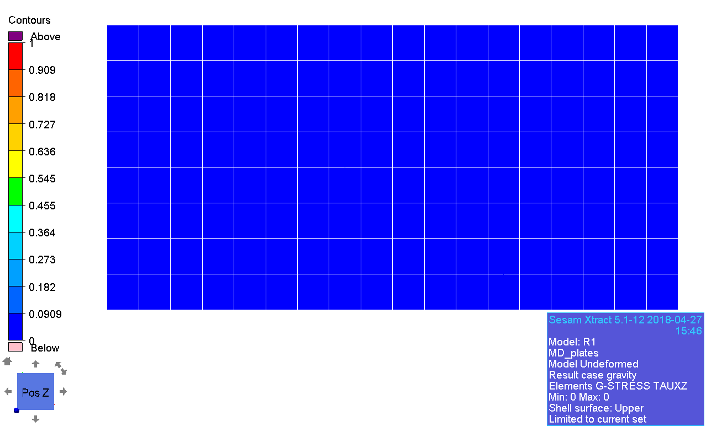

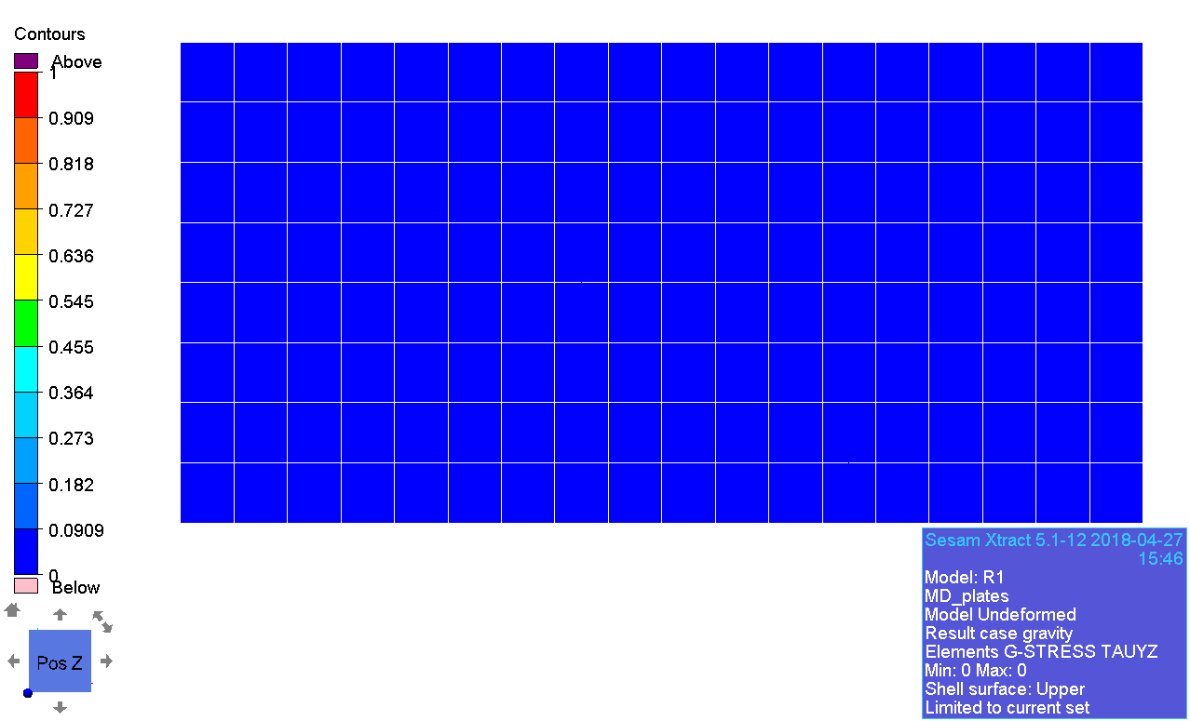

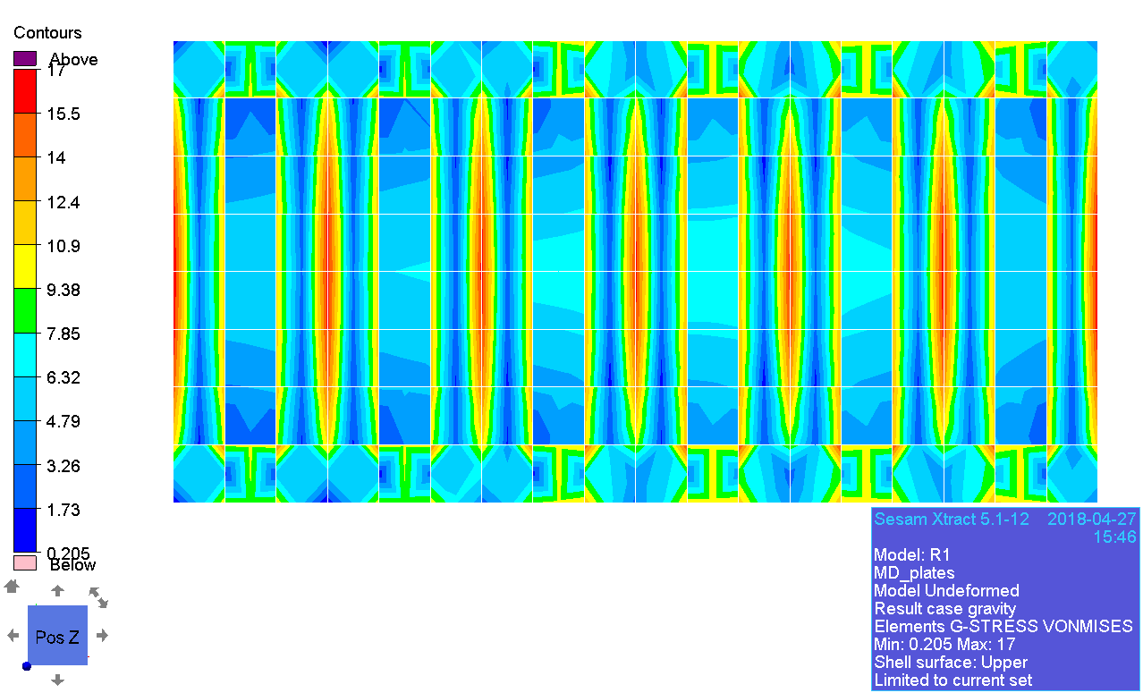

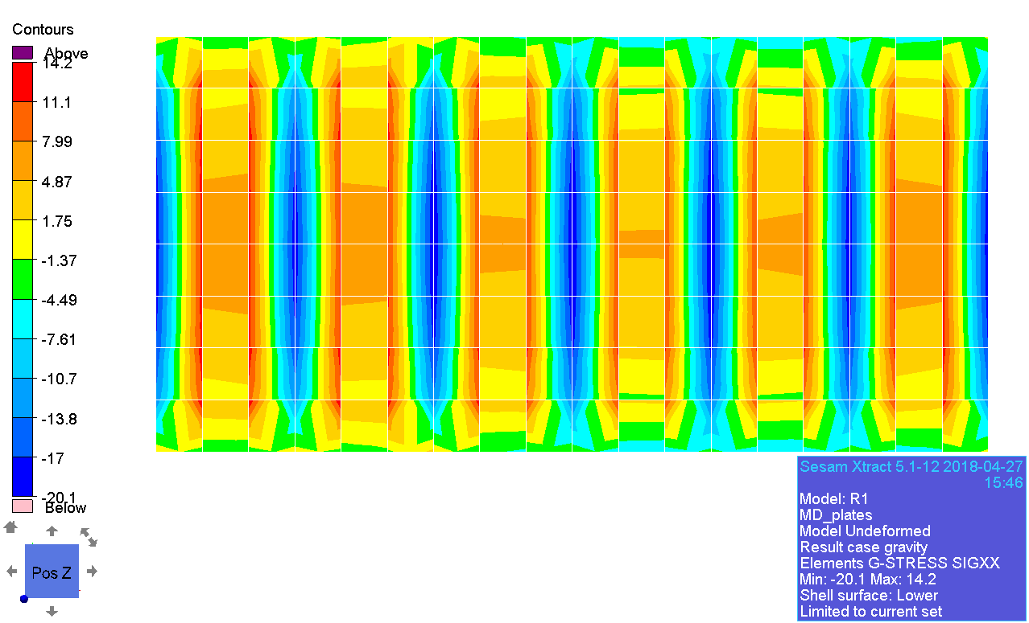

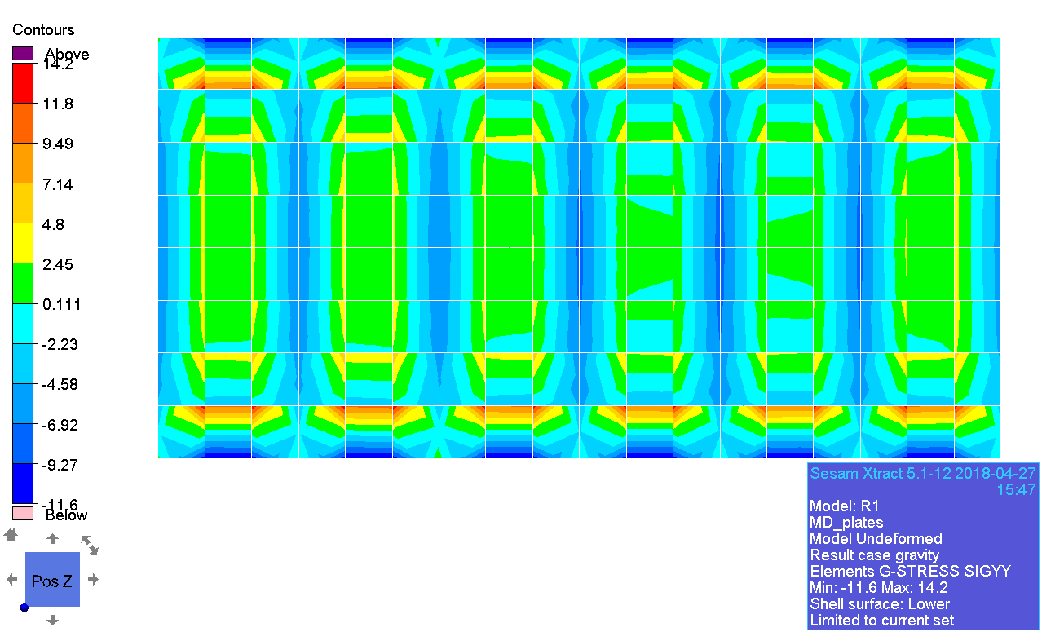

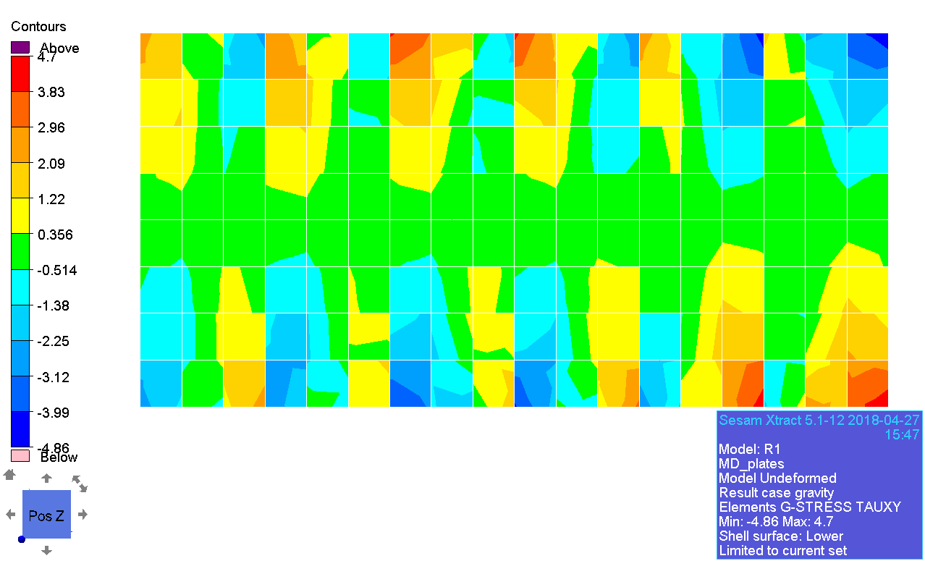

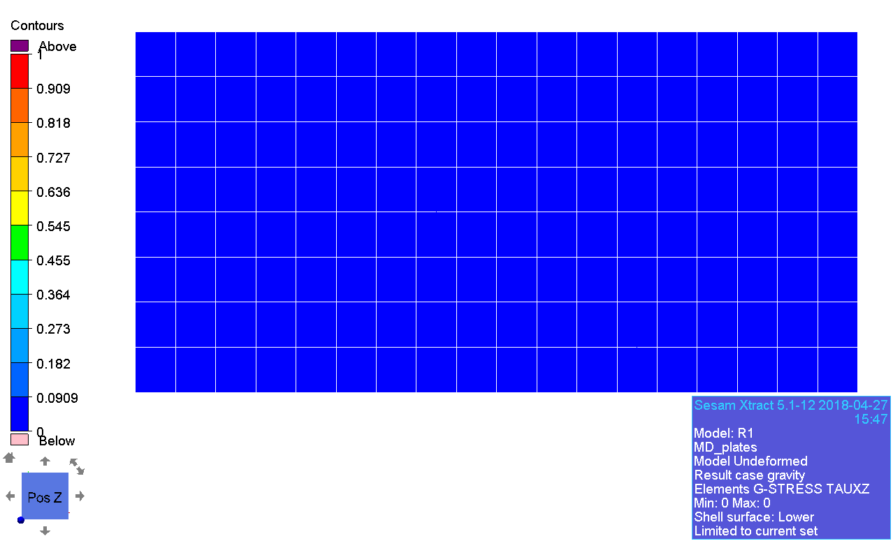

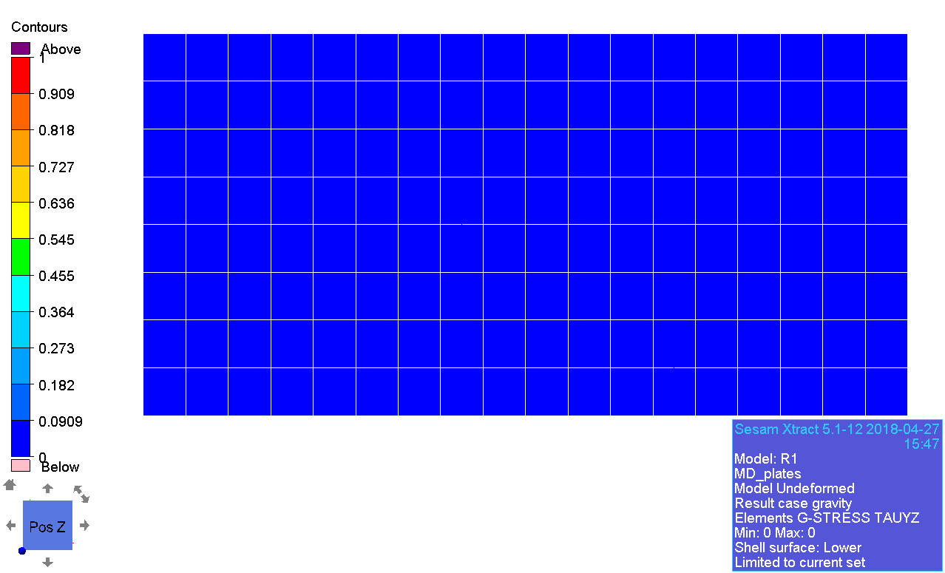

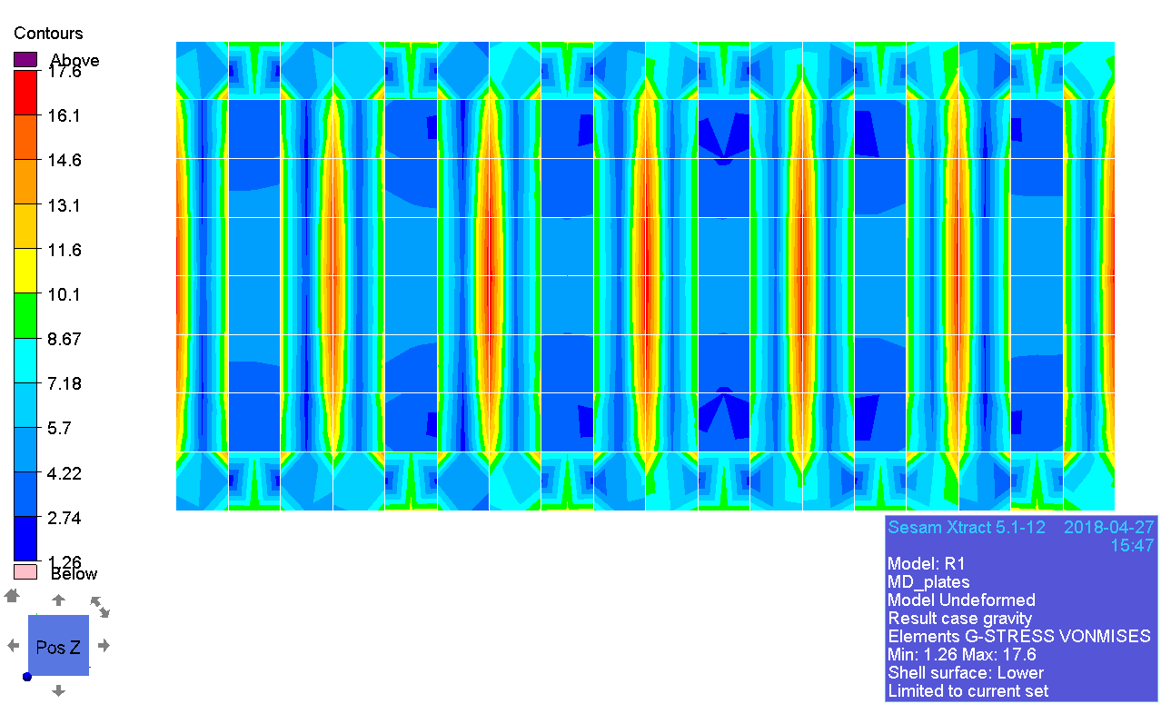

### Principal stress

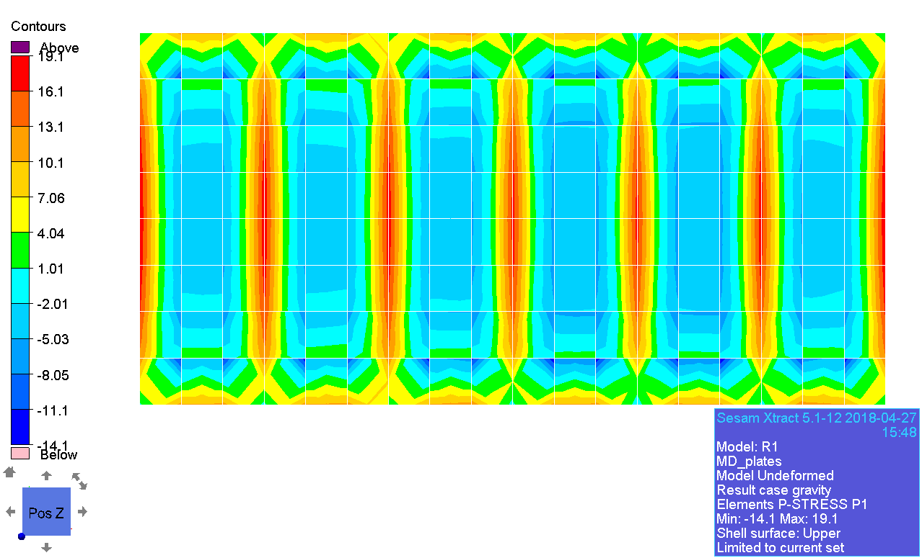

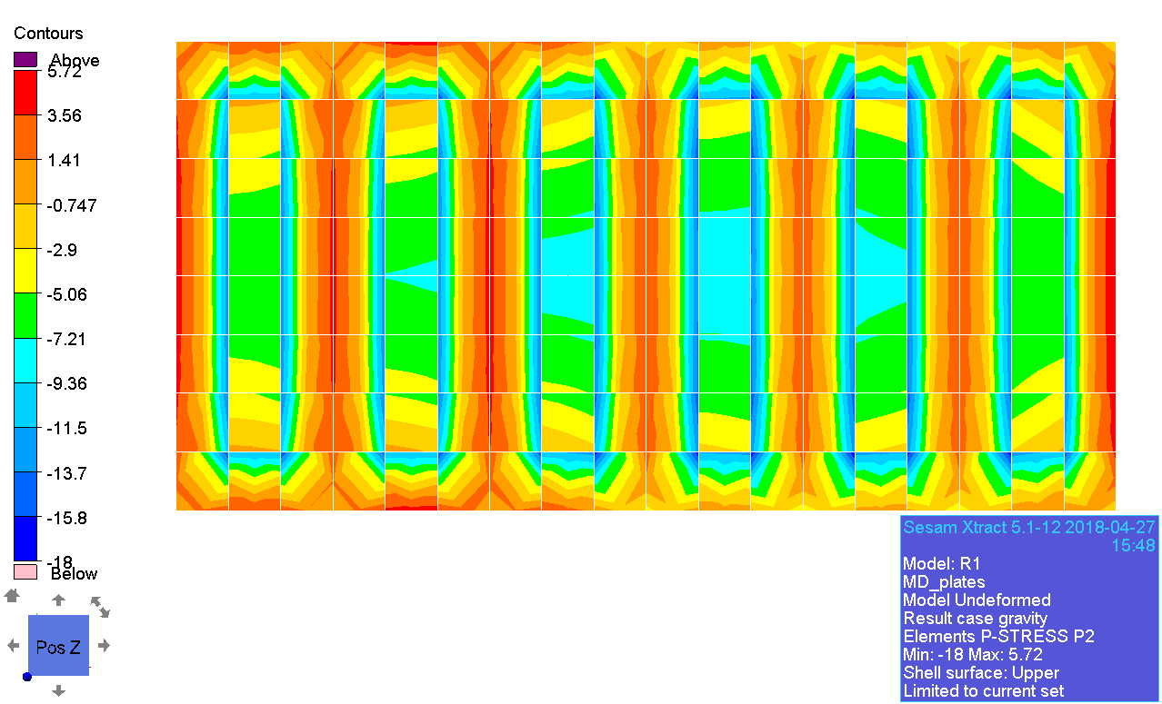

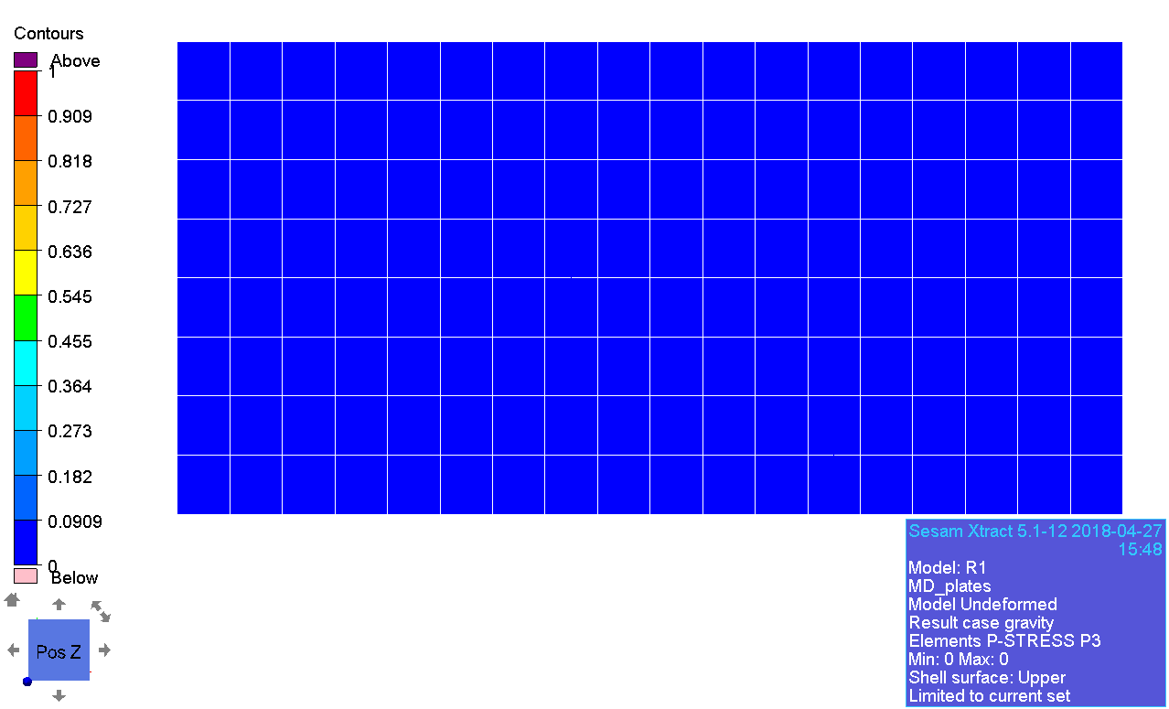

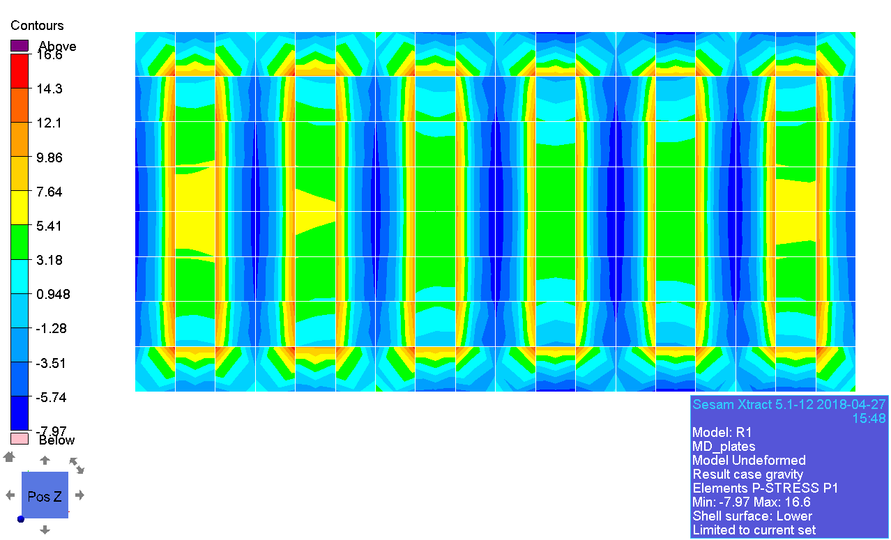

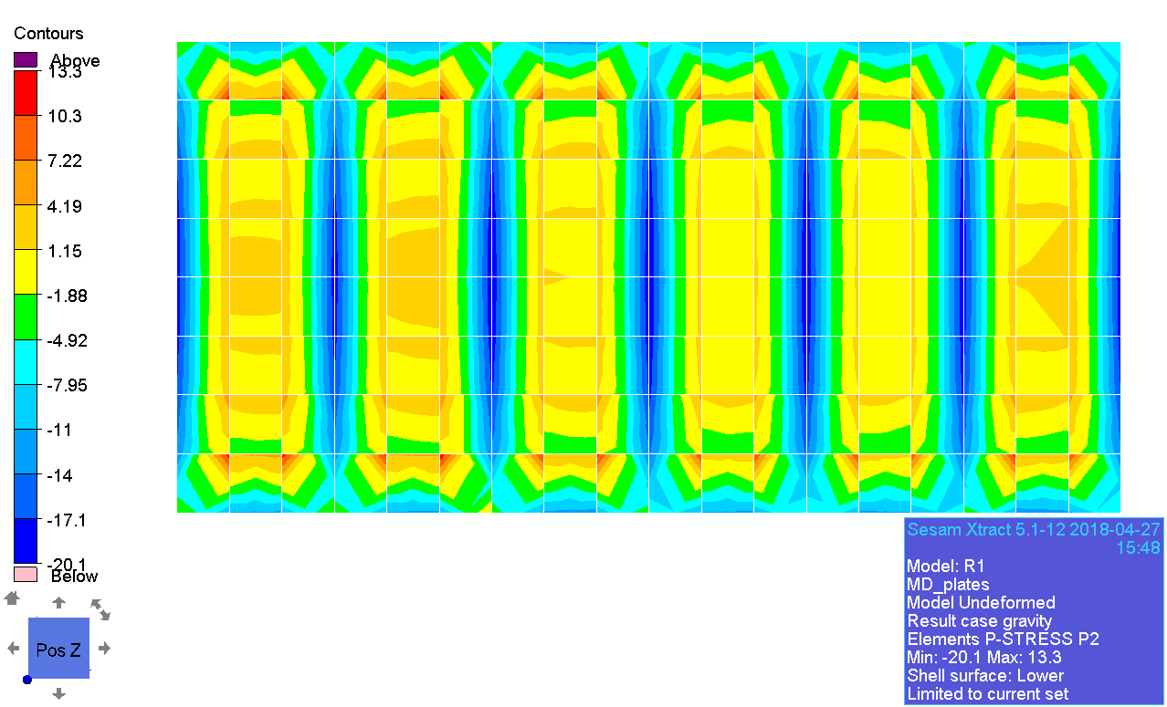

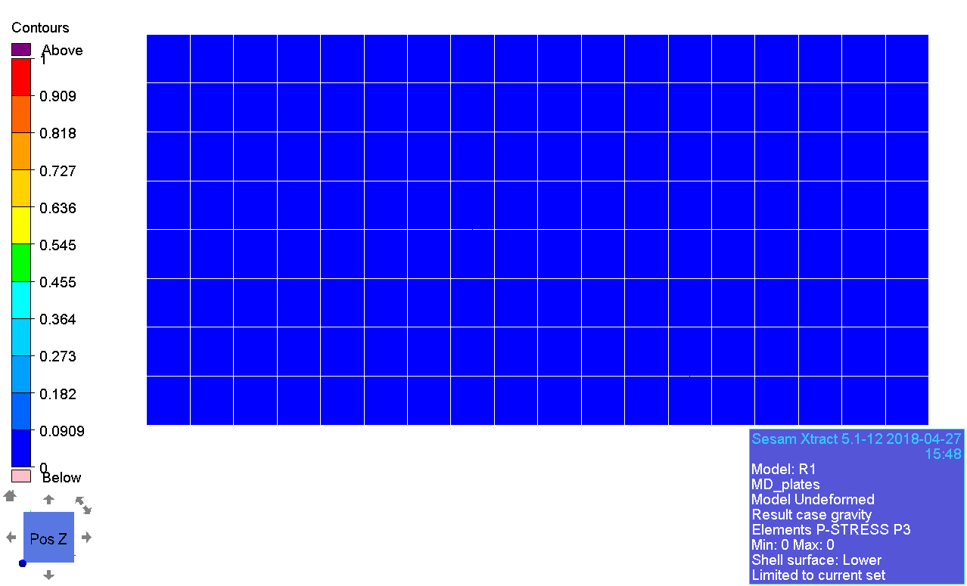

### Decomposed stress

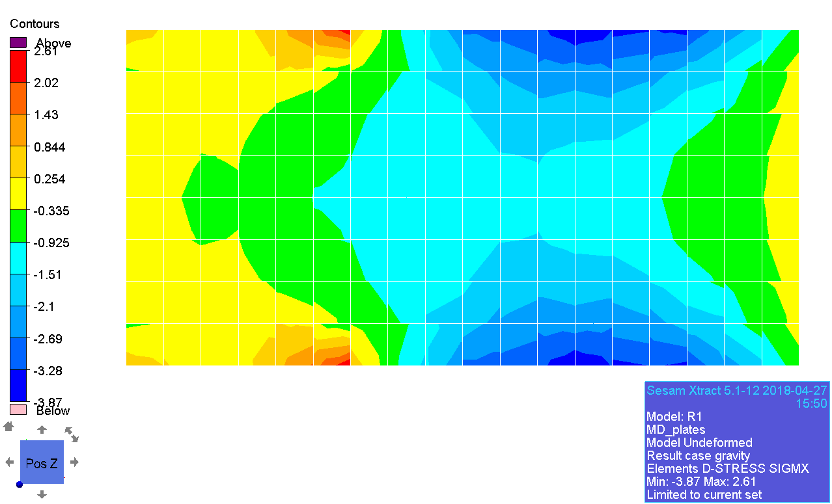

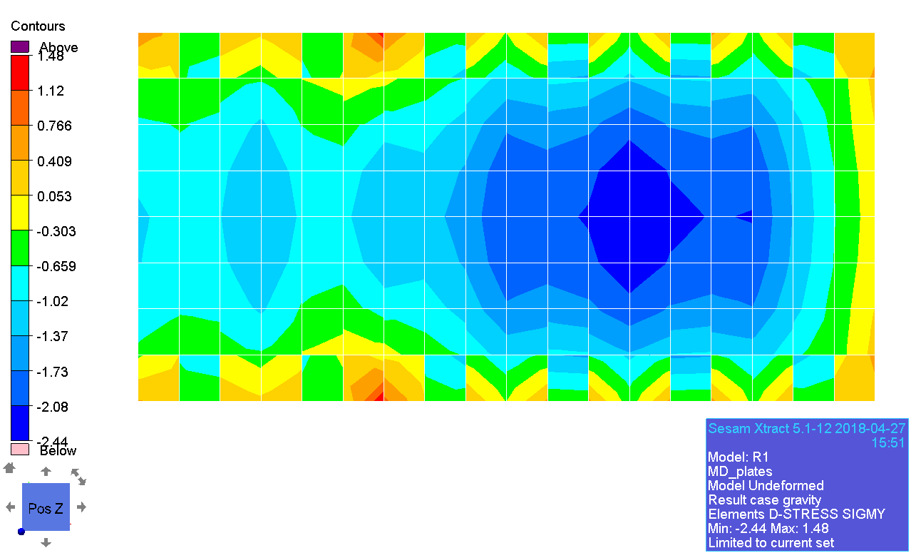

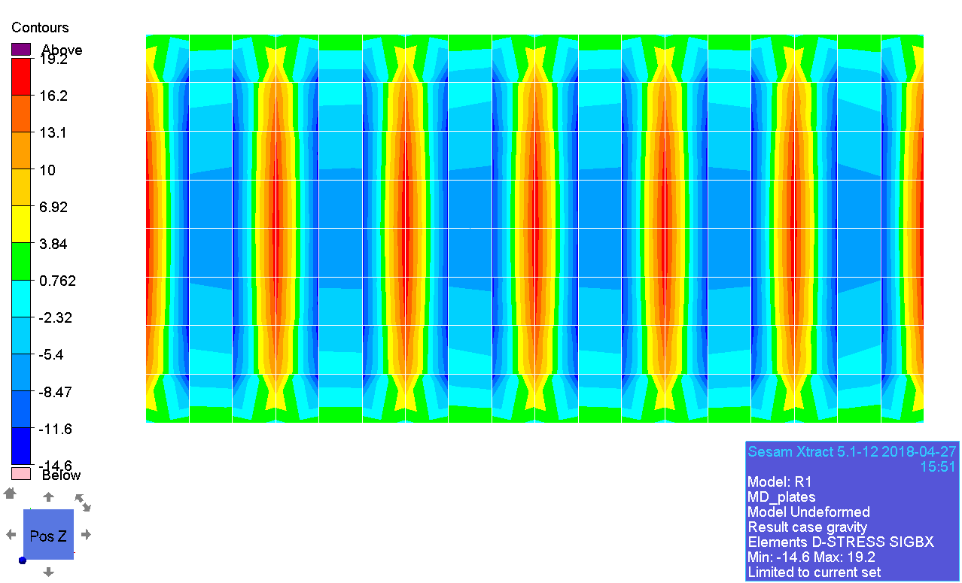

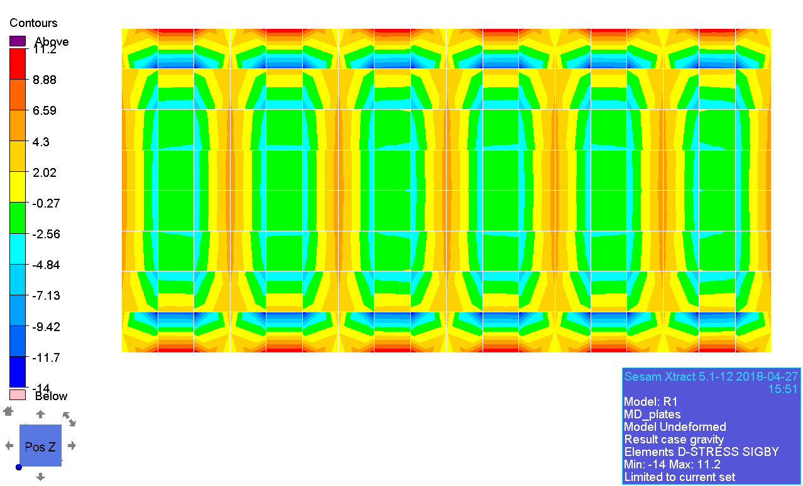

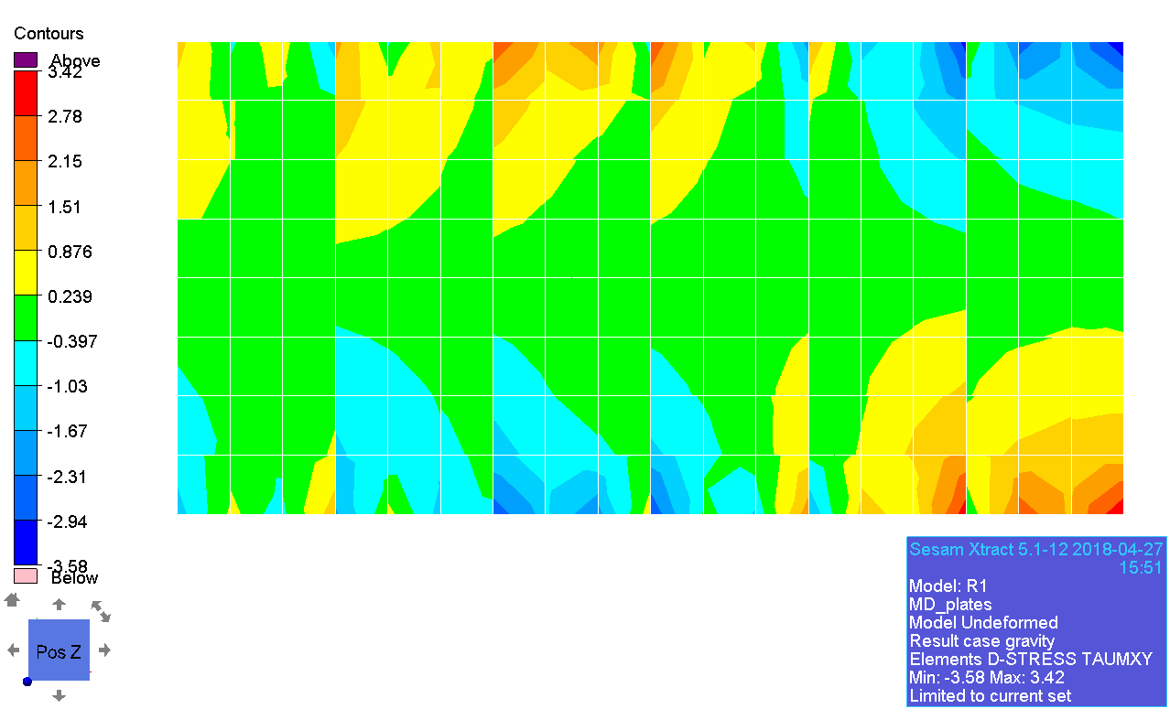

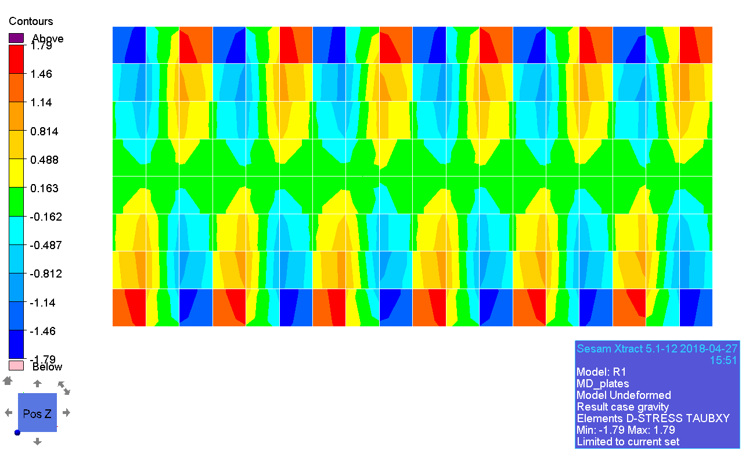

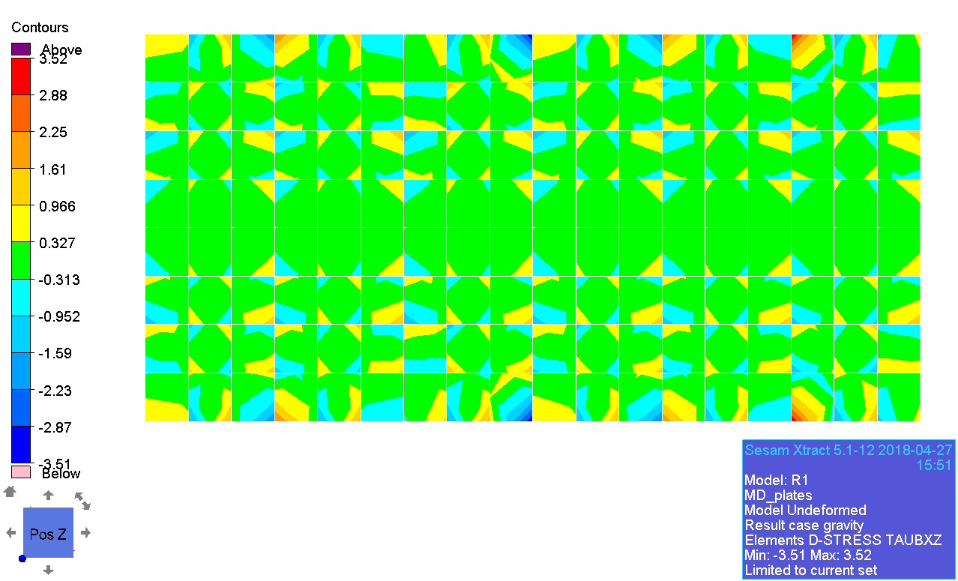

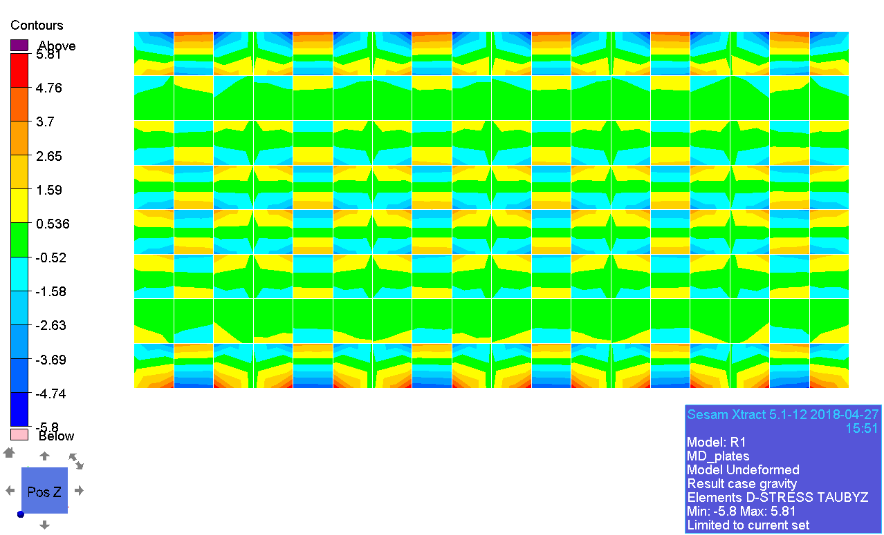

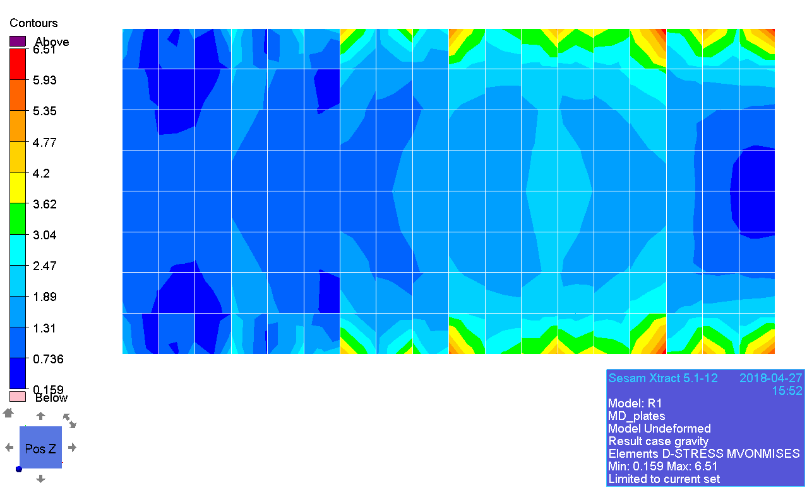

### Membrane principal stress

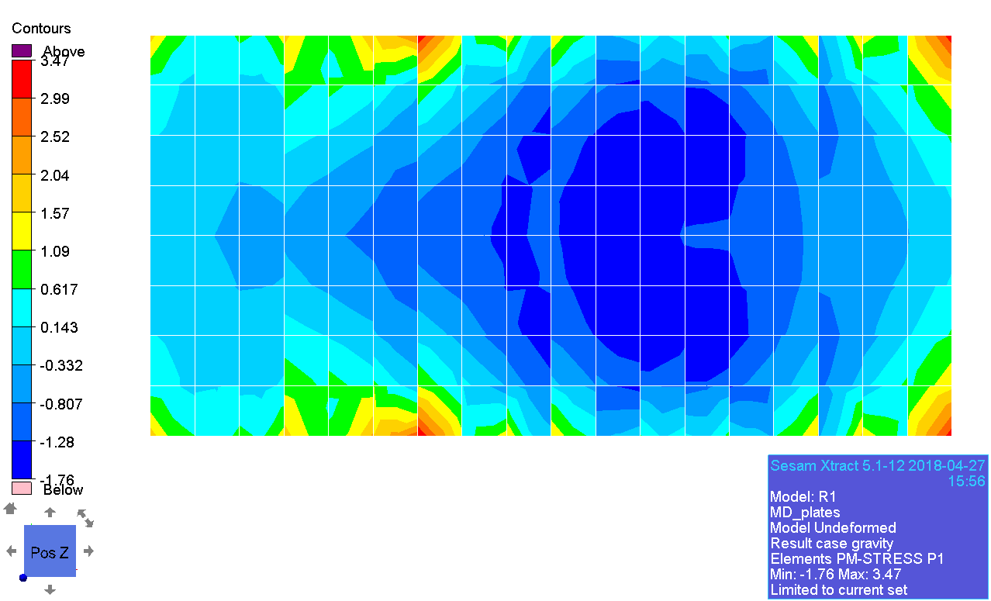

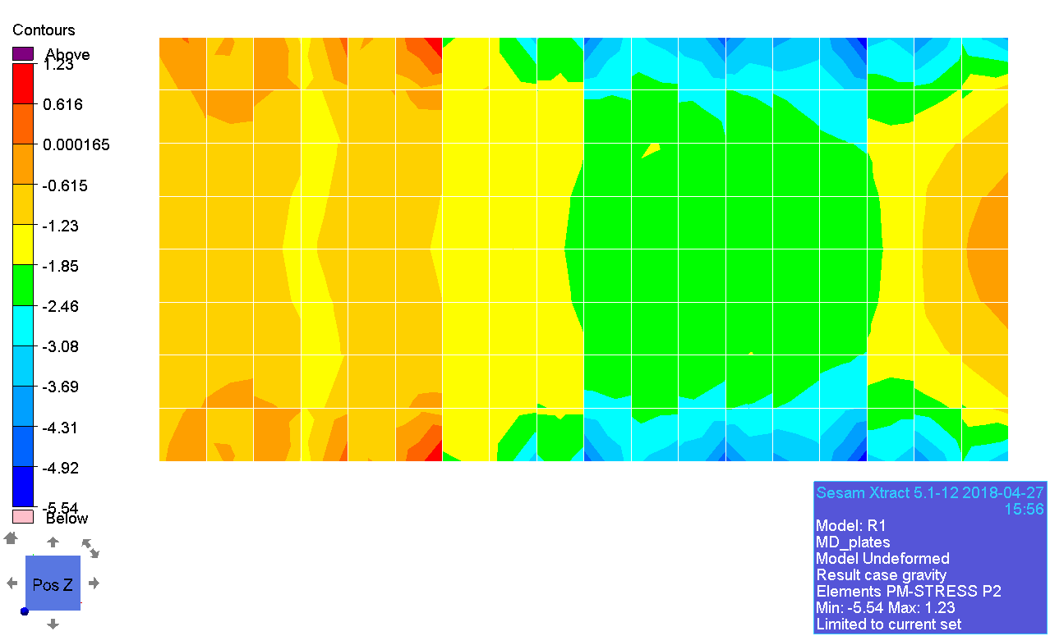

### Beam forces

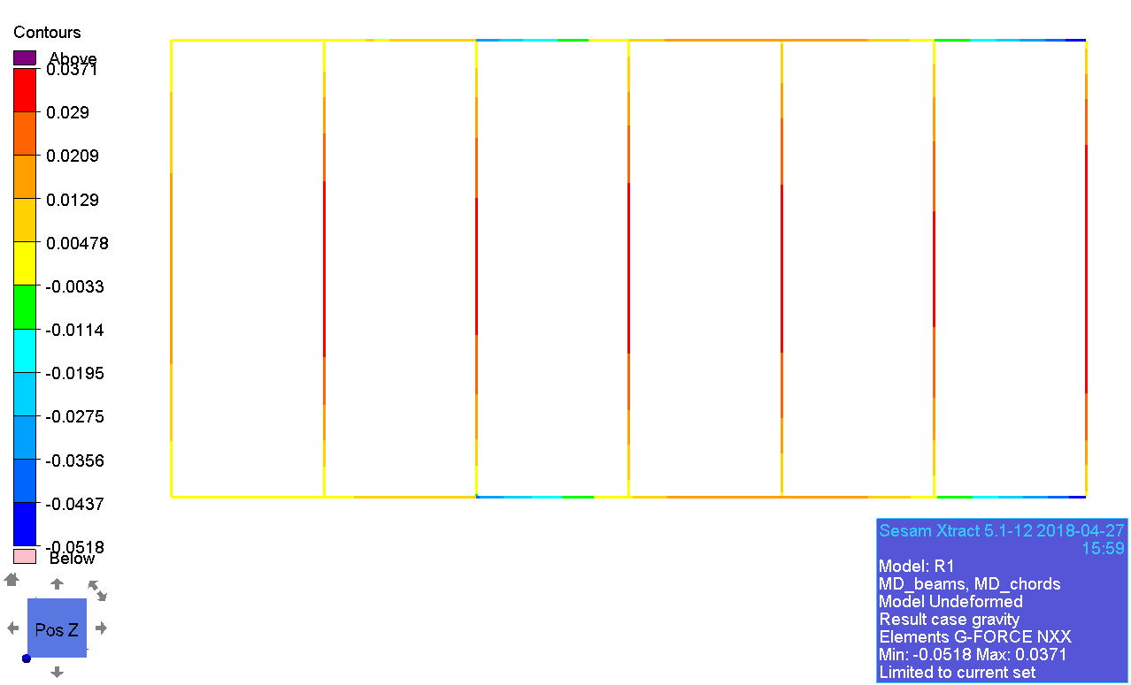

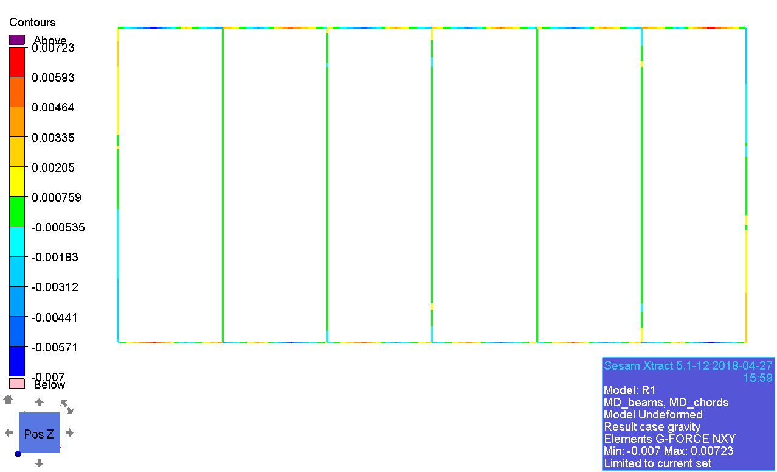

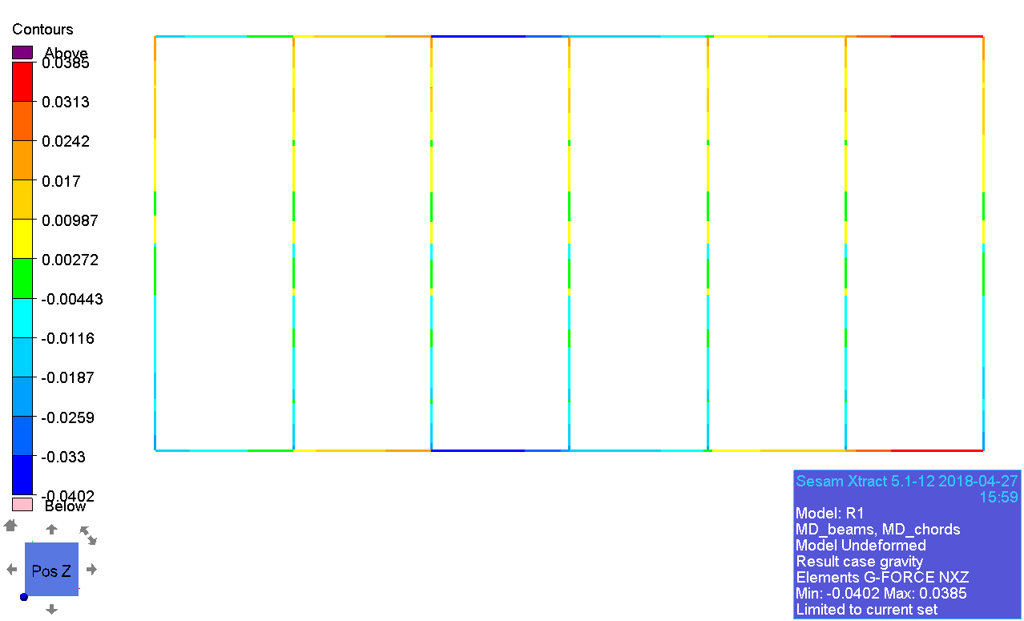

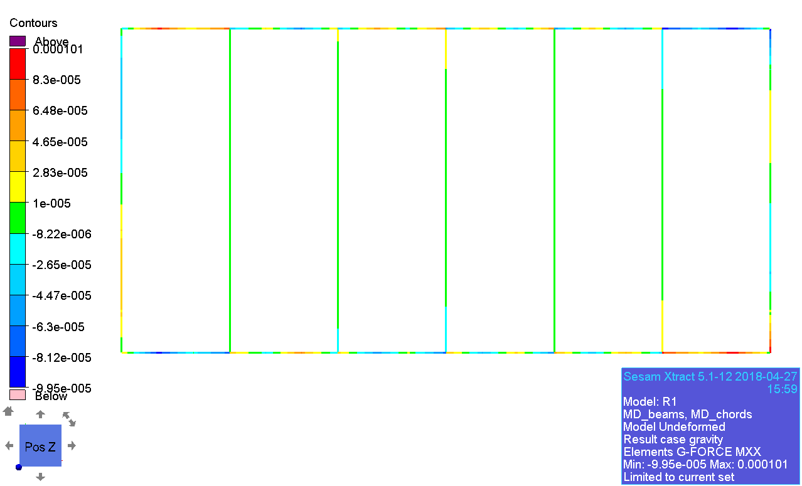

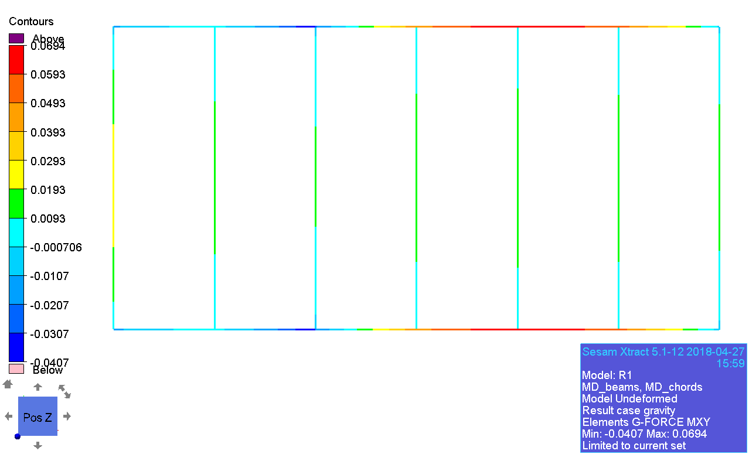

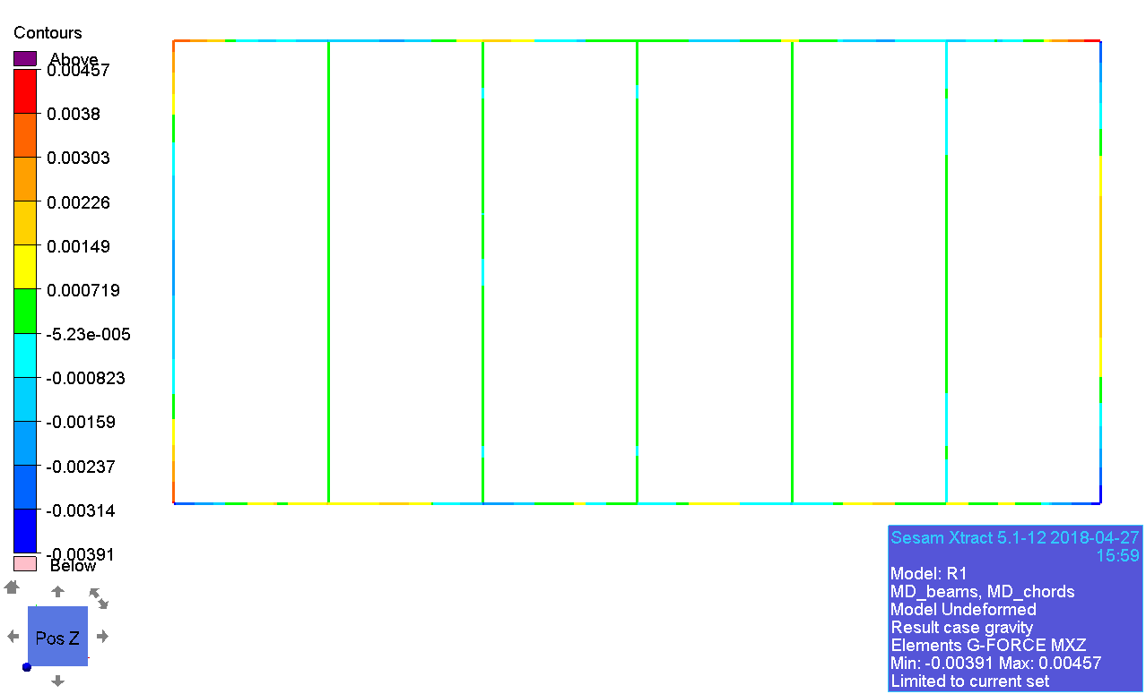

### Displacement

